**Content**

1A. Initial Data Exploration 2

1. Attribute types 2

2. Summarising properties for the attributes 7

3. Recorded data 11

4. Dealing with the missing values 16

5. Visualized by frequency graph and pie charts 19

6. Exploration 29

7. Identify the correlations 33

8. Explore dataset and identify any outliers, clusters of similar instances 41

1B Data Pre-processing 49

1. Binning techniques 49

2. Normalize： 55

3. Discretise the "PRICE" 57

5. Binarisation 59

1C Summary: 61

**1A. Initial Data Exploration**

1. **Attribute** **types**

|  |  |  |  |
| --- | --- | --- | --- |
| **Sl. No.** | **Attribute Name** | **Attribute Type** | **Justification** |
| 1 | BATHRM | Ratio | The type of BATHRM is ‘Ratio’ because it has a value that defines the zero point, which is the proportional origin. And it can sort based on the exact difference between the values. Zero means no bathroom. |
| 2 | HF_BATHRM | Ratio | The type of HF_BATHRM is ‘Ratio’ because it has a value that defines the zero point, which is the proportional origin. And it can sort based on the exact difference between the values.  Zero means no complete half bathroom. |
| 3 | HEAT | Nominal | The type of HEAT is ‘Nominal’ because it is categorical variables without ranking and is not sortable. The data is a discrete unit that can be represented and is used to label variables but has no quantitative value. The purpose of this data is to classify the data into mutually exclusive categories or groups |
| 4 | HEAT_D | Ordinal | The type of HEAT_D is ‘Ordinal’ because can categorize and rank data, but cannot tell for the interval value between rankings. It can be classified according to different values, but it does not mean that one method is more advantageous than another, and it does not mean that all differences are the same. |
| 5 | AC | Nominal | The type of AC is ‘Nominal’ because it is categorical variables without ranking and is not sortable. The data is a discrete unit that can be represented and is used to label variables but has no quantitative value. The purpose of this data is to classify the data into mutually exclusive categories or groups |
| 6 | NUM_UNITS | Ratio | The type of NUM_UNITS is ‘Ratio’ because it has a value that defines the zero point, which is the proportional origin. And it can sort based on the exact difference between the values. Zero means no unit. |
| 7 | ROOMS | Ratio | The type of ROOMS is ‘Ratio’ because it has a value that defines the zero point, which is the proportional origin. And it can sort based on the exact difference between the values.  Zero means no complete room. |
| 8 | BEDRM | Ratio | The type of BATHRM is ‘Ratio’ because it has a value that defines the zero point, which is the proportional origin. And it can sort based on the exact difference between the values. Zero means no bedroom. |
| 9 | AYB | Interval | The type of AYB is ‘Interval’ because variable values can be compared in size, and the difference between the two values is meaningful, and the values will be evenly distributed, but there will be no true zero. |
| 10 | YR_RMDL | Nominal | The type of YR_RMDL is ‘Nominal’ because it is categorical variables without ranking and is not sortable. The data is a discrete unit that can be represented and is used to label variables but has no quantitative value. The purpose of this data is to classify the data into mutually exclusive categories or groups. |
| 11 | EYB | Interval | The type of EYB is ‘Interval’ because variable values can be compared in size, and the difference between the two values is meaningful, and the values will be evenly distributed, but there will be no true zero. |
| 12 | STORIES | Ordinal | The type of STORIES is ‘Ordinal’ because can categorize and rank data, but cannot tell for the interval value between rankings. It can be classified according to different values, but this does not mean that higher floors or lower floors have more advantages. |
| 13 | SALEDATE | Interval | The type of SALEDATE is ‘Interval’ because variable values can be compared in size, and the difference between the two values is meaningful, and the values will be evenly distributed, but there will be no true zero. Because it could not have a date of sale that showed it was AD 0. |
| 14 | PRICE | Ratio | The type of PRICE is ‘Ratio’ because it has a value that defines the zero point, which is the proportional origin. And it can sort based on the exact difference between the values.  Zero means free. Higher prices mean more expensive. |
| 15 | SALE_NUM | Nominal | The type of SALE_NUM  is ‘Nominal’ because it is categorical variables without ranking and is not sortable. The data is a discrete unit that can be represented and is used to label variables but has no quantitative value. The purpose of this data is to classify the data into mutually exclusive categories or groups. There is no fixed logical order for sale number. |
| 16 | GBA | Ratio | The type of GBA is ‘Ratio’ because it has a value that defines the zero point, which is the proportional origin. And it can sort based on the exact difference between the values.  Zero represents no floor area. |
| 17 | BLDG_NUM | Nominal | The type of BLDG_NUM  is ‘Nominal’ because it is categorical variables without ranking and is not sortable. The data is a discrete unit that can be represented and is used to label variables but has no quantitative value. The purpose of this data is to classify the data into mutually exclusive categories or groups. |
| 18 | STYLE | Nominal | The type of STYLE is ‘nominal’ because it is categorical variables without ranking and is not sortable. The data is a discrete unit that can be represented and is used to label variables but has no quantitative value. The purpose of this data is to classify the data into mutually exclusive categories or groups. |
| 19 | STYLE_D | Nominal | The type of STYLE_D  is ‘Nominal’ because it is categorical variables without ranking and is not sortable. The data is a discrete unit that can be represented and is used to label variables but has no quantitative value. The purpose of this data is to classify the data into mutually exclusive categories or groups. There is no fixed logical order for sale number. |
| 20 | STRUCT | Nominal | The type of STRUCT is ‘nominal’ because it is categorical variables without ranking and is not sortable. The data is a discrete unit that can be represented and is used to label variables but has no quantitative value. The purpose of this data is to classify the data into mutually exclusive categories or groups. |
| 21 | STRUCT_D | Nominal | The type of STRUCT_D is ‘nominal’ because it is categorical variables without ranking and is not sortable. The data is a discrete unit that can be represented and is used to label variables but has no quantitative value. The purpose of this data is to classify the data into mutually exclusive categories or groups. |
| 22 | GRADE | Interval | The type of GRADE is ‘Interval’ because variable values can be compared in size, and the difference between the two values is meaningful, and the values will be evenly distributed, but there will be no true zero. The higher the code, the better the level. |
| 23 | GRADE_D | Nominal | The type of GRADE_D is ‘nominal’ because it is categorical variables without ranking and is not sortable. The data is a discrete unit that can be represented and is used to label variables but has no quantitative value. The purpose of this data is to classify the data into mutually exclusive categories or groups. |
| 24 | CNDTN | Interval | The type of CNDTN is ‘Interval’ because variable values can be compared in size, and the difference between the two values is meaningful, and the values will be evenly distributed, but there will be no true zero. The higher the code, the better the level. |
| 25 | CNDTN_D | Nominal | The type of CNDTN_D is ‘Nominal’ because it is categorical variables without ranking and is not sortable. The data is a discrete unit that can be represented and is used to label variables but has no quantitative value. The purpose of this data is to classify the data into mutually exclusive categories or groups. |
| 26 | EXTWALL | Nominal | The type of EXTWALL is ‘nominal’ because it is categorical variables without ranking and is not sortable. The data is a discrete unit that can be represented and is used to label variables but has no quantitative value. The purpose of this data is to classify the data into mutually exclusive categories or groups. |
| 27 | EXTWALL_D | Nominal | The type of EXTWALL_D is ‘nominal’ because it is categorical variables without ranking and is not sortable. The data is a discrete unit that can be represented and is used to label variables but has no quantitative value. The purpose of this data is to classify the data into mutually exclusive categories or groups. |
| 28 | ROOF | Nominal | The type of ROOF is ‘nominal’ because it is categorical variables without ranking and is not sortable. The data is a discrete unit that can be represented and is used to label variables but has no quantitative value. The purpose of this data is to classify the data into mutually exclusive categories or groups. |
| 29 | ROOF_D | Nominal | The type of ROOF_D is ‘nominal’ because it is categorical variables without ranking and is not sortable. The data is a discrete unit that can be represented and is used to label variables but has no quantitative value. The purpose of this data is to classify the data into mutually exclusive categories or groups. |
| 30 | INTWALL | Nominal | The type of INTWALL is ‘nominal’ because it is categorical variables without ranking and is not sortable. The data is a discrete unit that can be represented and is used to label variables but has no quantitative value. The purpose of this data is to classify the data into mutually exclusive categories or groups. |
| 31 | INTWALL_D | Nominal | The type of INTWALL_D is ‘nominal’ because it is categorical variables without ranking and is not sortable. The data is a discrete unit that can be represented and is used to label variables but has no quantitative value. The purpose of this data is to classify the data into mutually exclusive categories or groups. |
| 32 | KITCHENS | Ratio | The type of KITCHENS is ‘Ratio’ because it has a value that defines the zero point, which is the proportional origin. And it can sort based on the exact difference between the values.  Zero represents no kitchen. |
| 33 | FIREPLACES | Ratio | The type of FIREPLACES is ‘Ratio’ because it has a value that defines the zero point, which is the proportional origin. And it can sort based on the exact difference between the values.  Zero represents no fireplaces. |
| 34 | USECODE | Nominal | The type of USECODE is ‘nominal’ because it is categorical variables without ranking and is not sortable. The data is a discrete unit that can be represented and is used to label variables but has no quantitative value. The purpose of this data is to classify the data into mutually exclusive categories or groups. |
| 35 | LANDAREA | Ratio | The type of LANDAREA is ‘Ratio’ because it has a value that defines the zero point, which is the proportional origin. And it can sort based on the exact difference between the values.  Zero represents no floor area. |
| 36 | GIS_LAST_MOD_DTTM | Nominal | The type of GIS_LAST_MOD_DTTM is ‘nominal’ because it is categorical variables without ranking and is not sortable. The data is a discrete unit that can be represented and is used to label variables but has no quantitative value. The purpose of this data is to classify the data into mutually exclusive categories or groups. |
| 37 | QUALIFIED | Nominal | The type of QUALIFIED is ‘Nominal’ because it is categorical variables without ranking and is not sortable. The data is a discrete unit that can be represented and is used to label variables but has no quantitative value. The purpose of this data is to classify the data into mutually exclusive categories or groups. There is no fixed logical order for qualified and unqualified types. |

1. **Summarising properties for the attributes**

**2.1 Data Visualisations**

**2.1.1 Utilizing “statistics” to view data**

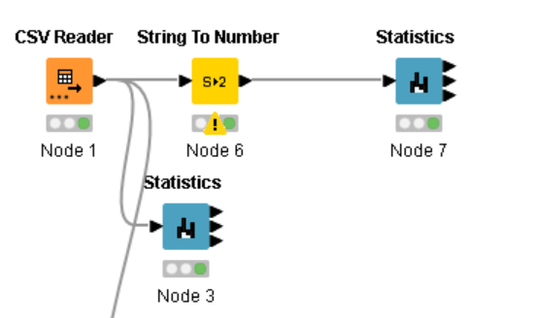

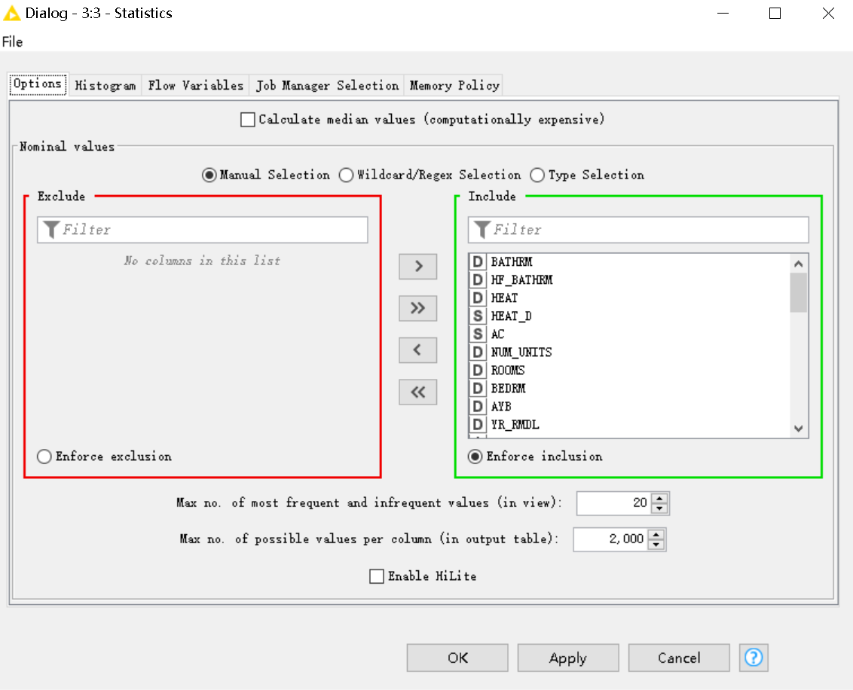

**Result:**

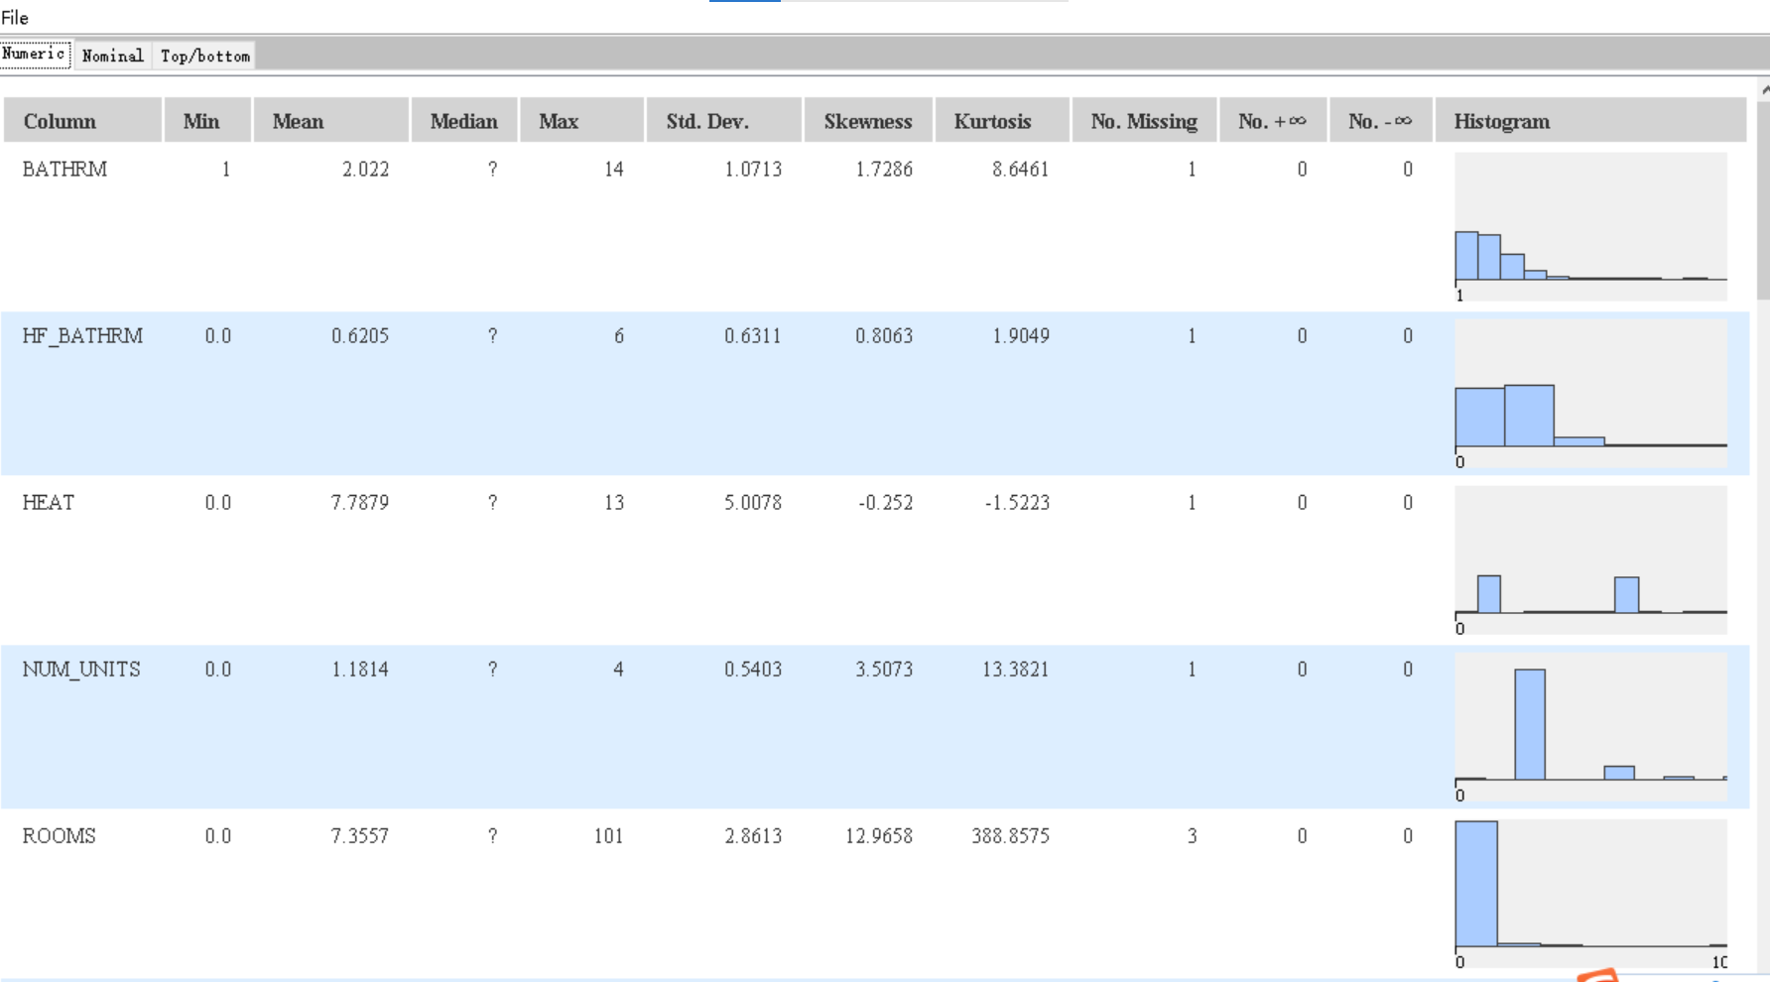

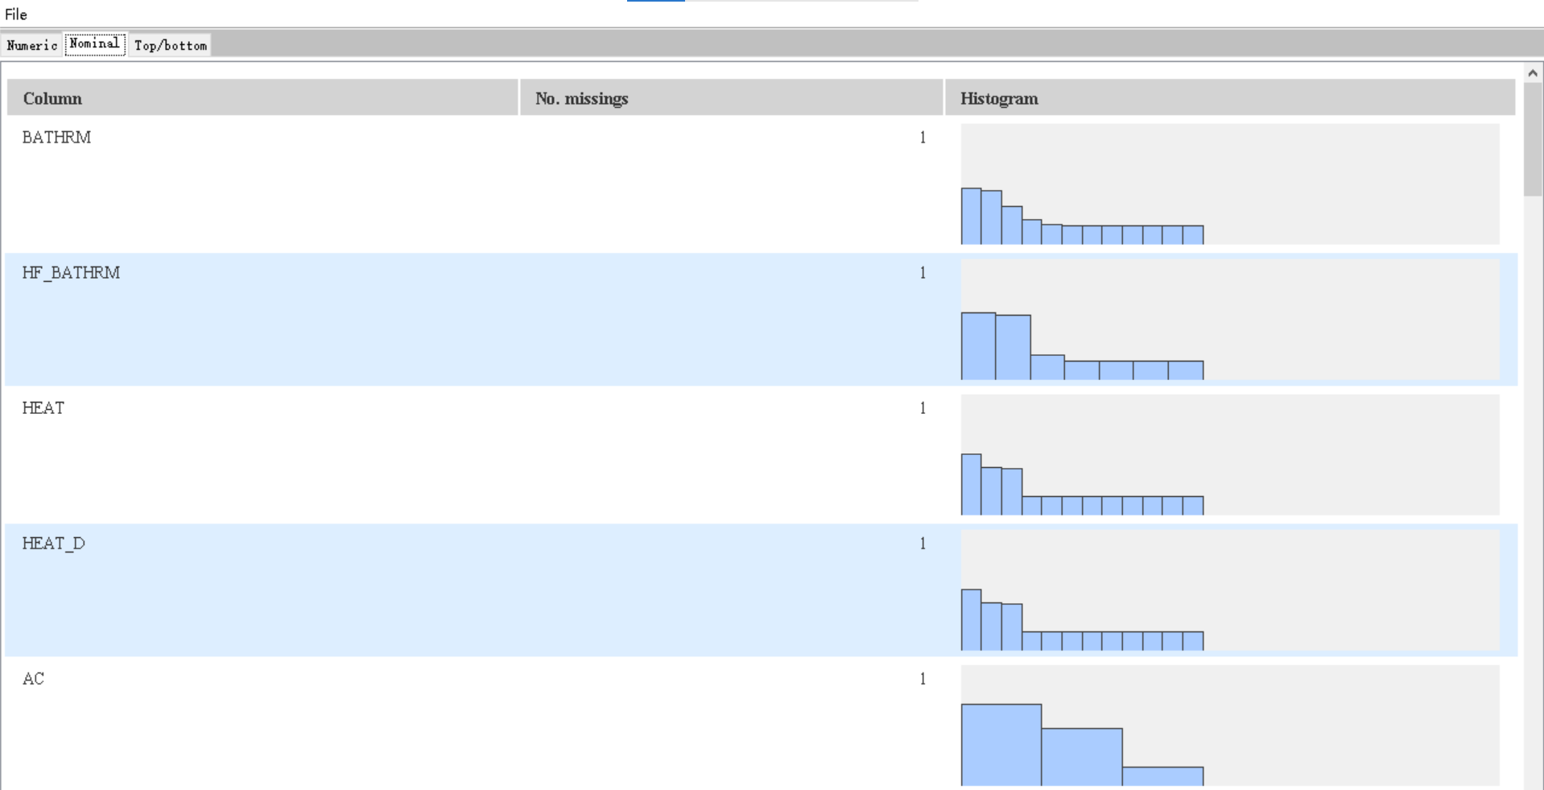

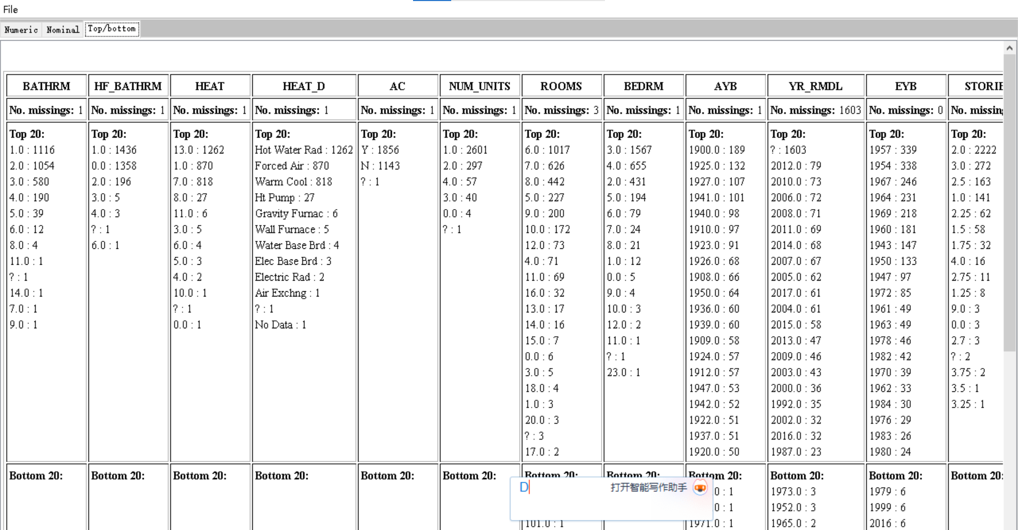

**2.2 Utilizing “GroupBy” to get “median” value**

**2.2.1 Judgment attributes**

The reason for selecting the property:

1. The selling price of the property: Properties with a high **selling price** may be more popular and valuable than properties with a lower selling price.

For example: PRICE

1. Attributes of house facilities: A house with facilities such as **air conditioning, heating, fireplaces and kitchen** will be more popular than a house without it, and the more **rooms and bedrooms and bathrooms** will be more popular than less. A house with **a larger land area** will be more valuable than a house with a smaller land area. The better the room **condition and grade**, the higher the likelihood of popularity.

For example: BATHRM, HF_BATHRM, HEAT, NUM_UNITS, ROOMS, BEDRM, GBA, STYLE, GRADE, CNDTN, Kitchens, Fireplaces, LANDAREA, QUALIFIED

1. Date: The **later the house** is built, the more likely it is to be popular. The **later the renovation** is built, the more popular it is likely to be.

For example: AYB, YR_RMDL, EYB

**2.2.2 Operate**

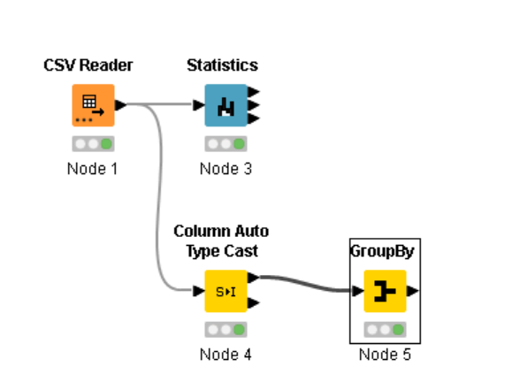

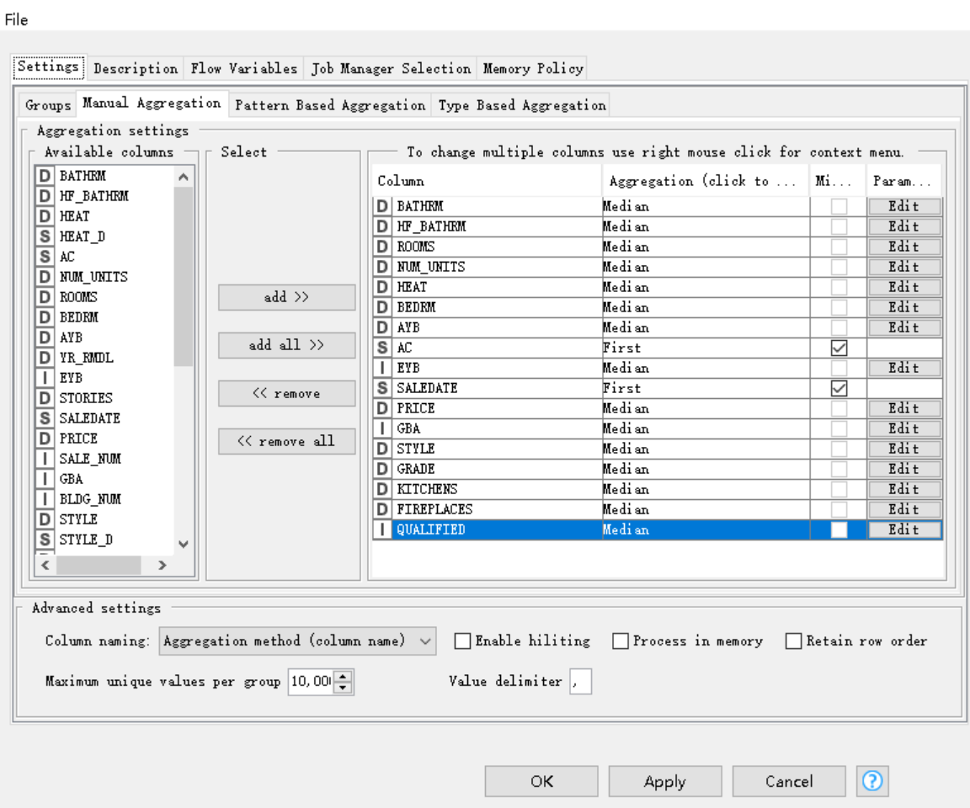

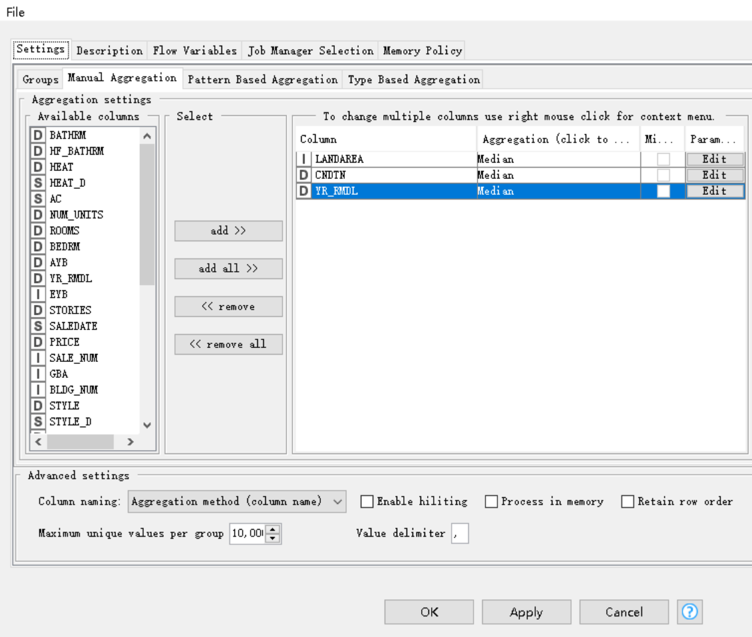

**2.2.3 Result**

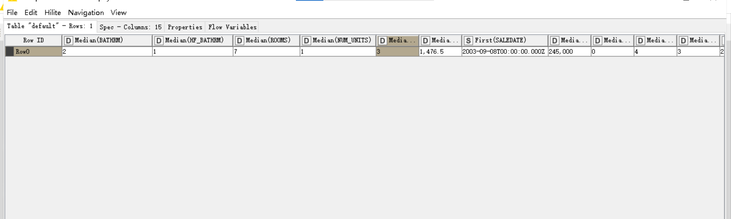

**3. Recorded data**

1. **BATHRM**

|  |  |
| --- | --- |
| **Statistics** | **Value** |
| **Mean** | 2.022 |
| **Median** | 2 |
| **Minimum Value** | 1 |
| **Maximum Value** | 14 |
| **Standard deviation** | 1.071 |
| **Variance** | 1.148 |
| **Skewness** | 1.729 |
| **Kurtosis** | 8.646 |
| **Overall sum** | 6,064 |
| **No. missing** | 1 |
| **Row count** | 3000 |

1. **HF_BATHRM**

|  |  |
| --- | --- |
| **Statistics** | **Value** |
| **Mean** | 0.621 |
| **Median** | 1 |
| **Minimum Value** | 0 |
| **Maximum Value** | 6 |
| **Standard deviation** | 0.631 |
| **Variance** | 0.398 |
| **Skewness** | 0.806 |
| **Kurtosis** | 1.905 |
| **Overall sum** | 1,861 |
| **No. missing** | 1 |
| **Row count** | 3000 |

1. **HEAT**

|  |  |
| --- | --- |
| **Statistics** | **Value** |
| **Mean** | 7.788 |
| **Median** | 7 |
| **Minimum Value** | 0 |
| **Maximum Value** | 13 |
| **Standard deviation** | 5.008 |
| **Variance** | 25.078 |
| **Skewness** | -0.252 |
| **Kurtosis** | -1.522 |
| **Overall sum** | 23,356 |
| **No. missing** | 1 |
| **Row count** | 3000 |

1. **NUM_UNITS**

|  |  |
| --- | --- |
| **Statistics** | **Value** |
| **Mean** | 1.181 |
| **Median** | 1 |
| **Minimum Value** | 0 |
| **Maximum Value** | 4 |
| **Standard deviation** | 0.54 |
| **Variance** | 0.292 |
| **Skewness** | 3.507 |
| **Kurtosis** | 13.382 |
| **Overall sum** | 3,543 |
| **No. missing** | 1 |
| **Row count** | 3000 |

1. **ROOMS**

|  |  |
| --- | --- |
| **Statistics** | **Value** |
| **Mean** | 7.356 |
| **Median** | 7 |
| **Minimum Value** | 0.0 |
| **Maximum Value** | 101 |
| **Standard deviation** | 2.861 |
| **Variance** | 8.187 |
| **Skewness** | 12.966 |
| **Kurtosis** | 388.858 |
| **Overall sum** | 22,045 |
| **No. missing** | 3 |
| **Row count** | 3000 |

1. **BEDRM**

|  |  |
| --- | --- |
| **Statistics** | **Value** |
| **Mean** | 3.367 |
| **Median** | 3 |
| **Minimum Value** | 0.0 |
| **Maximum Value** | 23 |
| **Standard deviation** | 1.168 |
| **Variance** | 1.363 |
| **Skewness** | 3.156 |
| **Kurtosis** | 31.989 |
| **Overall sum** | 10,099 |
| **No. missing** | 1 |
| **Row count** | 3000 |

1. **AYB**

|  |  |
| --- | --- |
| **Statistics** | **Value** |
| **Mean** | 1928.647 |
| **Median** | 1928 |
| **Minimum Value** | 0 |
| **Maximum Value** | 2019 |
| **Standard deviation** | 102.613 |
| **Variance** | 10,529.406 |
| **Skewness** | -17.213 |
| **Kurtosis** | 318.898 |
| **Overall sum** | 5,784,013 |
| **No. missing** | 1 |
| **Row count** | 3000 |

1. **YR_RMDL**

|  |  |
| --- | --- |
| **Statistics** | **Value** |
| **Mean** | 2,001.188 |
| **Median** | 2006 |
| **Minimum Value** | 1,923 |
| **Maximum Value** | 2,018 |
| **Standard deviation** | 14.982 |
| **Variance** | 224.452 |
| **Skewness** | -1.504 |
| **Kurtosis** | 2.169 |
| **Overall sum** | 2,795,659 |
| **No. missing** | 1603 |
| **Row count** | 3000 |

1. **EYB**

|  |  |
| --- | --- |
| **Statistics** | **Value** |
| **Mean** | 1,965.426 |
| **Median** | 1964 |
| **Minimum Value** | 0 |
| **Maximum Value** | 2,018 |
| **Standard deviation** | 39.439 |
| **Variance** | 1,555.471 |
| **Skewness** | -41.197 |
| **Kurtosis** | 2,057.741 |
| **Overall sum** | 5,896,277 |
| **No. missing** | 0 |
| **Row count** | 3000 |

1. **PRICE**

|  |  |
| --- | --- |
| **Statistics** | **Value** |
| **Mean** | 391,045.743 |
| **Median** | 245,000 |
| **Minimum Value** | 0 |
| **Maximum Value** | 8,500,000 |
| **Standard deviation** | 562,599.823 |
| **Variance** | 316,518,560,278.7 |
| **Skewness** | 4.967 |
| **Kurtosis** | 47.743 |
| **Overall sum** | 957,279,978 |
| **No. missing** | 552 |
| **Row count** | 3000 |

1. **GBA**

|  |  |
| --- | --- |
| **Statistics** | **Value** |
| **Mean** | 1,712.341 |
| **Median** | 1476.5 |
| **Minimum Value** | 0 |
| **Maximum Value** | 16,658 |
| **Standard deviation** | 894.985 |
| **Variance** | 800,997.899 |
| **Skewness** | 4.038 |
| **Kurtosis** | 37.345 |
| **Overall sum** | 5,137,024 |
| **No. missing** | 0 |
| **Row count** | 3000 |

1. **STYLE**

|  |  |
| --- | --- |
| **Statistics** | **Value** |
| **Mean** | 4.376 |
| **Median** | 4 |
| **Minimum Value** | 0 |
| **Maximum Value** | 99 |
| **Standard deviation** | 2.281 |
| **Variance** | 5.203 |
| **Skewness** | 24.369 |
| **Kurtosis** | 989.513 |
| **Overall sum** | 13,123 |
| **No. missing** | 1 |
| **Row count** | 3000 |

1. **GRADE**

|  |  |
| --- | --- |
| **Statistics** | **Value** |
| **Mean** | 4.27 |
| **Median** | 4 |
| **Minimum Value** | 2 |
| **Maximum Value** | 12 |
| **Standard deviation** | 1.396 |
| **Variance** | 1.948 |
| **Skewness** | 1.503 |
| **Kurtosis** | 3.043 |
| **Overall sum** | 12,806 |
| **No. missing** | 1 |
| **Row count** | 3000 |

1. **CNDTN**

|  |  |
| --- | --- |
| **Statistics** | **Value** |
| **Mean** | 3.526 |
| **Median** | 3 |
| **Minimum Value** | 1 |
| **Maximum Value** | 6 |
| **Standard deviation** | 0.699 |
| **Variance** | 0.488 |
| **Skewness** | 0.9 |
| **Kurtosis** | 0.873 |
| **Overall sum** | 10,574 |
| **No. missing** | 1 |
| **Row count** | 3000 |

1. **Kitchens**

|  |  |
| --- | --- |
| **Statistics** | **Value** |
| **Mean** | 1.201 |
| **Median** | 1 |
| **Minimum Value** | 0 |
| **Maximum Value** | 4 |
| **Standard deviation** | 0.55 |
| **Variance** | 0.303 |
| **Skewness** | 3.312 |
| **Kurtosis** | 11.999 |
| **Overall sum** | 3,601 |
| **No. missing** | 1 |
| **Row count** | 3000 |

1. **Fireplaces**

|  |  |
| --- | --- |
| **Statistics** | **Value** |
| **Mean** | 0.627 |
| **Median** | 0 |
| **Minimum Value** | 0 |
| **Maximum Value** | 9 |
| **Standard deviation** | 0.895 |
| **Variance** | 0.8 |
| **Skewness** | 2.101 |
| **Kurtosis** | 7.5 |
| **Overall sum** | 1,879 |
| **No. missing** | 1 |
| **Row count** | 3000 |

1**7. LANDAREA**

|  |  |
| --- | --- |
| **Statistics** | **Value** |
| **Mean** | 3,586.204 |
| **Median** | 2,314.5 |
| **Minimum Value** | 266 |
| **Maximum Value** | 691,817 |
| **Standard deviation** | 13,076.041 |
| **Variance** | 170,982,843.379 |
| **Skewness** | 48.815 |
| **Kurtosis** | 2,561.739 |
| **Overall sum** | 10,758,612 |
| **No. missing** | 0 |
| **Row count** | 3000 |

**18. QUALIFIED**

|  |  |
| --- | --- |
| **Statistics** | **Value** |
| **Mean** | 0436 |
| **Median** | 0 |
| **Minimum Value** | 0 |
| **Maximum Value** | 1 |
| **Standard deviation** | 0.496 |
| **Variance** | 0.246 |
| **Skewness** | 0.26 |
| **Kurtosis** | -1.934 |
| **Overall sum** | 1,307 |
| **No. missing** | 0 |
| **Row count** | 3000 |

1. **Dealing with the missing values**

**To solve the missing numbers in the data table using the mean or median instead of missing values, the tool used here is ‘missing value’.**

**4.1 Use “Mean” to replace missing data**

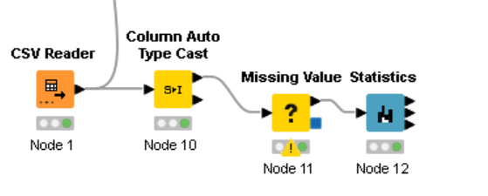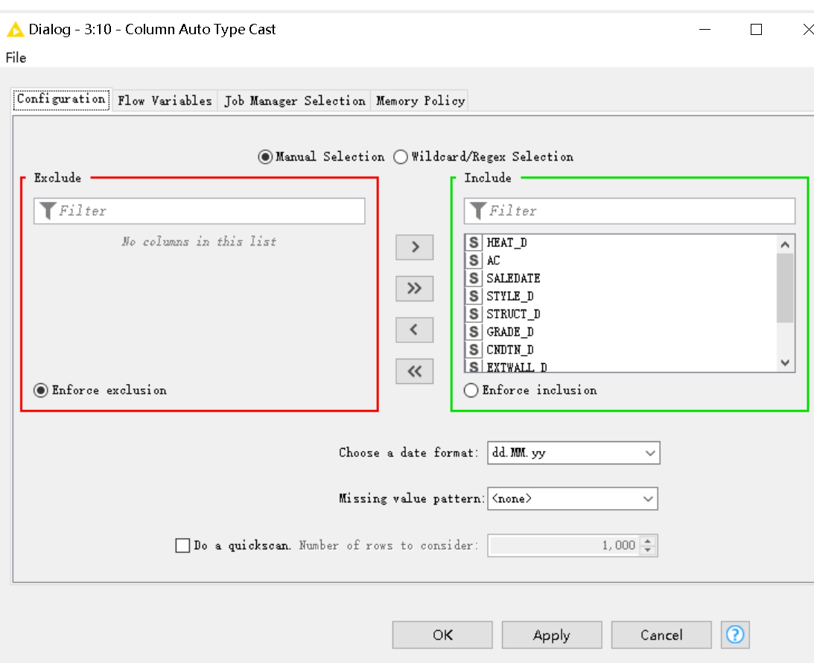

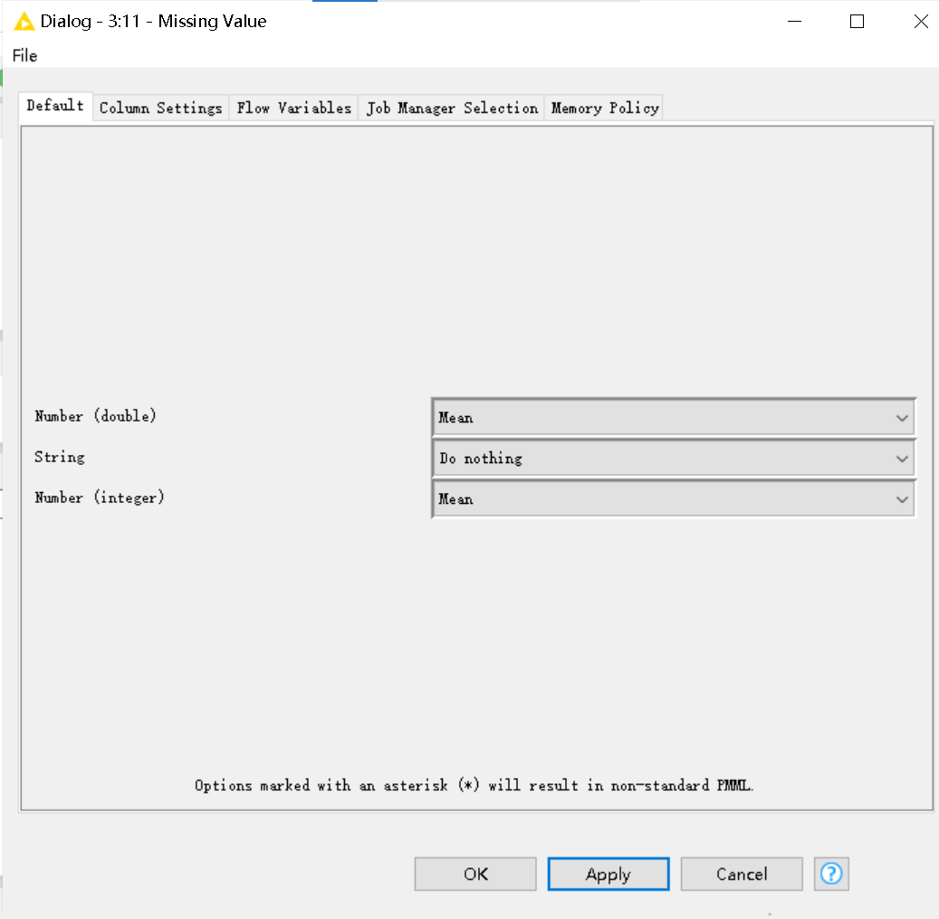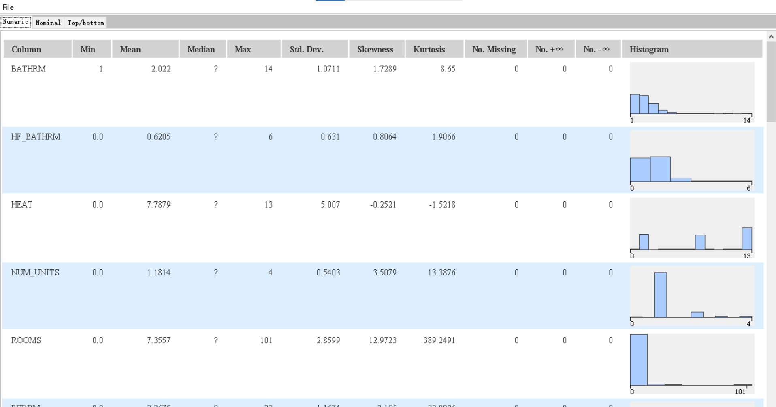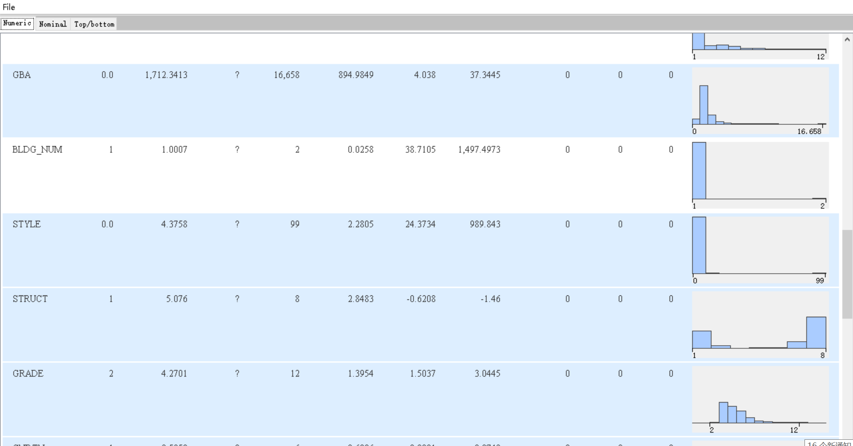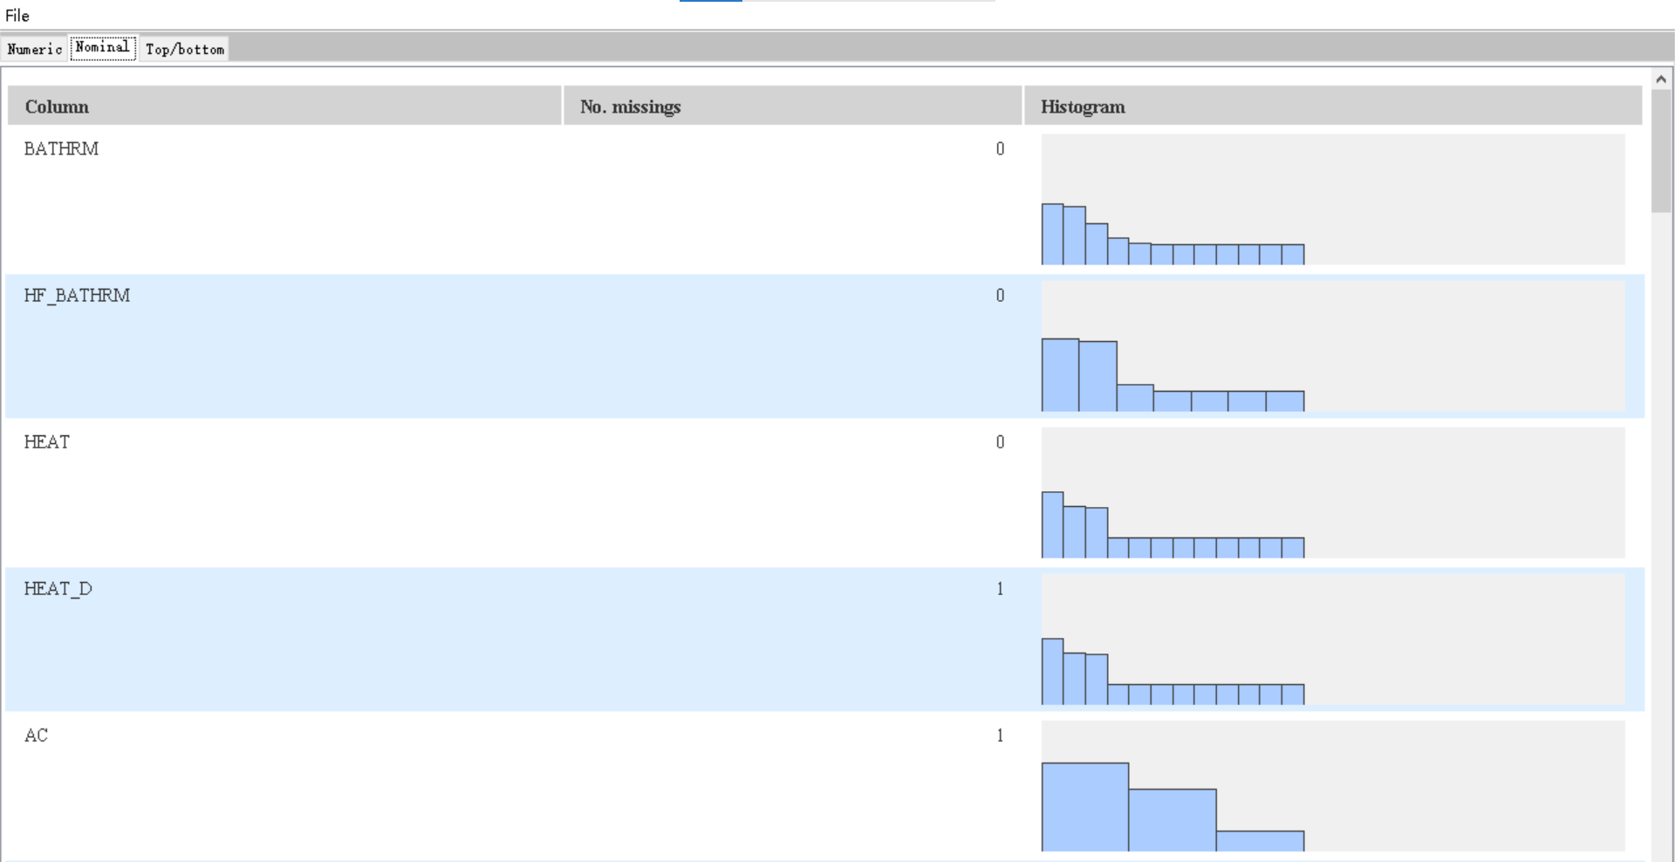

**4.2 Use “Median” to replace missing data**

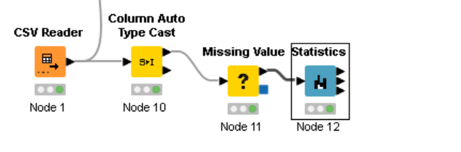

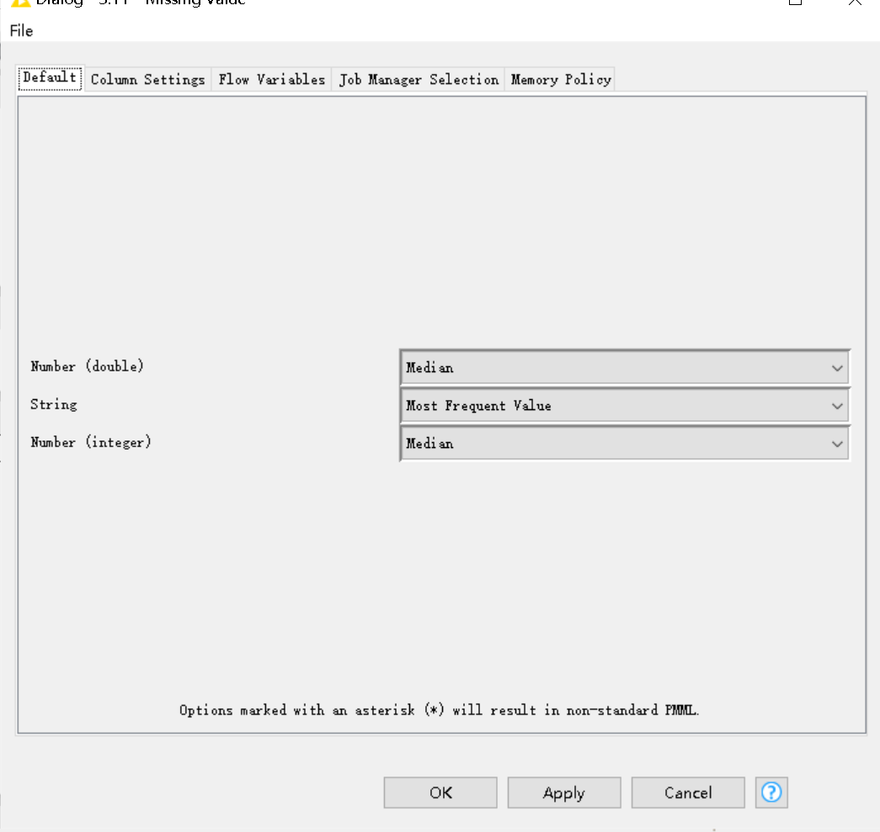

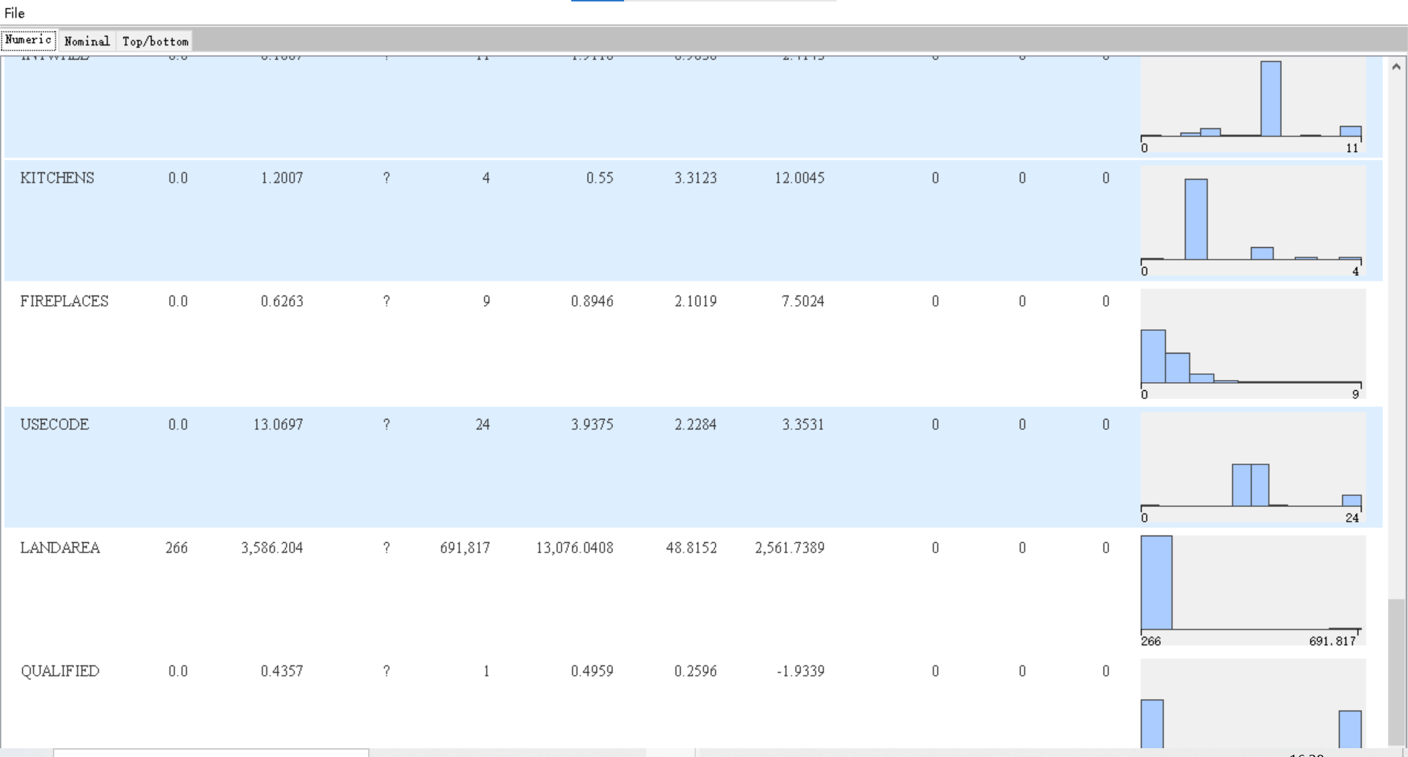

1. **Visualized by frequency graph and pie charts**

The methods used here contain: “Histogram” and “Pie chart”.

**5.1 BATHRM**

The pie chart (figure 2) and Frequency Graph(figure 1) below show the number of bedrooms, from 1 to 14. Only one bathroom was the largest proportion, with 37.2% of a total of 1,116 houses. The second largest was 2 bathrooms, with only 1,054 new homes accounting for 35.13 percent.Houses with three and four bedrooms accounted for 19.33% and 6.33%, respectively. Fewer houses own other numbers of bathrooms. Using the pie chart (figure 2) can clearly see the relatively large type of bathroom. But when the number of bathroom is greater than 5, the proportion of bathroom is less, there will be multiple data accumulation together is not easy to view.

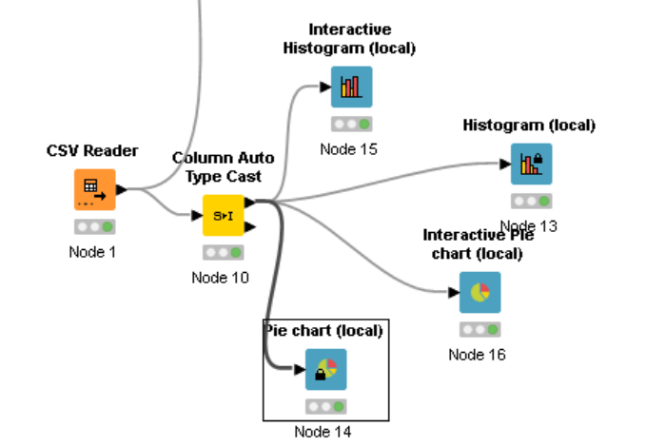

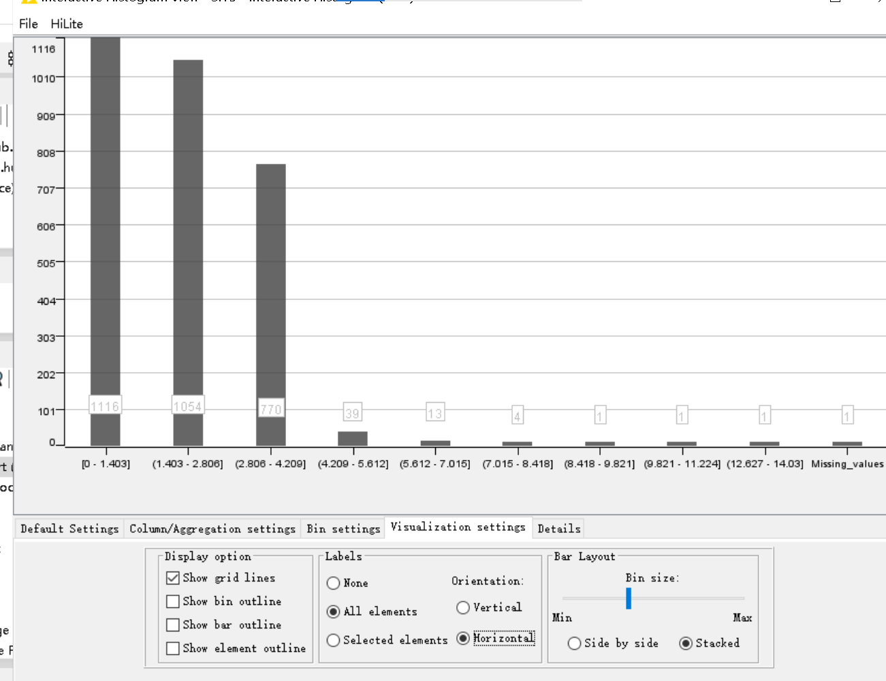

*Figure* 1 *Frequency* *Graph* *for* *BATHRM*

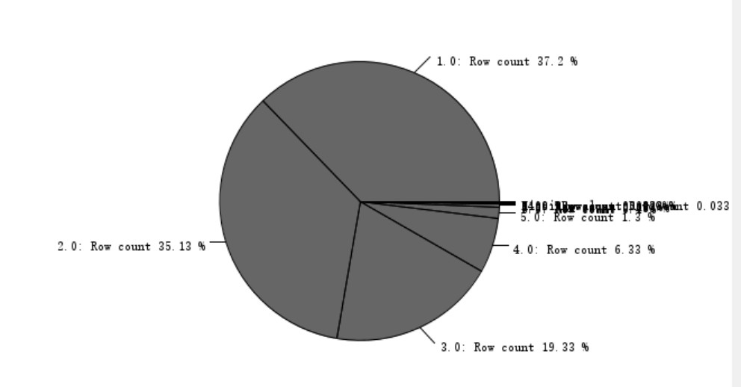

*Figure 2 Pie Chart for BATHRM*

**5.2 NUM_UNITS**

The Frequency Graph(figure 3) and pie chart (figure 4) below show the number of units

, from 0 to 4. The largest number was only one unit, with 86.7% of 2,605 houses. Conversely, the smallest number of houses with 3 units that can be clearly seen from the pie chart was 1.33%.

The proportion of houses with two and four units was 9.9% and 1.9%, and the number was 297 and 57, respectively. In this data, the data in the pie chart will be clearer than that in the frequency graph.It can be seen from here that the vast majority of houses have a unit.

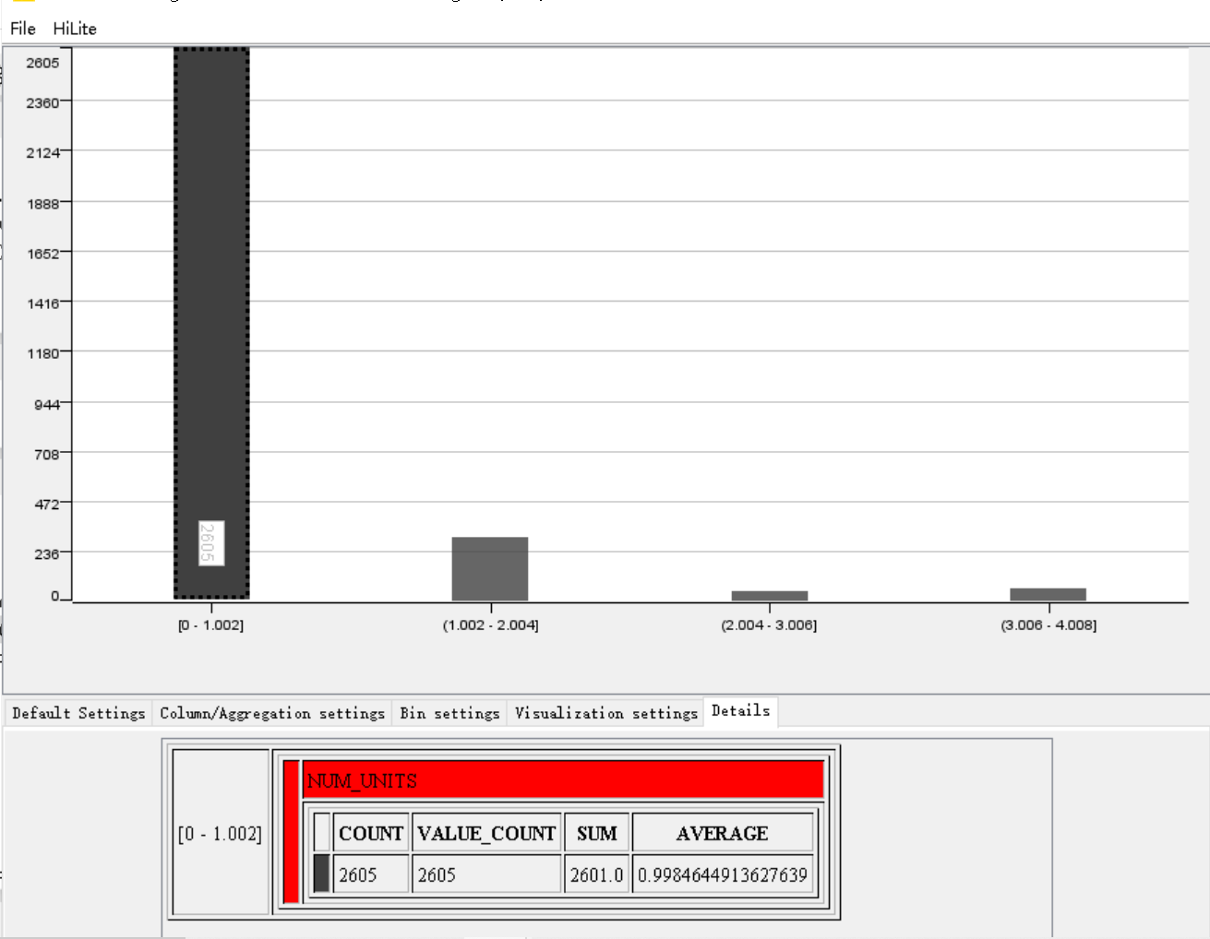

*Figure 3 Frequency Graph for NUM_UNITS*

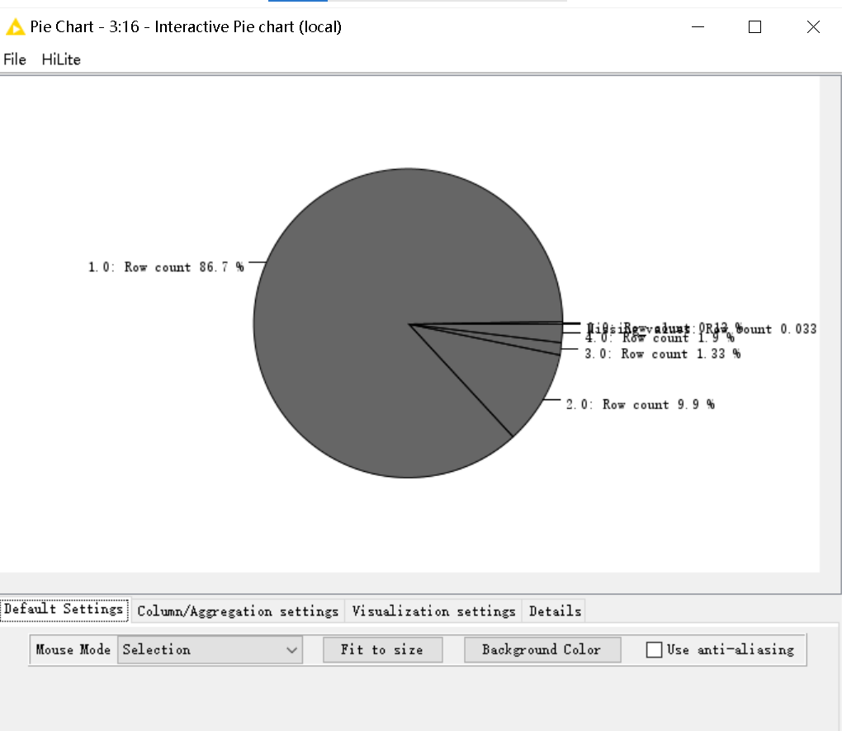

*Figure 4 Pie Chart for NUM_UNITS*

**5.3 ROOMS**

The Frequency Graph(figure 5) and pie chart (figure 6) below show the number of rooms

, from 0 to 101. From the pie chart, we can clearly see that the most abundant type of house uses houses with six rooms, with 33.9% owning 1,017 houses. Obviously, the second largest proportion is 626 houses with 7 rooms in 20.87%. In this data, because the data is scattered, the frequency chart can clearly see the scattered general area, and the pie chart can clearly see the proportion of rooms.From the trends in the chart, it can be predicted that the number of rooms that the house is most likely to have is 3 to 11.

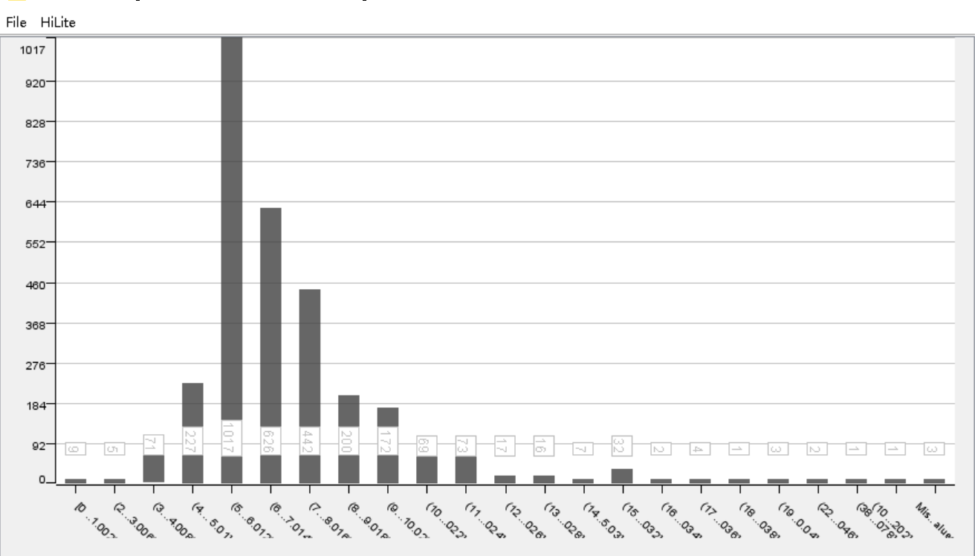

*Figure 5 Frequency Graph for ROOMS*

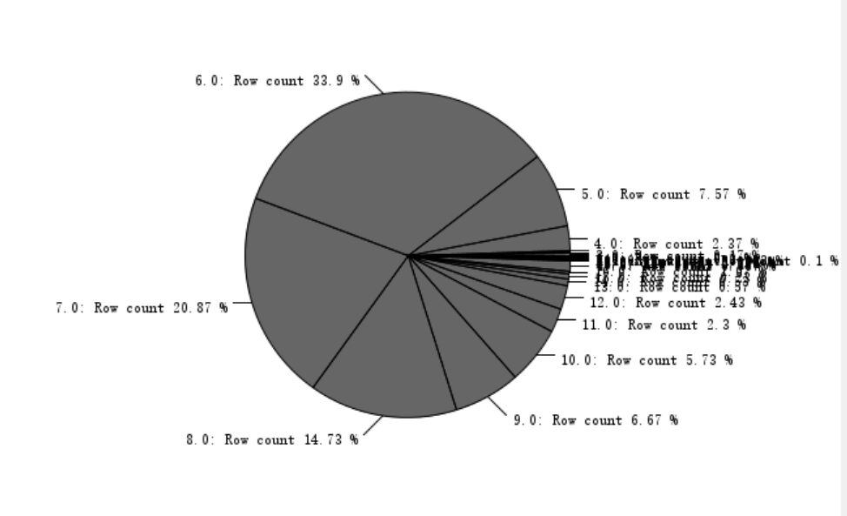

*Figure 6 Pie Chart for ROOMS*

**5.4 BEDRM**

The Frequency Graph(figure 7) and pie chart (figure 8) below show the number of bedroom

, from 0 to 24. We can clearly see through the pie chart (figure 8) that the highest proportion of houses with three bedrooms is 52.23% and 1,567 houses. The proportion of houses with four bedrooms is 21.83%, and the proportion of houses with two bedrooms is 14.37%, and their number is 655 and 431, respectively. 6.47% of houses with five bedrooms and 2.63% with six bedrooms. Therefore, the vast majority of rooms are usually concentrated between two and six.

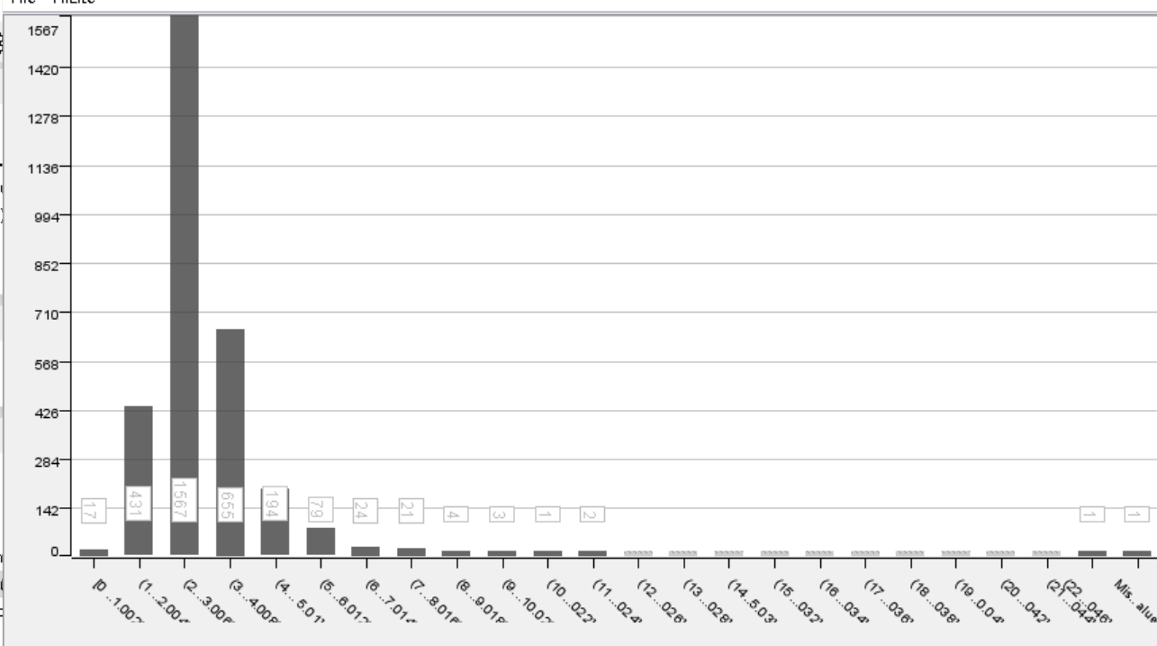

*Figure* 7 *Frequency* *Graph* *for* *BEDRM*

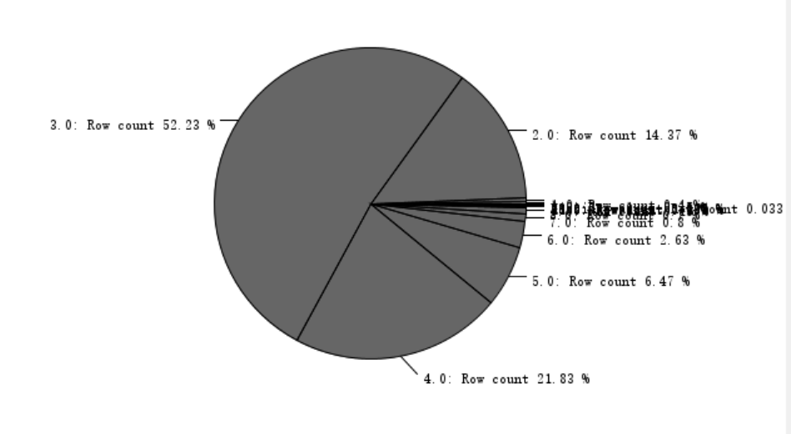

*Figure 8 Pie Chart for BEDRM*

**5.5 GRADE_D**

The Frequency Graph(figure 9) and pie chart (figure 10) below show Grade description. Through the frequency graph, it can be clearly seen that the average proportion is the largest, accounting for 35.7% of all room types, but the proportion of rooms below the average is very high, accounting for 28.97%, and the third proportion is good quality, accounting for 20.11%. In this data, a pie chart will more directly represent the area where each data is distributed.

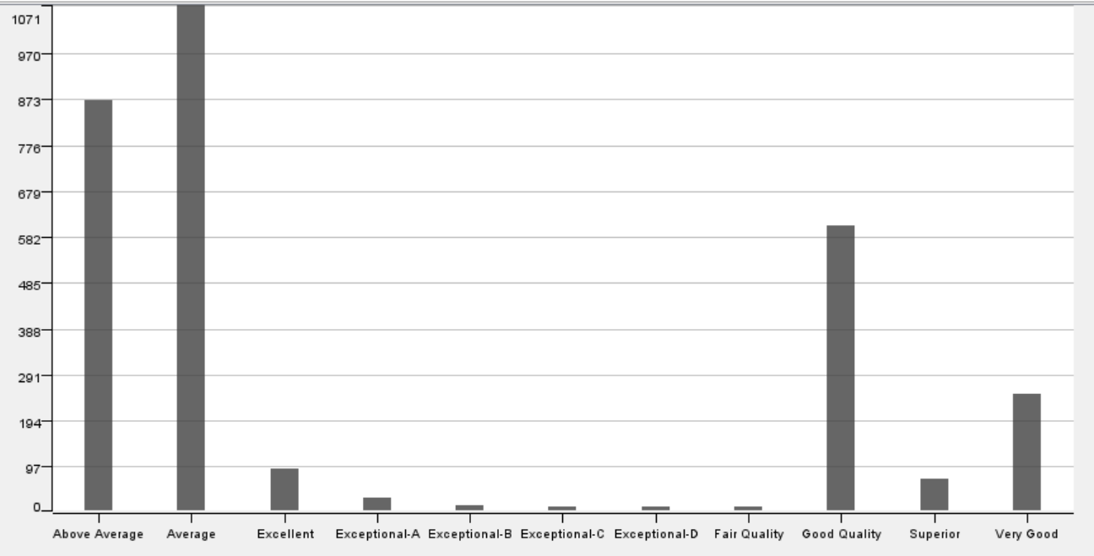

*Figure 9 Frequency Graph for GRADE_D*

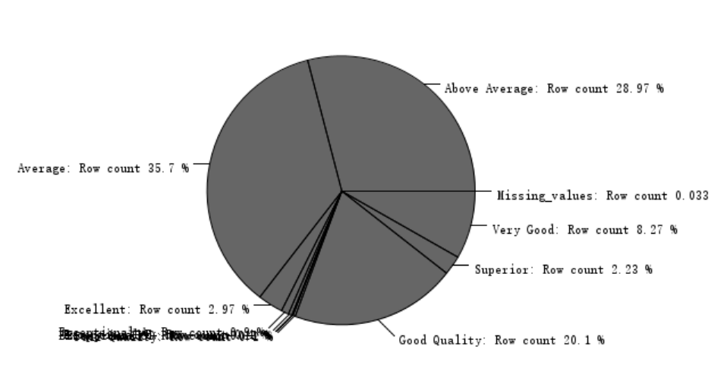

*Figure 10 Pie Chart for GRADE_D*

**5.6 CNDTN_D**

The Frequency Graph (figure 11) and pie chart (figure 12) below show Condition description. From the frequency distribution chart and pie chart, it can be clearly seen that the average proportion reached 54.73% at most, the number was 1642 houses, and the second place was a good house with 35.77%, with 1073 houses. In third place are very good rooms with 7.3%, the other rooms are excellent and fail as well as the frequency of poor to account for very little. As can be inferred from the chart, most of its house condition are concentrated in average and good.

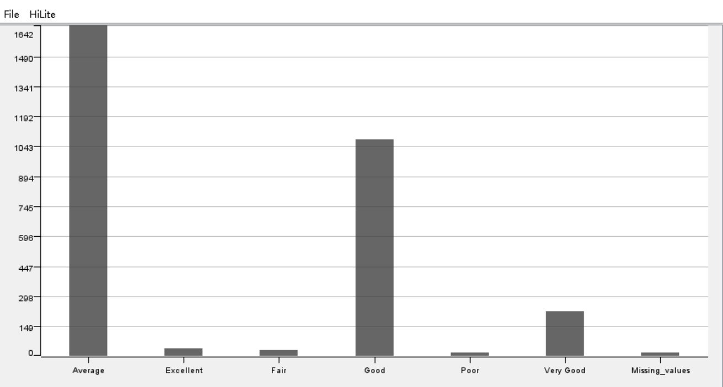

*Figure 11 Frequency Graph for CNDTN_D*

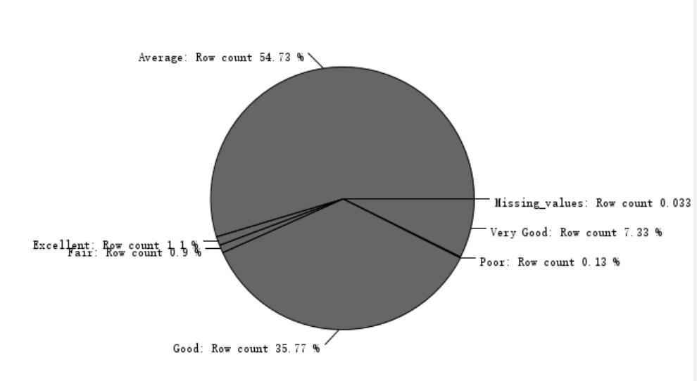

*Figure 12 Pie Chart for CNDTN_D*

**5.7 KITCHENS**

The Frequency Graph (figure 13) and pie chart (figure 14) below show kitchens. From the pie chart, it can be clearly seen that the proportion of houses with only one kitchen reaches 84.97%, and the proportion of houses with two kitchens is as high as 11.77%. In this data, the pie chart will be clearly clear and intuitive over the frequency chart. And we can roughly guess that the vast majority of houses only have one kitchen.

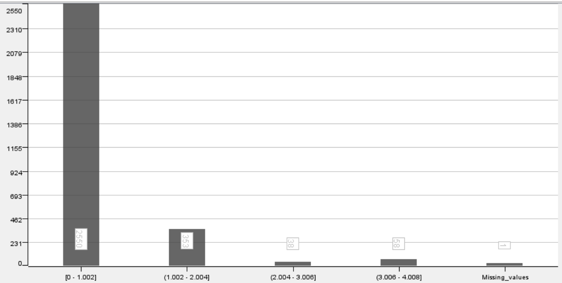

*Figure 13 Frequency Graph for KITCHENS*

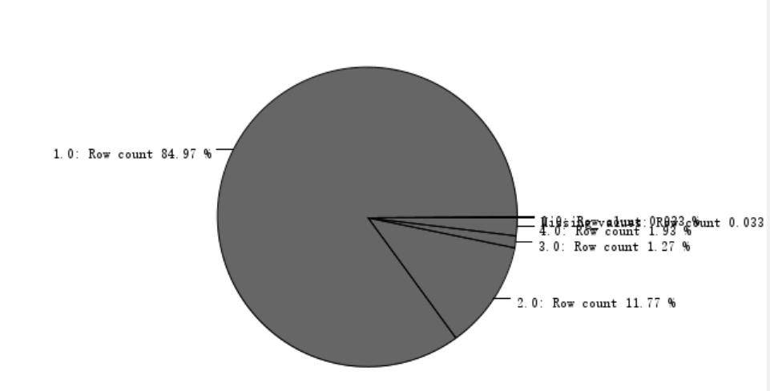

*Figure 14 Pie Chart for KITCHENS*

**5.8 FIREPLACES**

The Frequency Graph (figure 15) and pie chart (figure 16) below show FIREPLACES number. From chart 15 and 16, we can clearly see the rooms without fireplaces, accounting for the highest proportion of 56.17%, the number of which is 1685. The number of houses with a fireplace ranked second with 30.8%, with 924. In this data, a pie chart is more visually intuitive than a frequency chart.

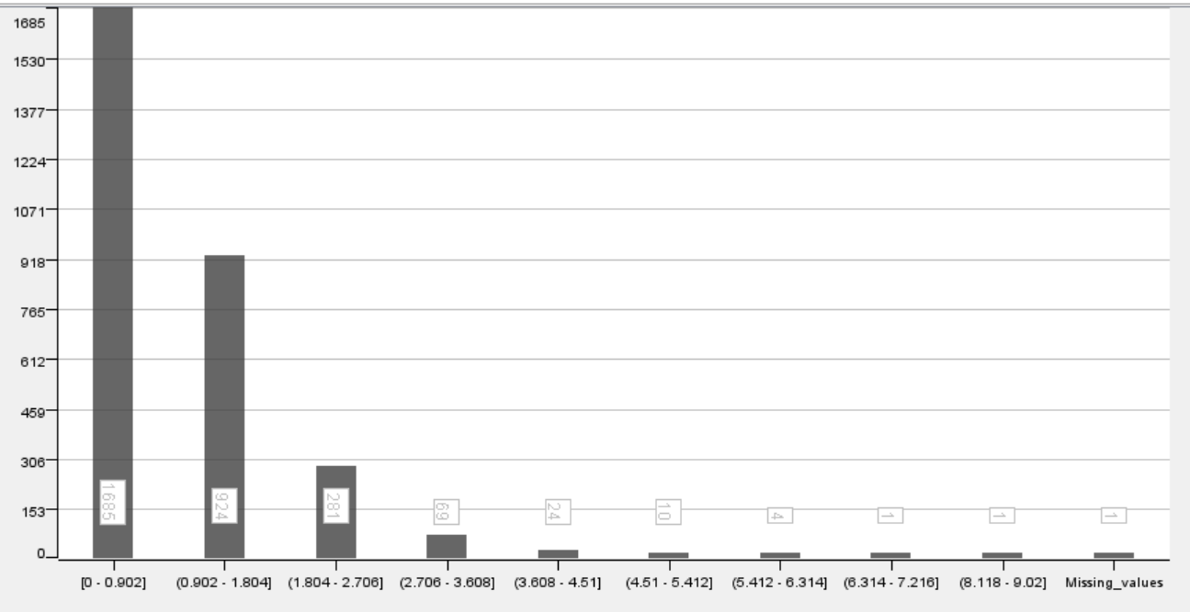

*Figure 15 Frequency Graph for FIREPLACES*

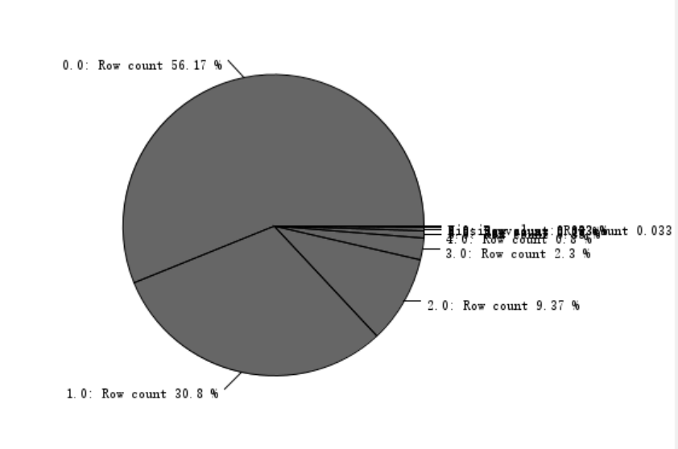

*Figure 16 Pie Chart for FIREPLACES*

**5.9 QUALIFIED**

The Frequency Graph (figure 17) and pie chart (figure 18) below show Qualified (Q) and unqualified (U). Utilising that logic in this data, ‘0’ refers to Qualified (Q) and ‘1’ refers to the unqualified (U). From the chart, it can be clearly seen that the proportion of qualified is up to 56.43%, the number is 1693, the number of unqualified accounts for 43.57%, and the number is 1307. This data pie chart will show the proportion more clearly and visually than the frequency chart.

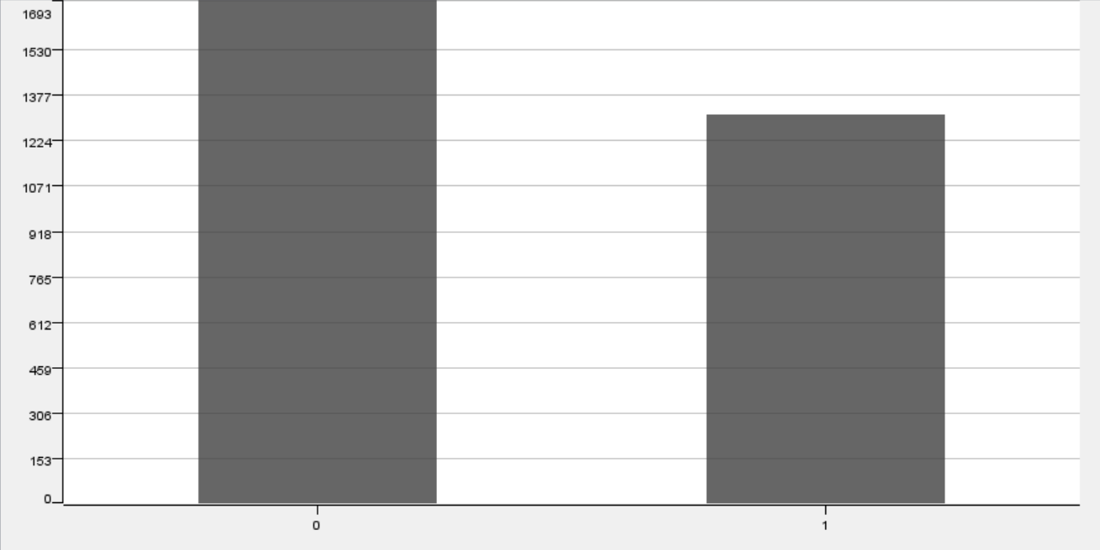

*Figure 17 Frequency Graph for Qualified*

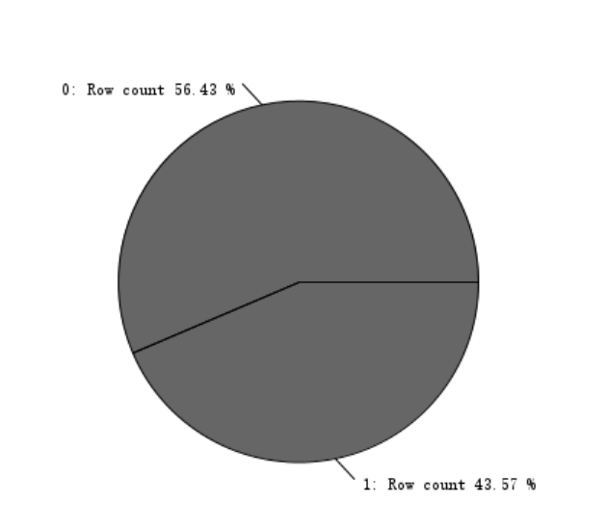

*Figure 18 Pie Chart for Qualified*

1. **Exploration**

Using the tool "Box Plot" to view the correlation of different attributes. Boxplots are a commonly used data visualization method commonly used to view the distribution and outliers of data. In the chart below, we can clearly see the distribution of the data, outliers, median quartiles, and intergroup comparisons. X is thought to have multiple outliers, o is thought to have a single outlier in the data, both of which need to be observed by researchers to see if they are potential anomalies. We can see the most common types of houses and the distribution of quantities of different properties through the following charts.

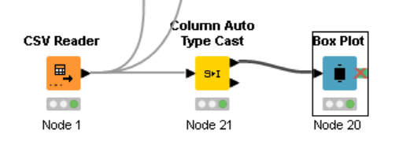

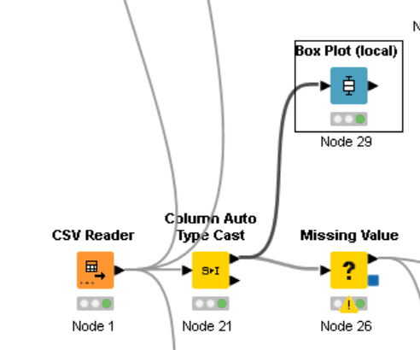

**BATHRM and NUM_UNITS**

From the chart below, we can clearly see that the normal is to have one to three bathrooms is the norm, and the number of bathrooms with 10 to 14 is a minority. The most commonly built house is to own a unit.

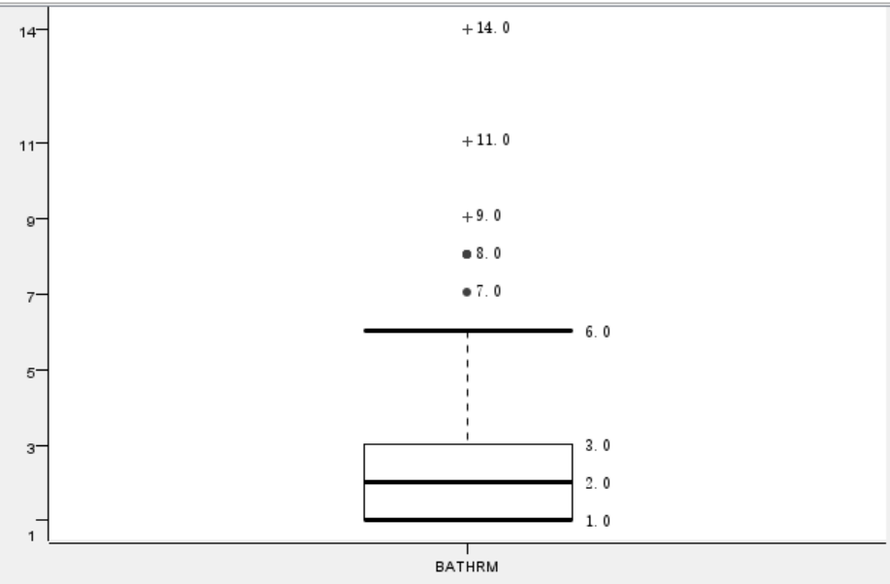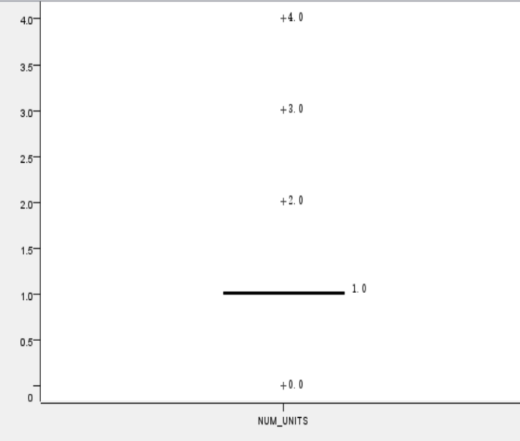

**PRICE and ROOMS**

The most commonly built house is to own a unit. The most commonly built house is to own 6 or 11 rooms. One of the houses that may be an anomaly has 101 rooms.

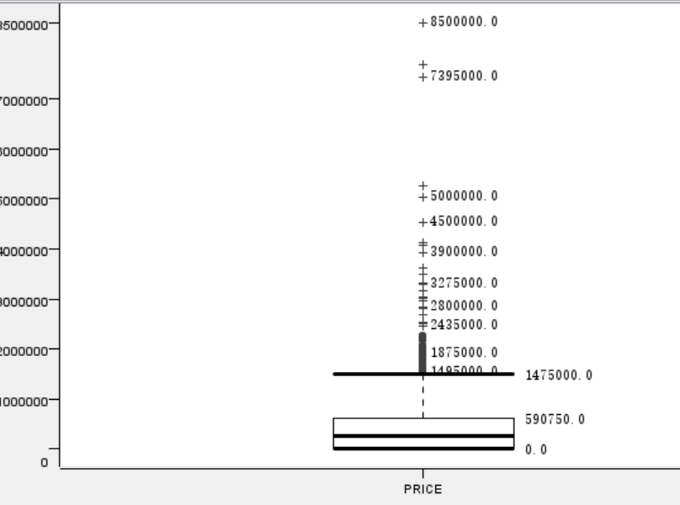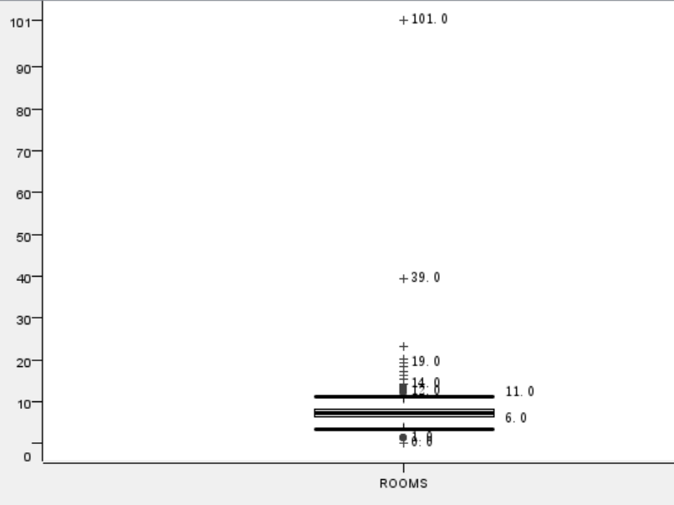

**BEDRM and Kitchens**

The amount of room bedrooms is usually distributed between three and five, and the number of kitchens is usually one.

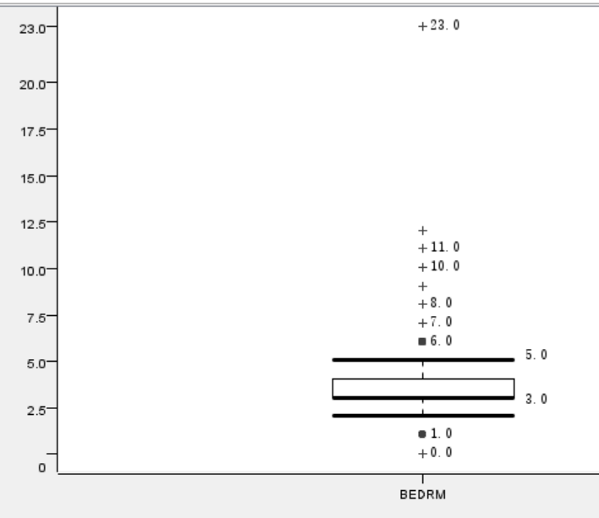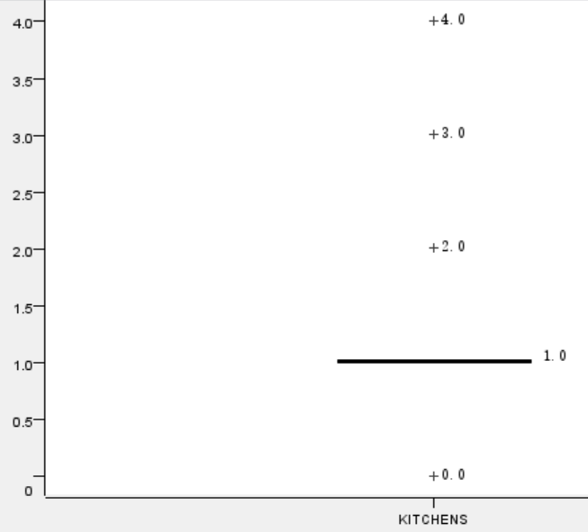

**Qualified and FIREPLACES**

Houses usually have one fireplace and a small number have two.

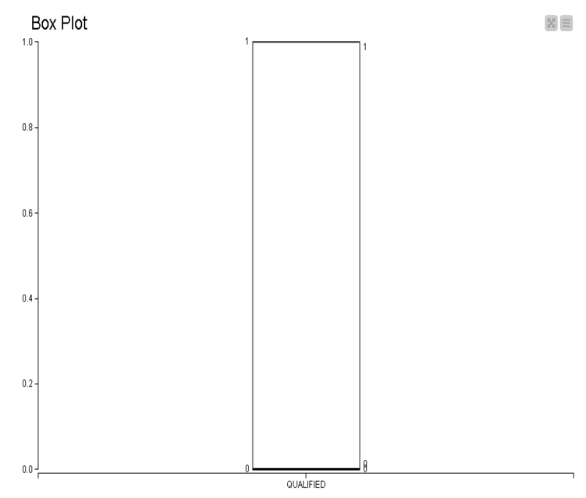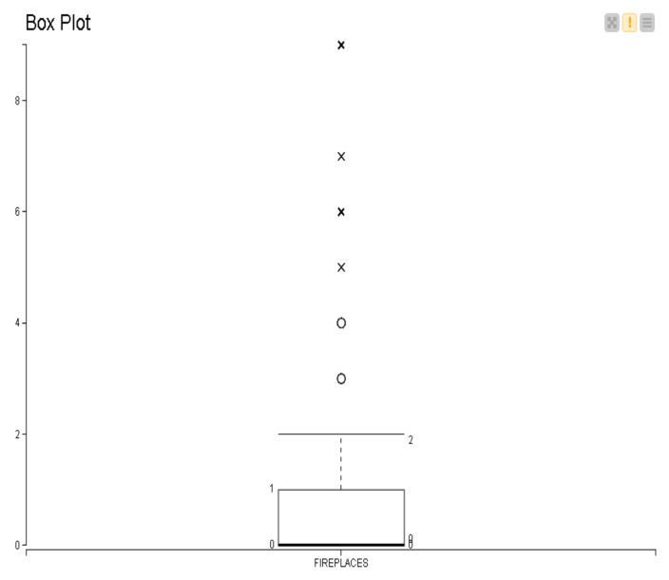

**AYB and EYB**

AYB and EYB are usually concentrated around 1870-2000 years.

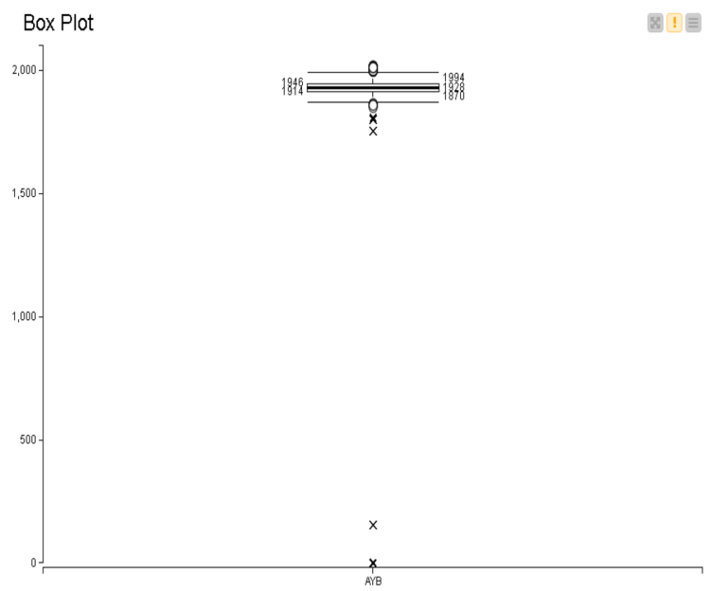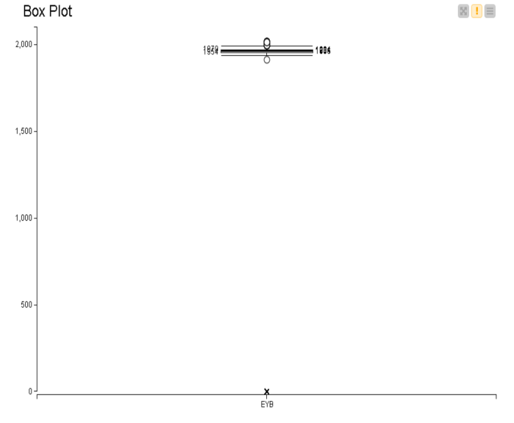

**GRADE and CNDTN**

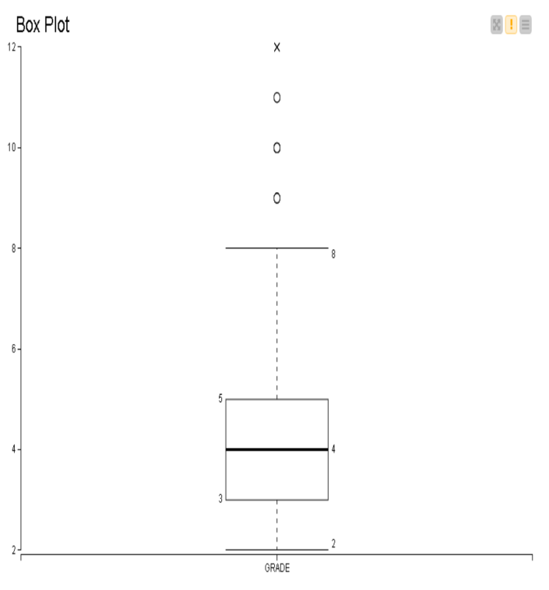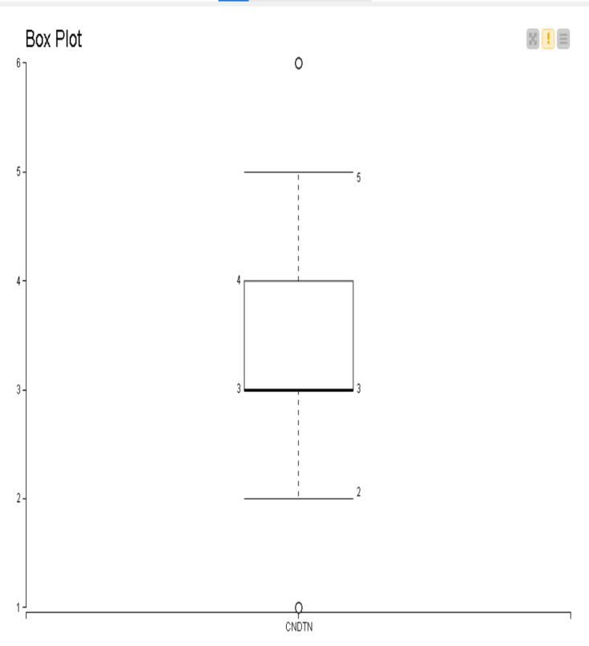

**GBA and LANDAREA**

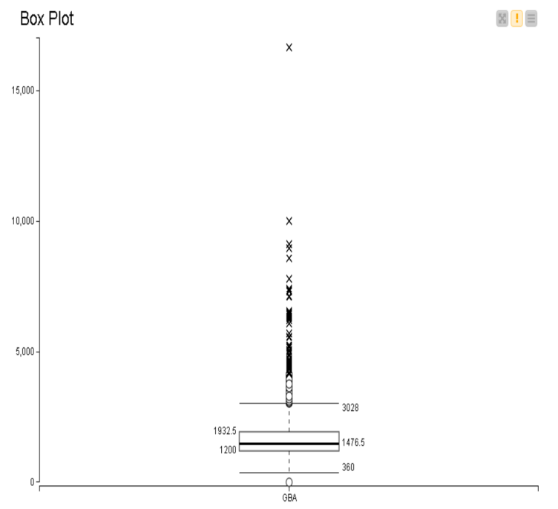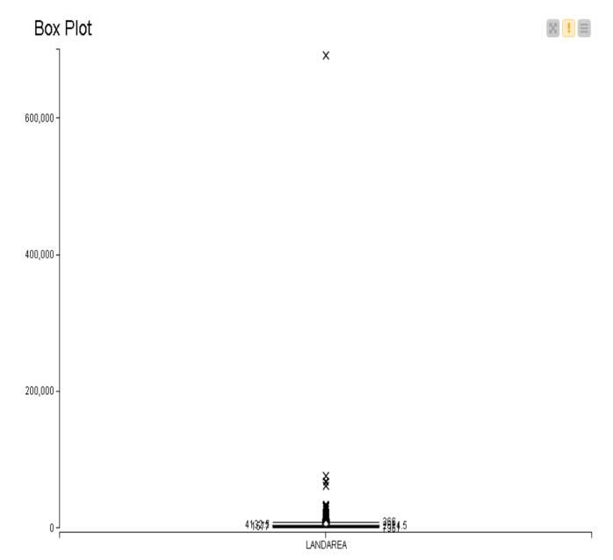

1. **Identify the correlations**

**7.1 Using "Linear Correlation" and “Rank Correlation”**

Using the tool "Linear Correlation" and “Rank Correlation” to view the correlation of different attributes. As shown in the figure below, blue represents high relevance, and red represents low

relevance. The high linear relationship between NUM_UNITS and Kitchen can be clearly seen from Figures 19. The high linear relationship between KITCHENS, USERCODE and NUM_UNIT can be clearly seen from Figures 19. KITCHENS and FIRPLACE have a high correlation in figure 19.

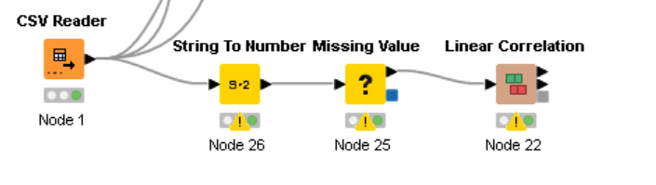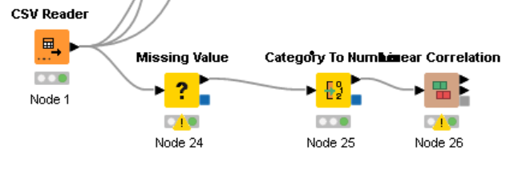

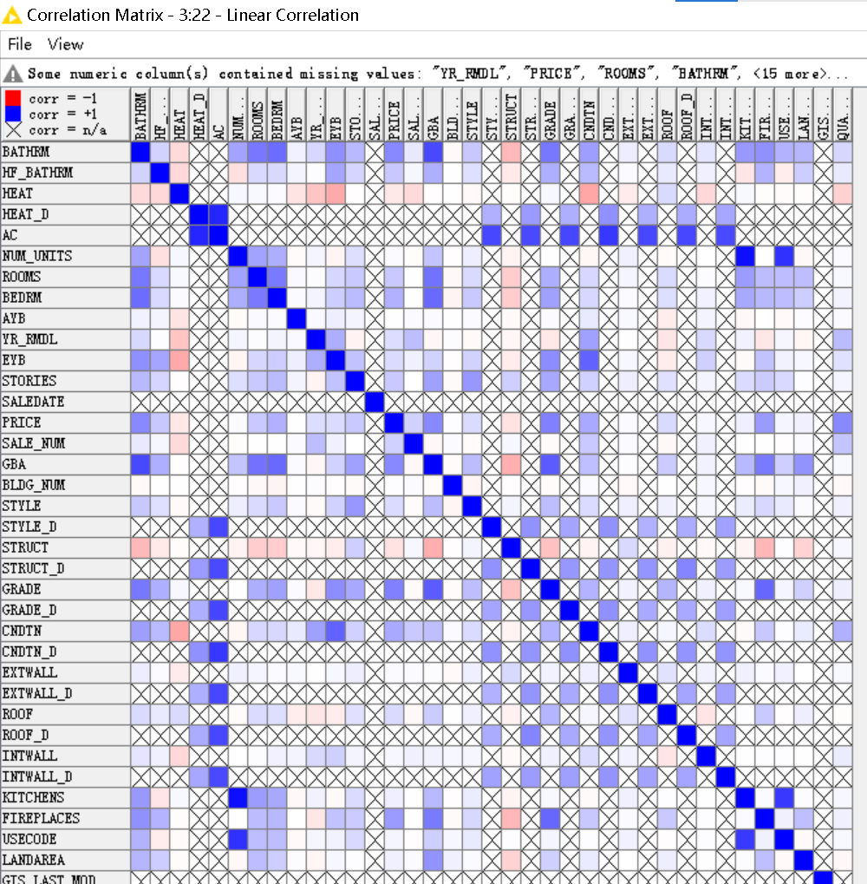

*Figure 19 Linear Correlation graph*

In Figure 20, we clearly can see STORIES and STYPLE have a strong correlation. NUM_UNITS and Kitchen have a high relationship. BAthrm and ROOMS Have a high relationship.

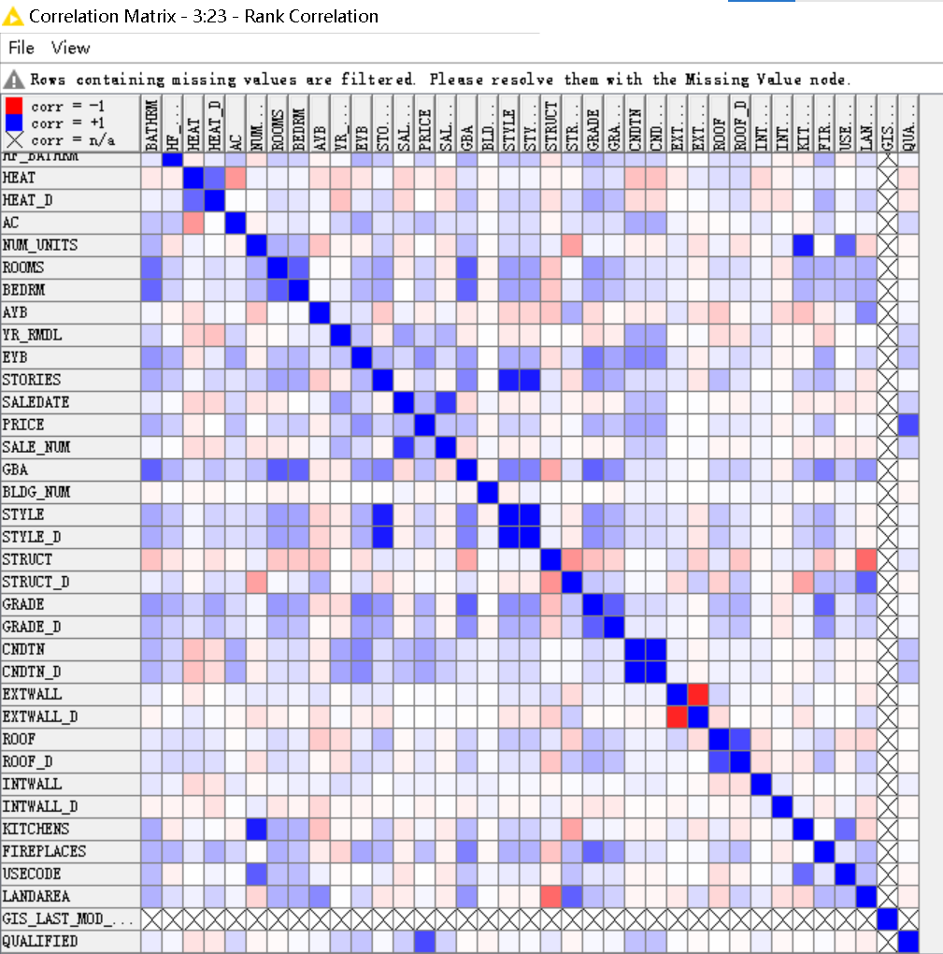

*Figure 20 Rank Correlation graph*

**7.2 Using"Scatter Plot"**

Using the tool "Scatter Plot" and showing the relationship between two quantitative variables. We can determine whether there is a positive correlation, a negative correlation, or no relationship by observing scatter plot.

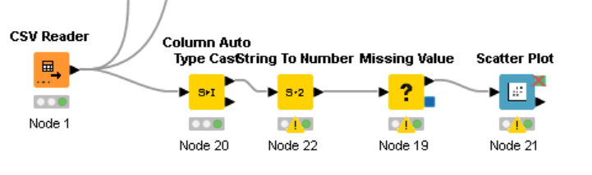

We can see from the figure (figure 21) below that the interesting phenomenon is that as the value of the **style** increases, the value of the **story** increases.

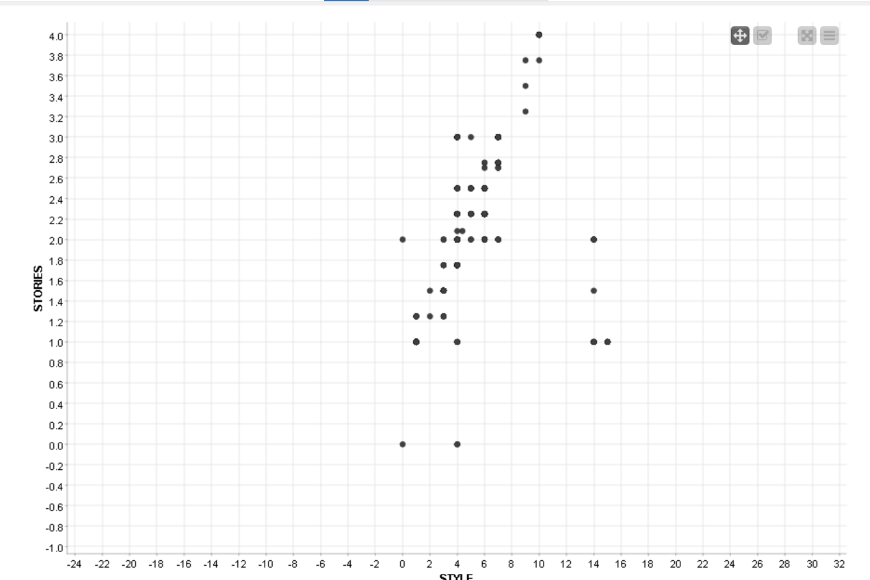

*Figure 21 Scatter Plot-- Style VS Stories*

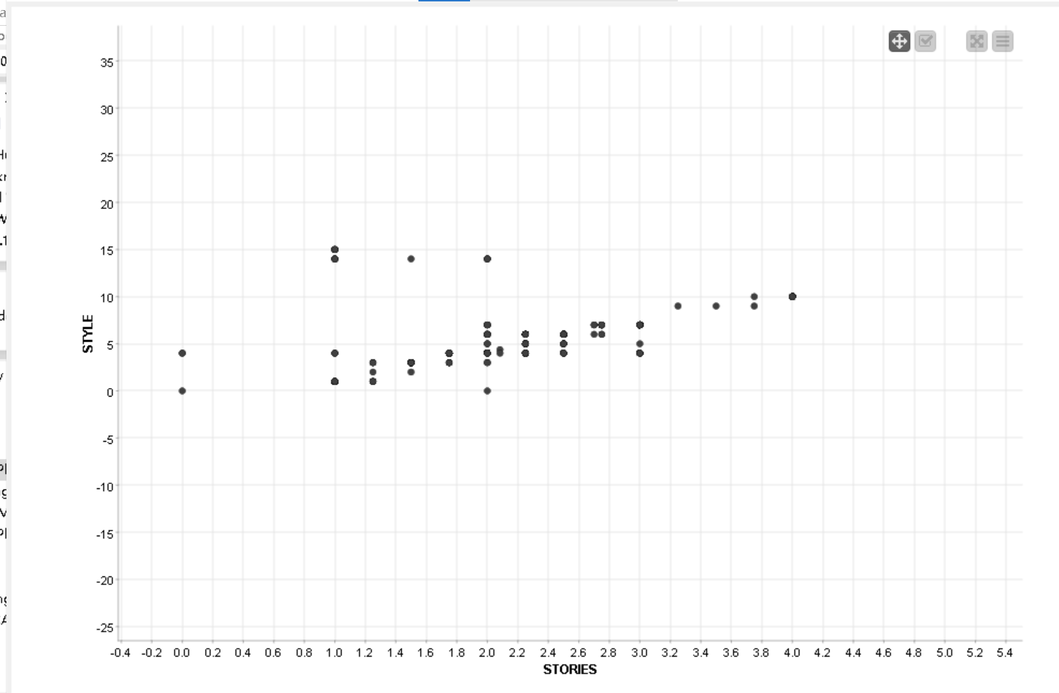

This diagram(figure 21) shows that the more **bathroom**s a house has, the more **rooms** it is. This is in line with the normal situation in our lives, since more rooms mean more people who may live together, and more bathrooms are needed to provide a better and more comfortable environment.

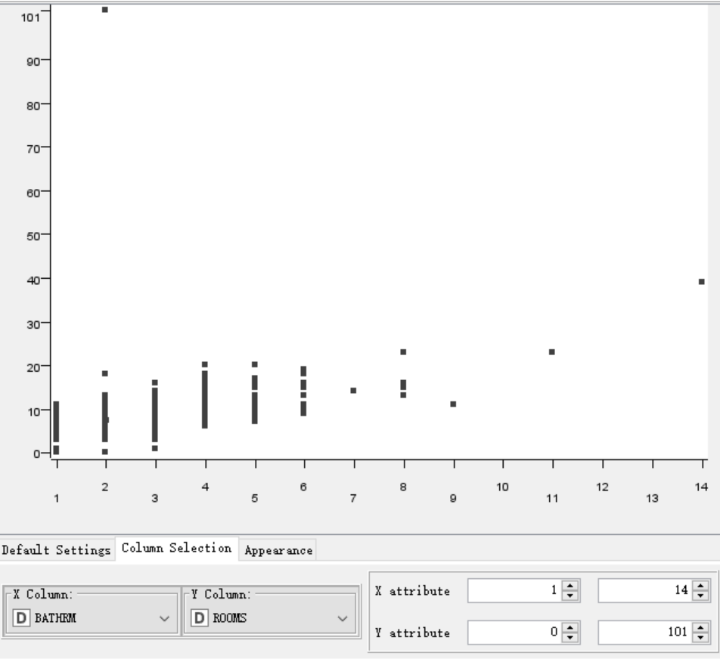

*Figure 22 Scatter Plot-- Bathrm VS ROOMs*

From the following figure (figure 23), we can see that the interesting phenomenon is that if you get a higher **grade**, the higher the chance of getting a high **price**.

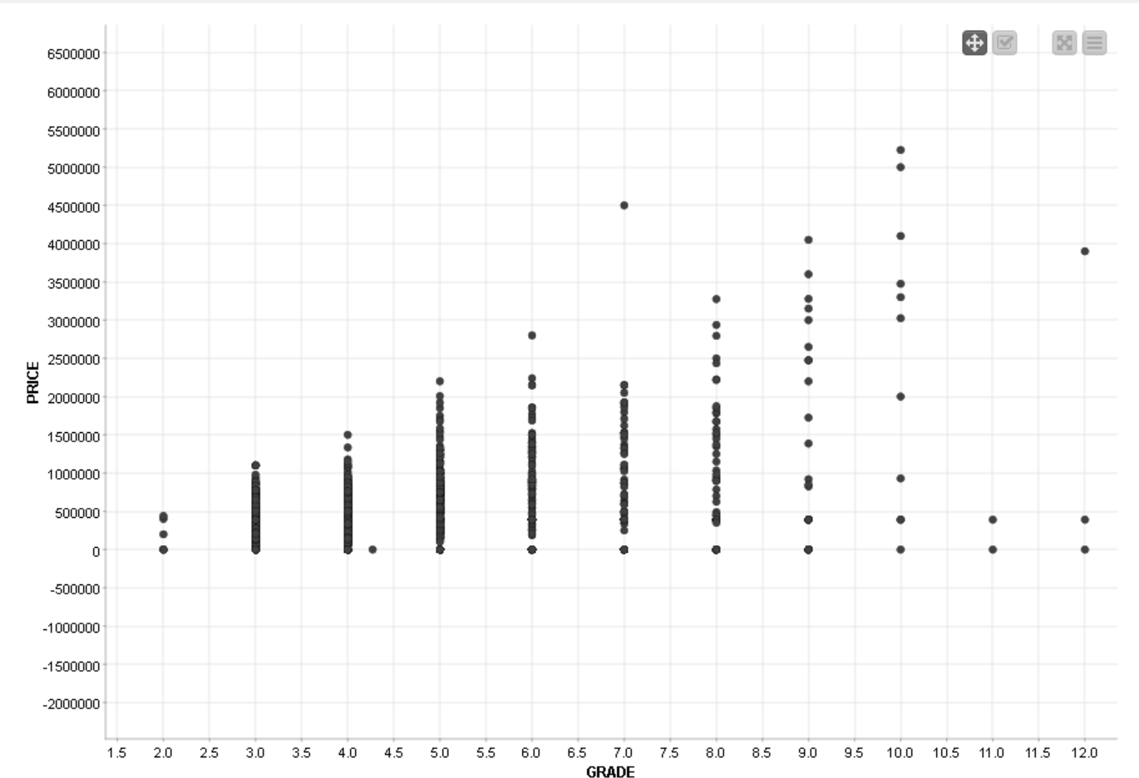

*Figure 23 Scatter Plot-- GRADE VS Price*

Through the following figure (figure 24), we can find that the number of more **units** will be higher, but the higher the **price** may be when the unit is one. The illustrative unit is not the reason why people decide how high or low the price is.

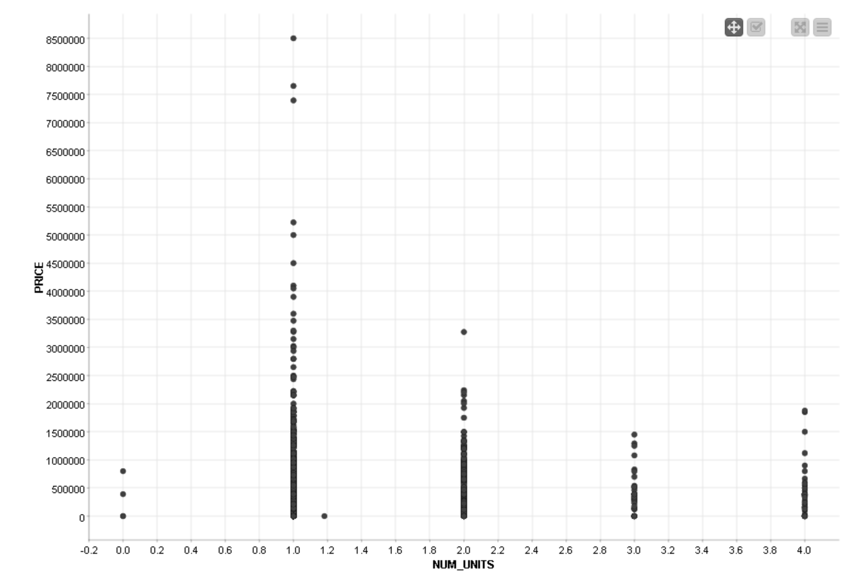

*Figure 24 Scatter Plot-- NUM_UNITS VS Price*

Through the following figure (figure 25), the EYB's time is mainly concentrated after 1940, which means that the vast majority of buildings were not remodeled until after 1940. After 1940, part of the building **EYB** and **A Y B** are of the same year, which means that the part of the earliest construction of the building is the same as the remodeled part. After 1950, the later the AYB year, the higher the probability that the EYB year is later.

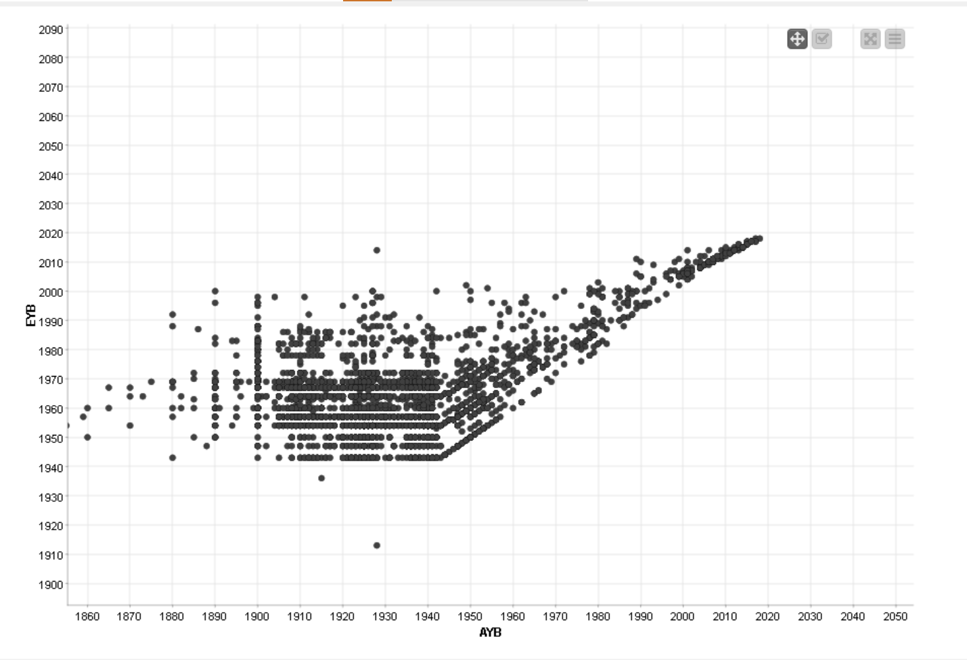

*Figure 25* *Scatter Plot-- AYB VS EYB*

Through the following figure (figure 26), there is a linear relationship between **rooms** and GBA, and the **GBA** area will become larger as the number of rooms increases. This means that the greater the number of rooms, the larger the total floor area.

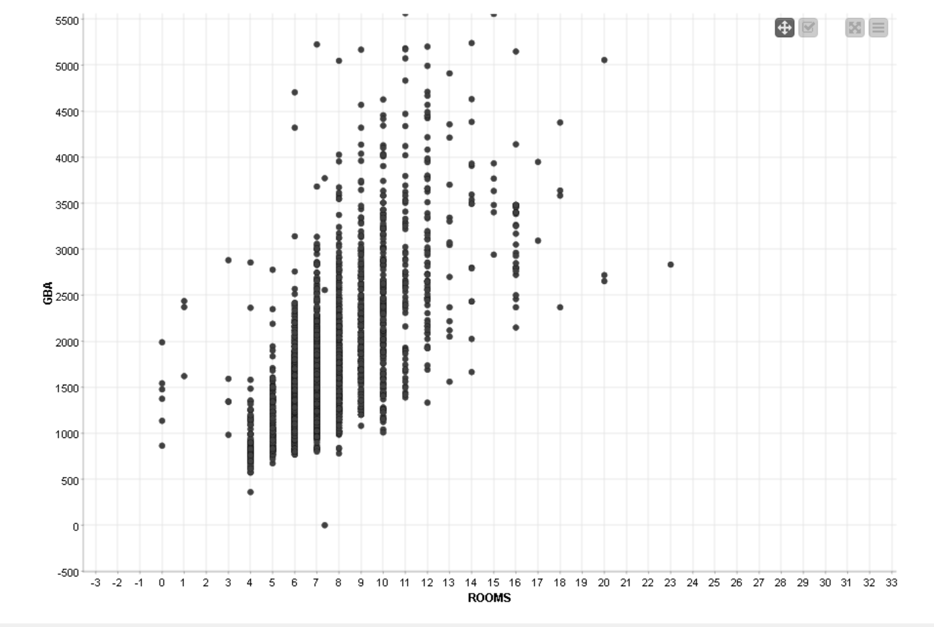

*Figure 26 Scatter Plot-- GBA VS Rooms*

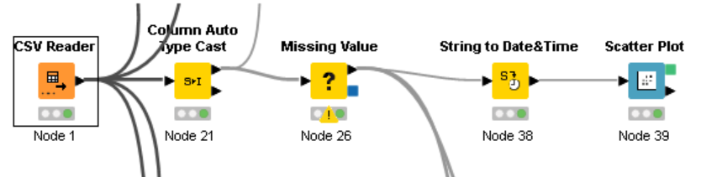 As you can see from the figure 27 below, the later the **sale date**, the higher the **price**, which is in line with the concept that the newer the house is more valuable in real life

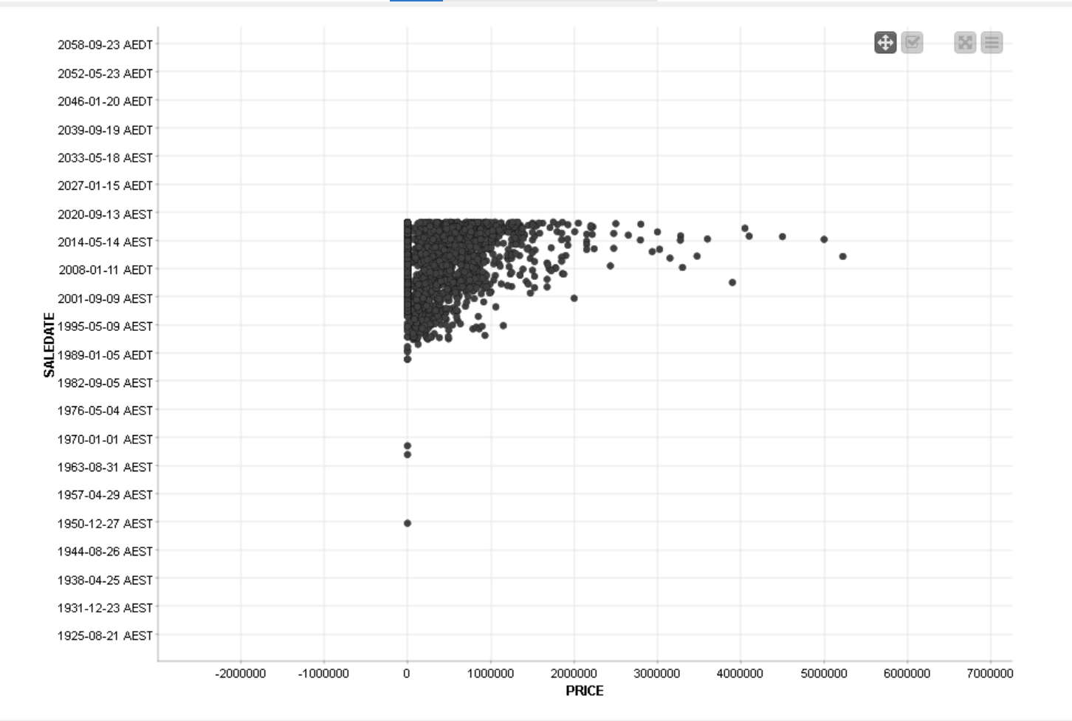

*Figure 27 Scatter Plot-- SALEDATE VS Price*

From Figure 28, it can be seen that the **price** has a certain relationship with **GBA**, and when **GBA** is larger, the higher the probability of price.

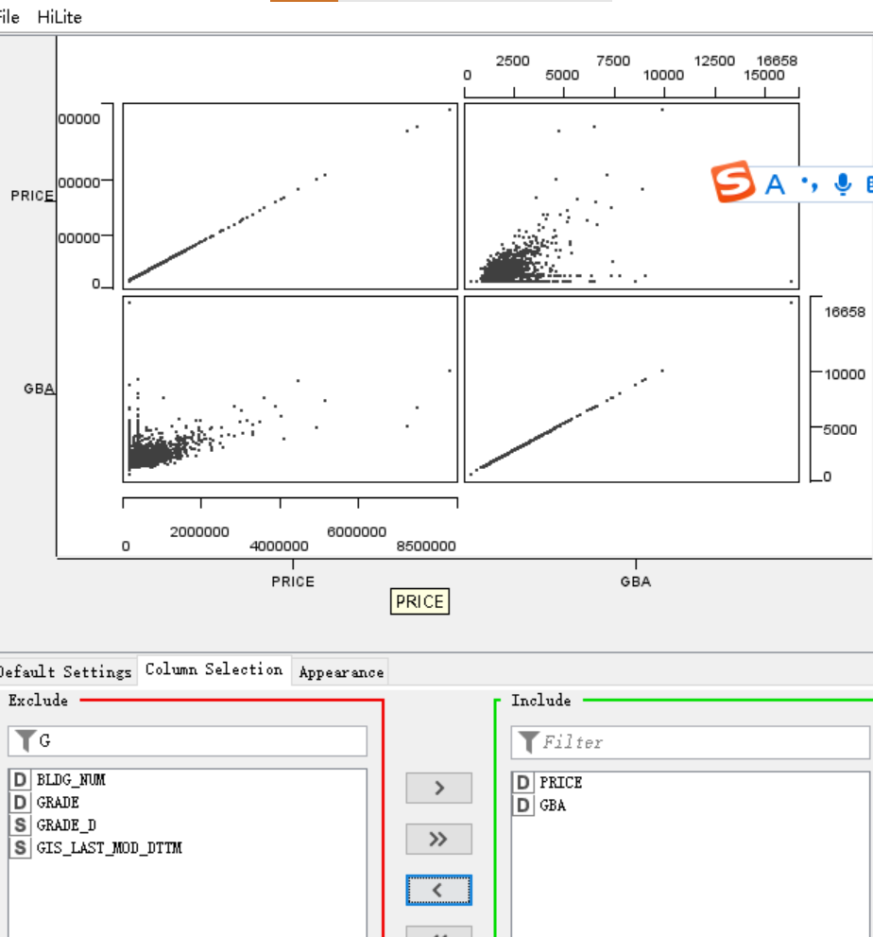

*Figure 28 Scatter Plot-- GBA VS Price*

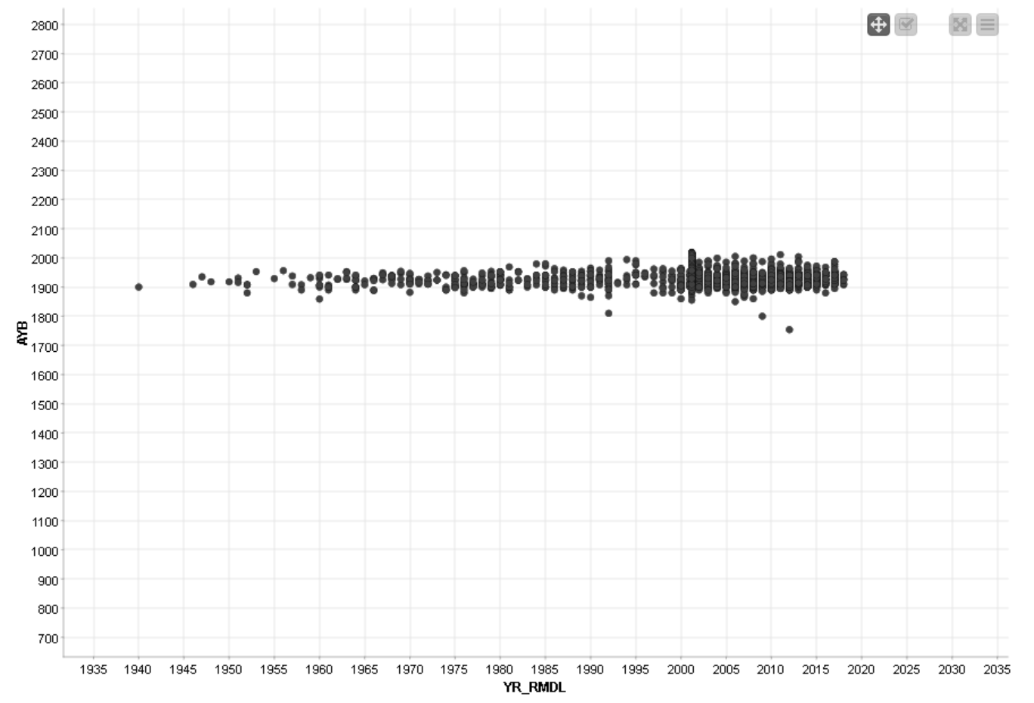

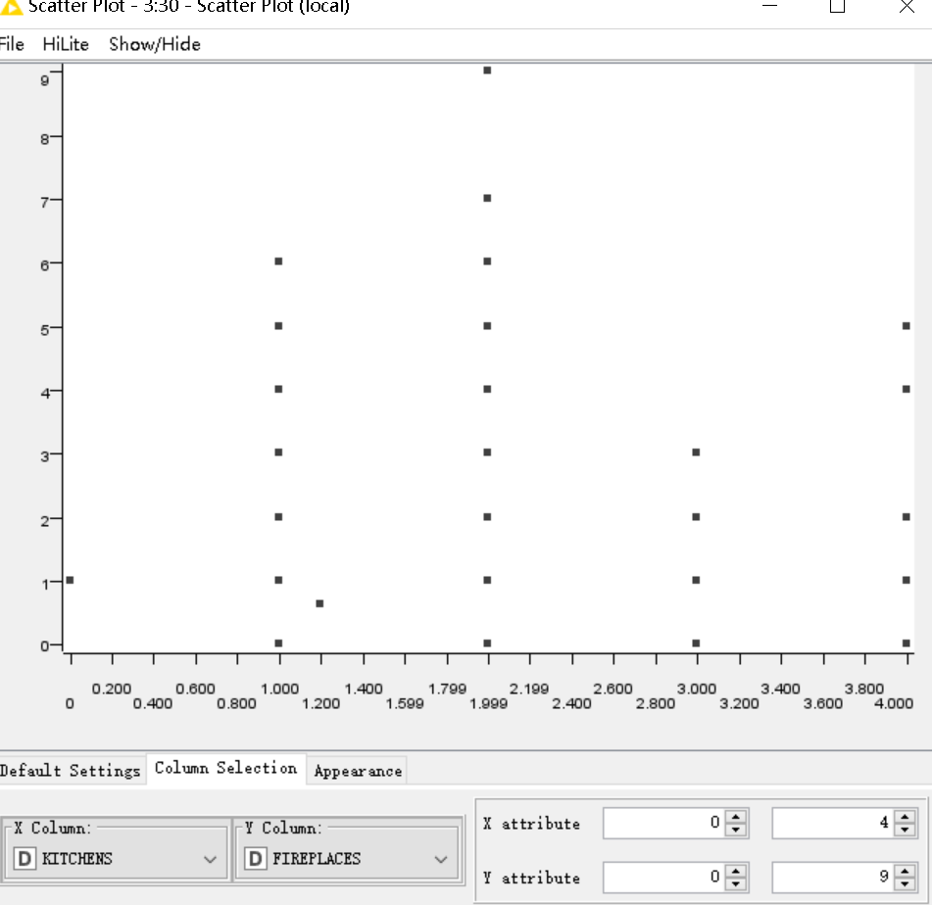

**7.3 Using “Parallel coordinate”**

Parallel coordinate graphs can help us visually observe the relationship and trend between different numerical variables. “Color manage” is used to color the maximum and minimum values blue.

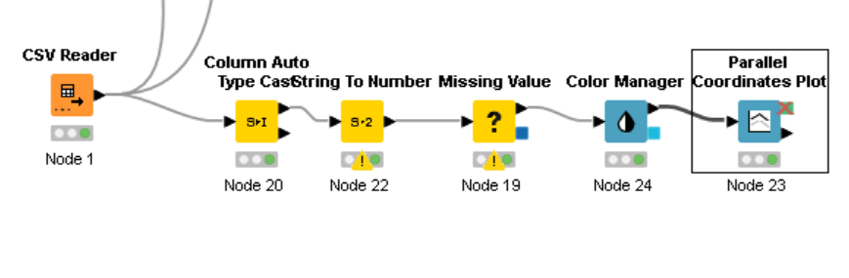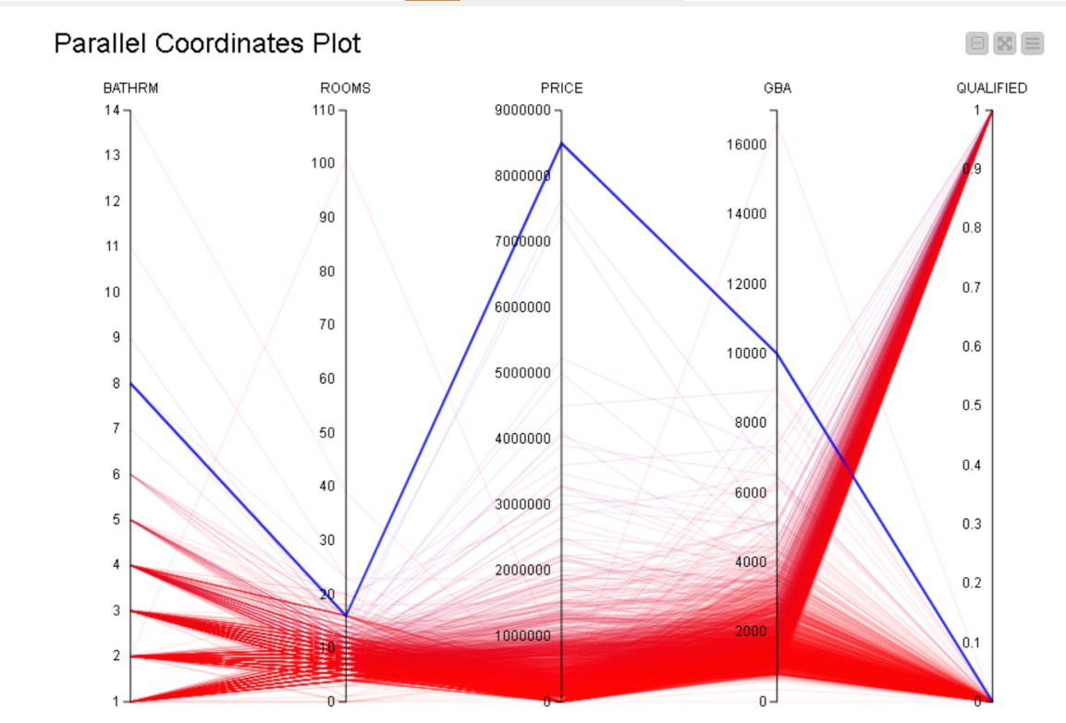

1. **Explore dataset and identify any outliers, clusters of similar instances**

It is a clustering algorithm used to group data and objects, and different connection methods can be selected by adjusting the linkage type to calculate the distance between clusters.

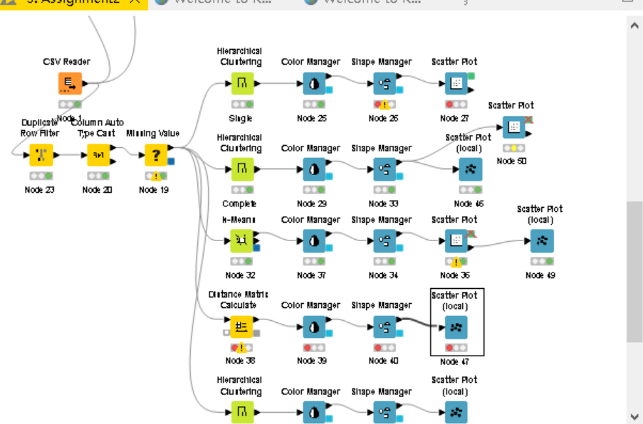

**8.1 Hierarchical Clustering (Single)**

Setting up 3 output clusters, with the distance function Euclidean and Linkage type “STNPLE”. It is the distance between the two closest data points in two combined data as the distance between the two combined data points, which is susceptible to extreme values.

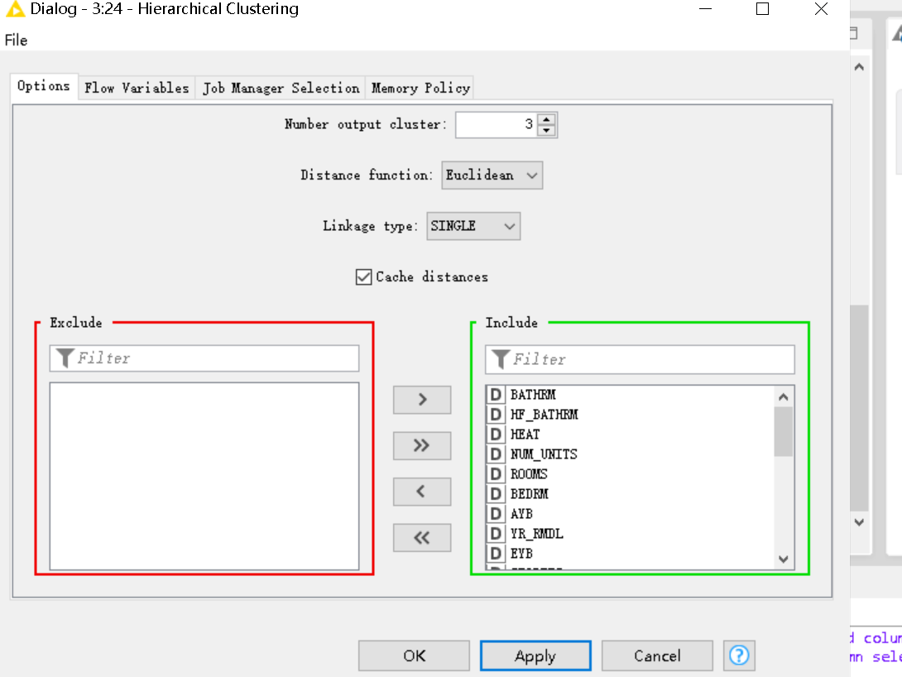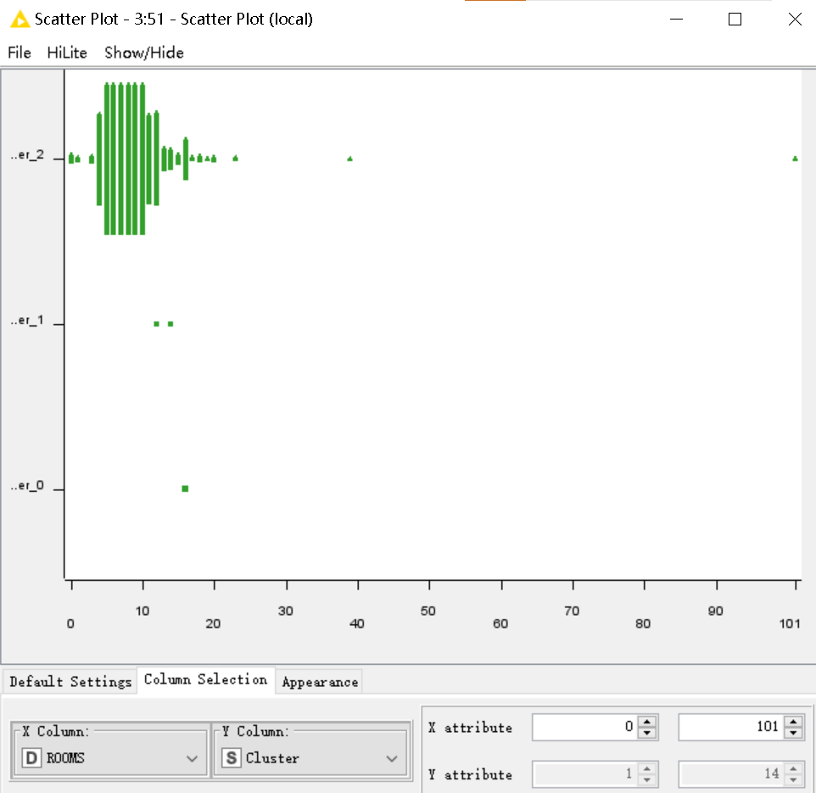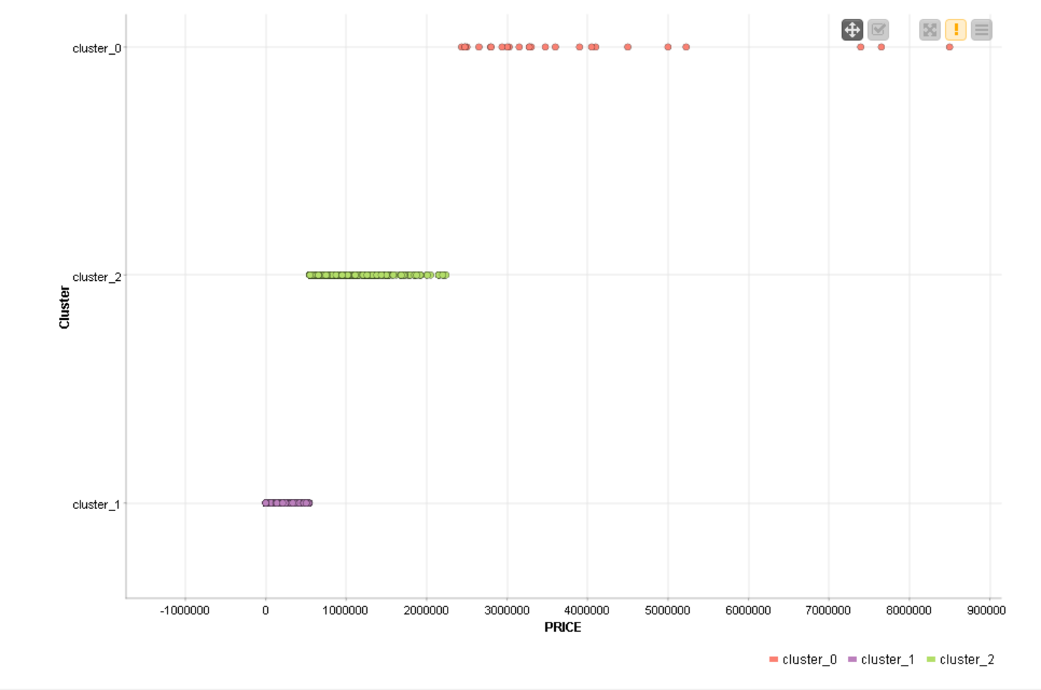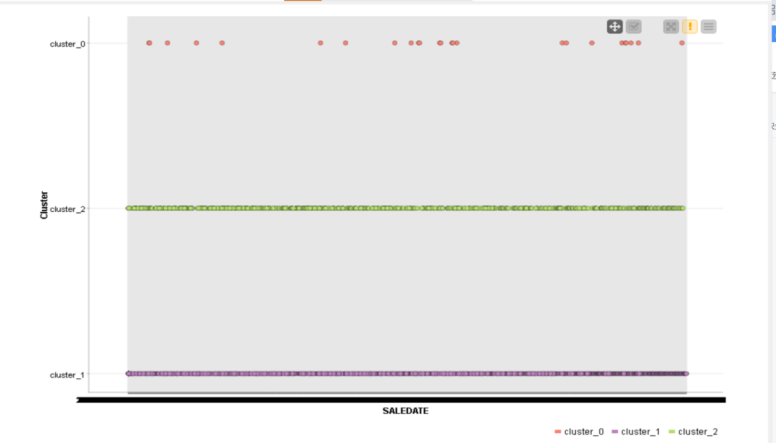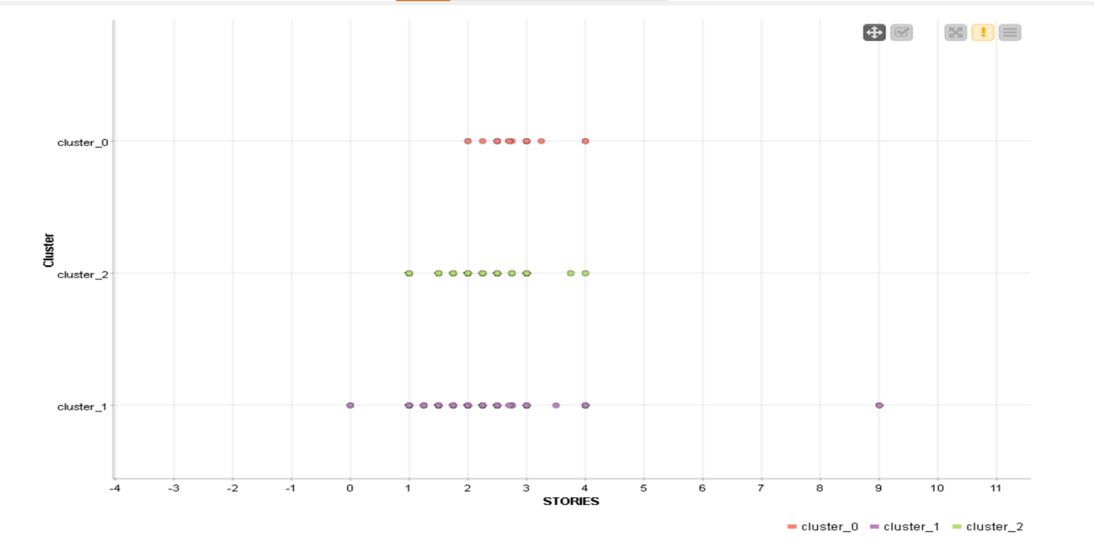

**8.2 Hierarchical Clustering (COMPLETE)**

Setting up 3 output clusters, the distance function “Euclidean” and Linkage type “COMPLETE”. “Complete” means that the distance of its masses is determined by the two farthest points in a group, and the advantage of this algorithm is that it can identify more scattered groups, but it is susceptible to noise and outlier images. It shows that there is only few data point in both cluster_0 and cluster_1. Therefore, this data is not suitable for completed structured clustering.

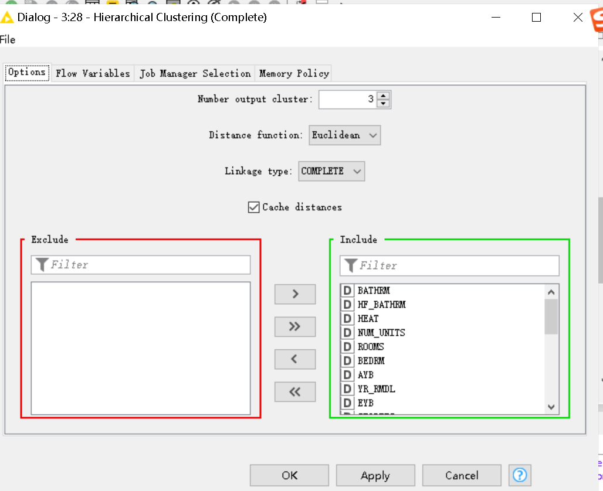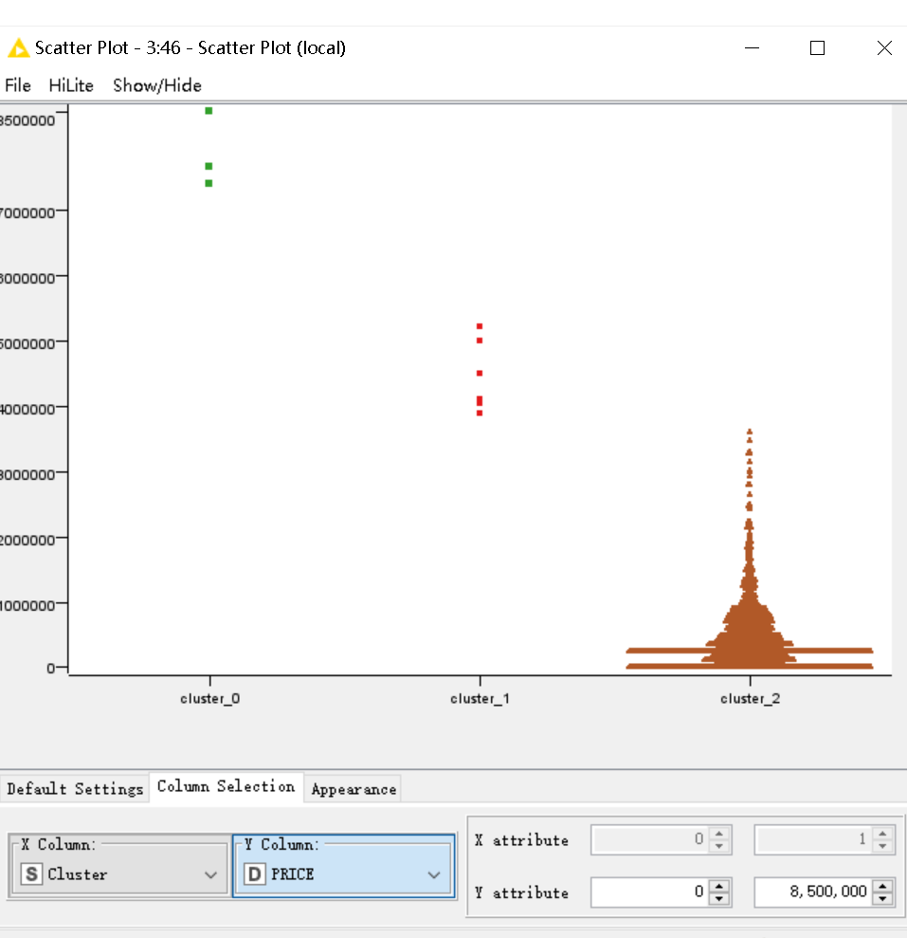

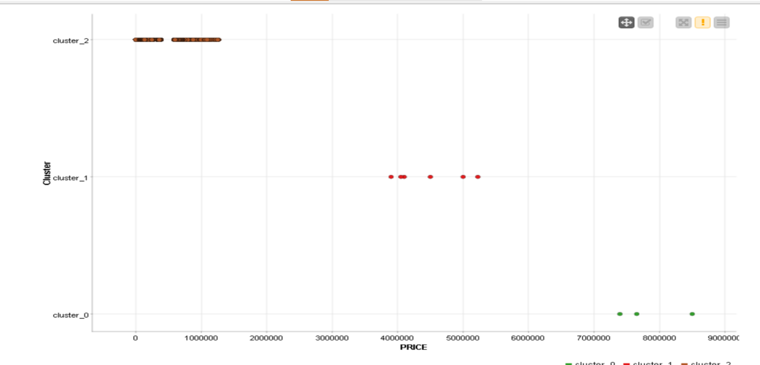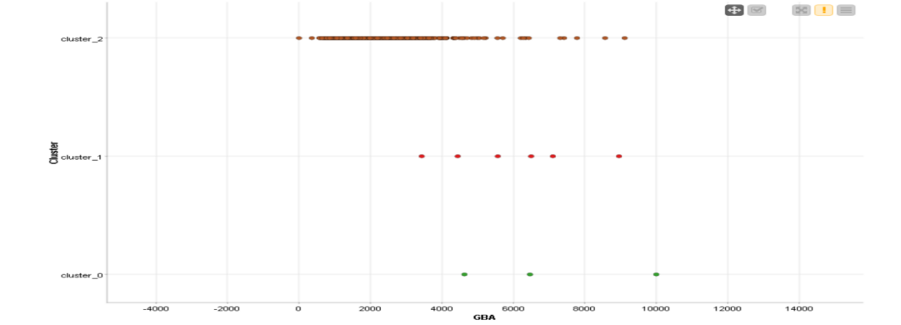

**8. 3 Hierarchical Clustering (Average)**

Setting up 3 output clusters, the distance function “Euclidean” and Linkage type “Average”. Average is the distance in the cluster is determined by the average of the distances between points in the cluster. When two clusters merge, the distance between them is averaged by the distance between all points, and this algorithm is good for eliminating anomalies, but may ignore more scattered clusters.

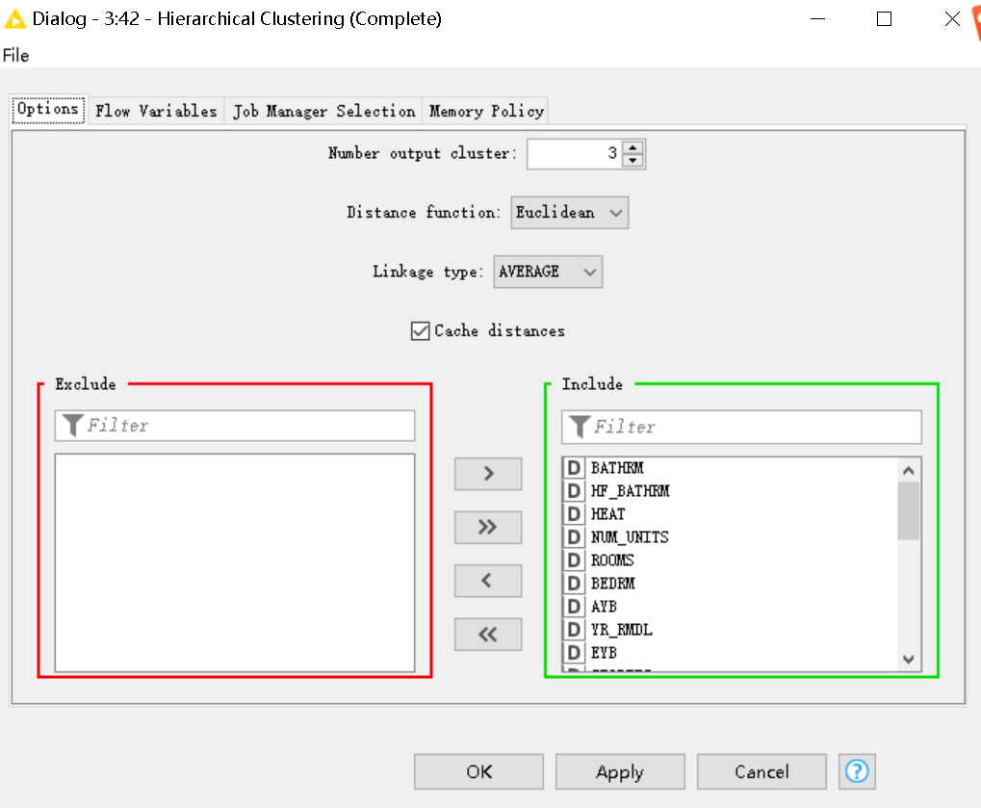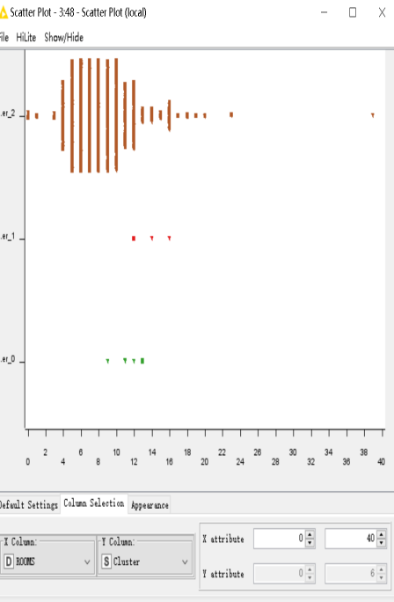

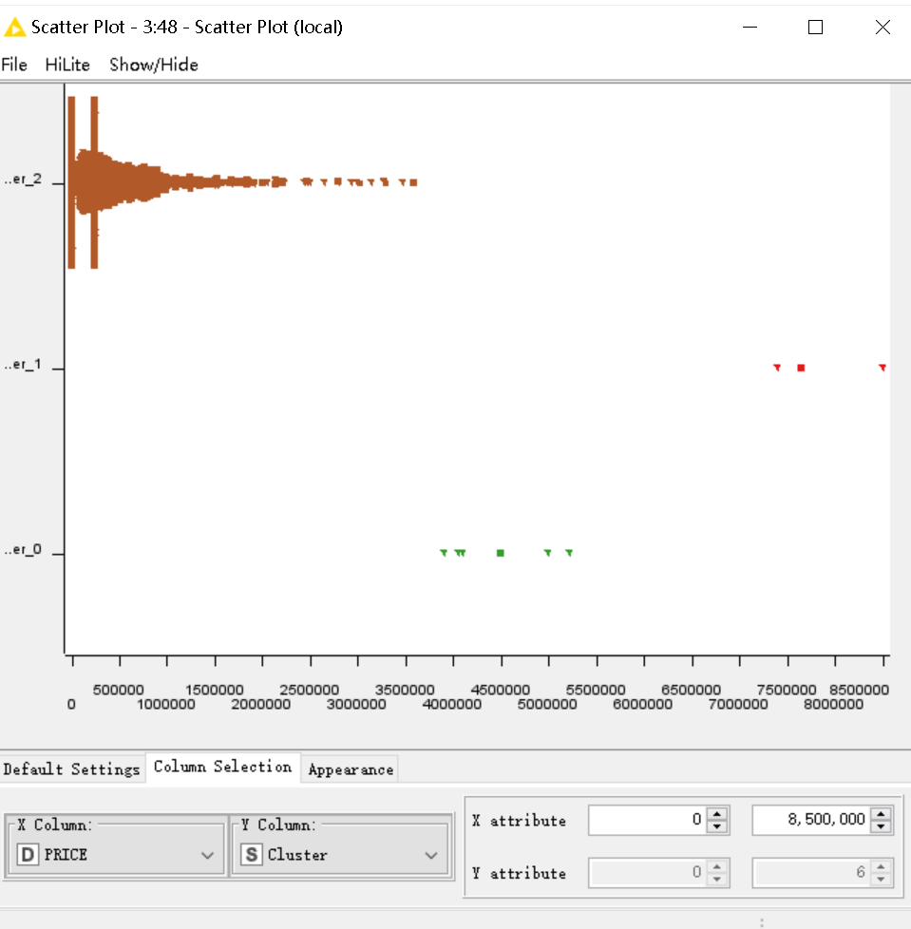

**8. 4 K-Means**

The goal of the K-mean algorithm is to divide a set of data points into K cluster classes, so that the sum of squared errors of cluster classes is minimized. This method requires random selection of K points as initial particles, so it is easy to fall into local optimization.

**Setting up 3 output clusters**.

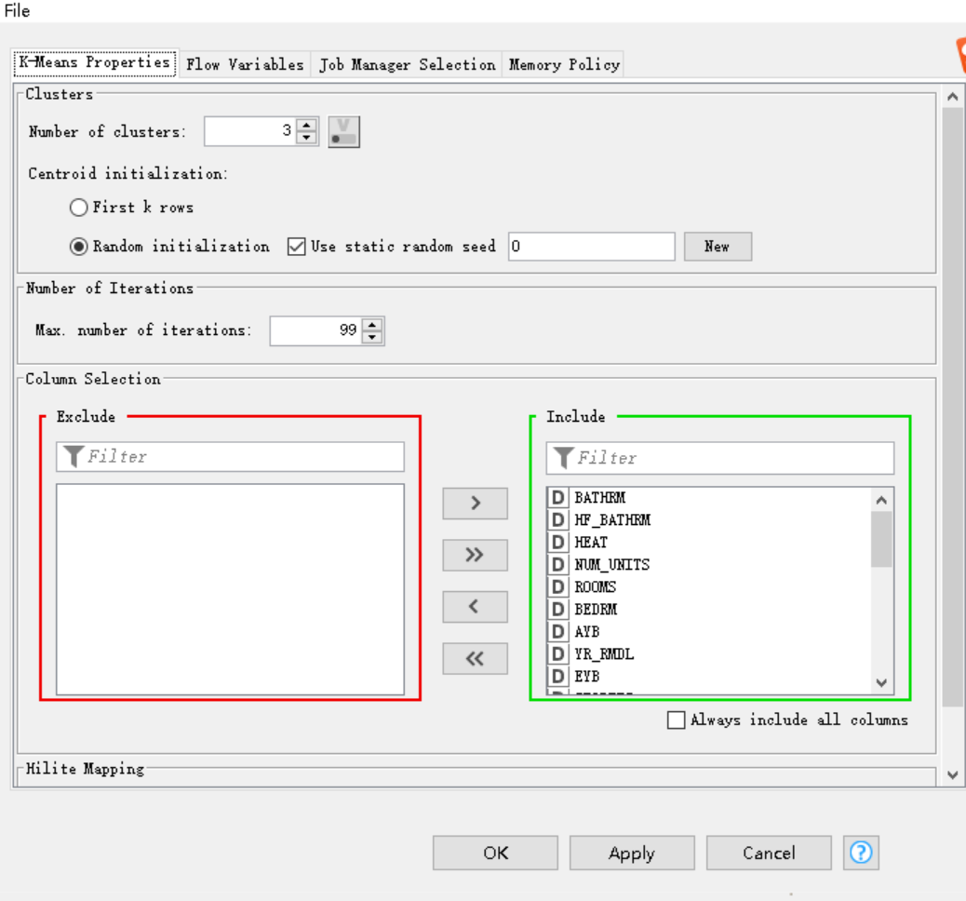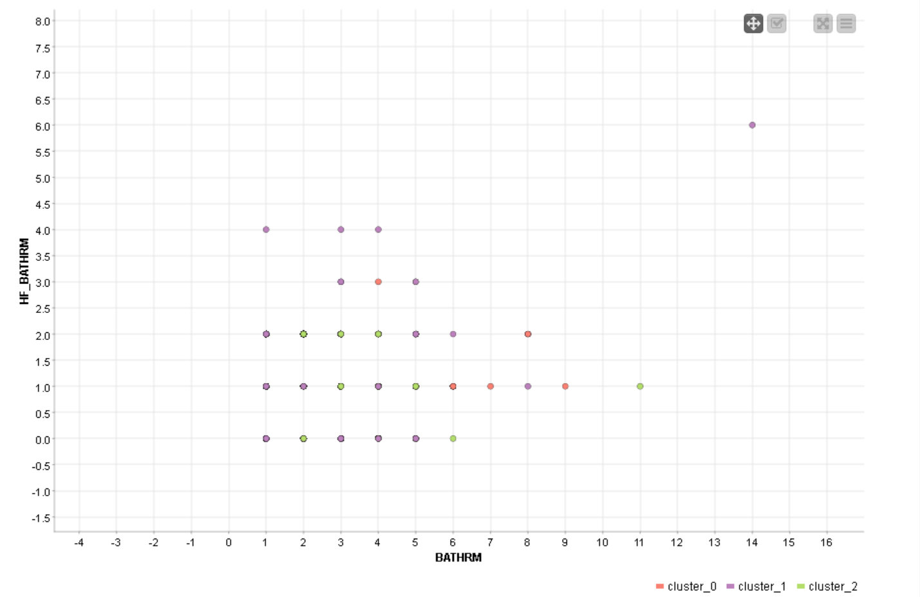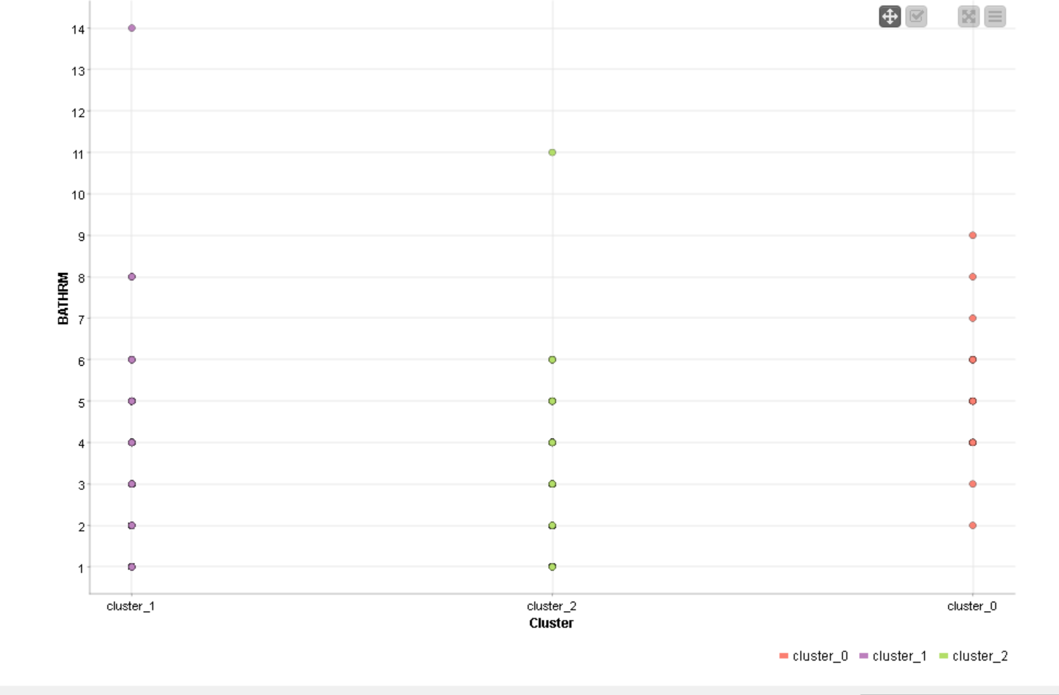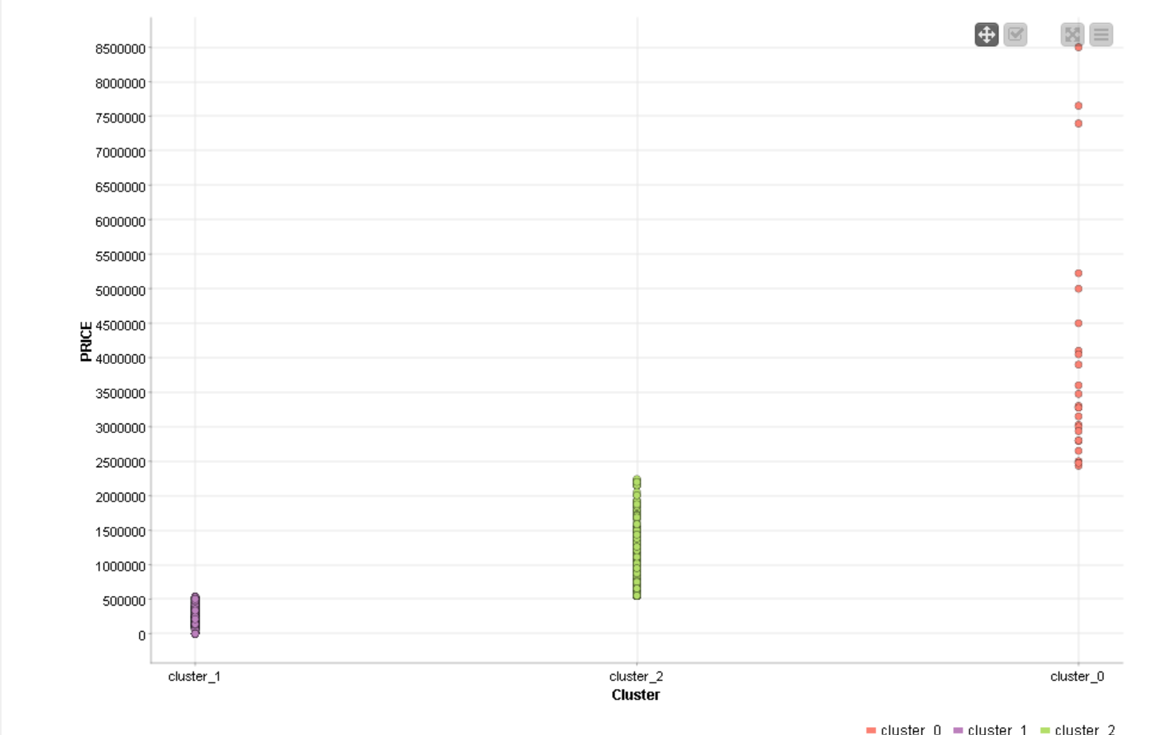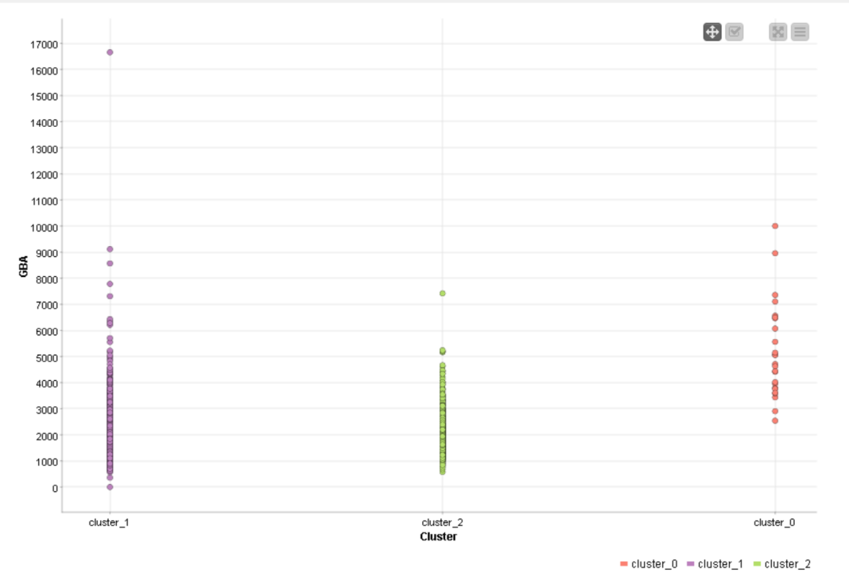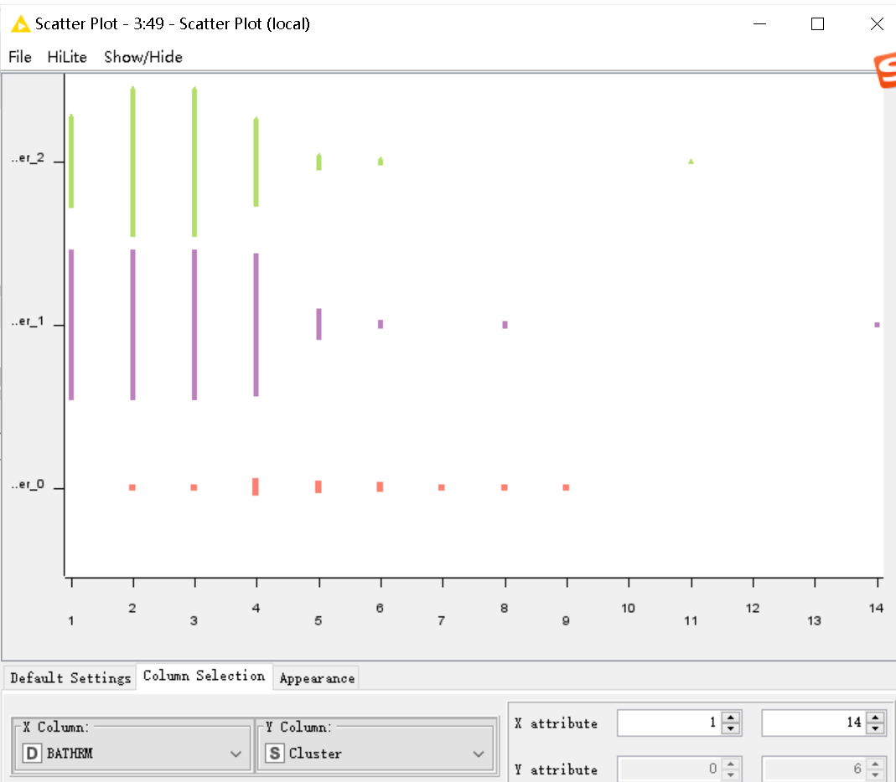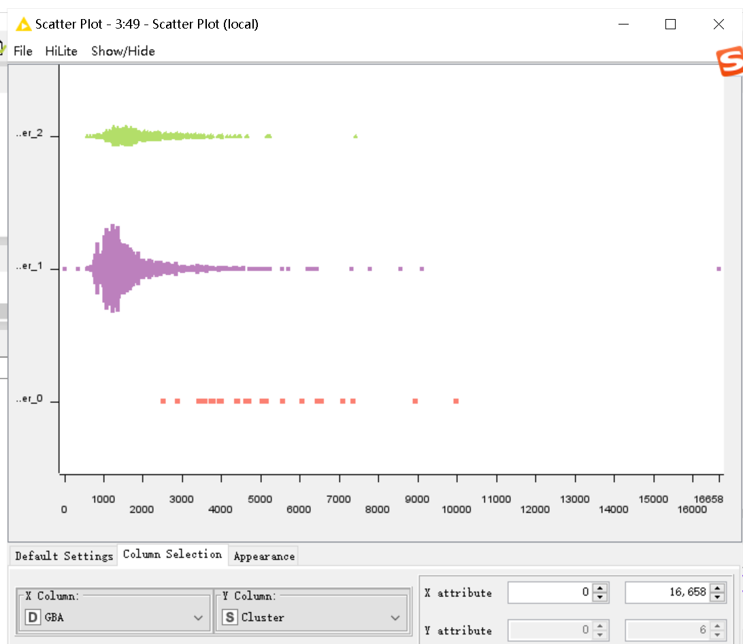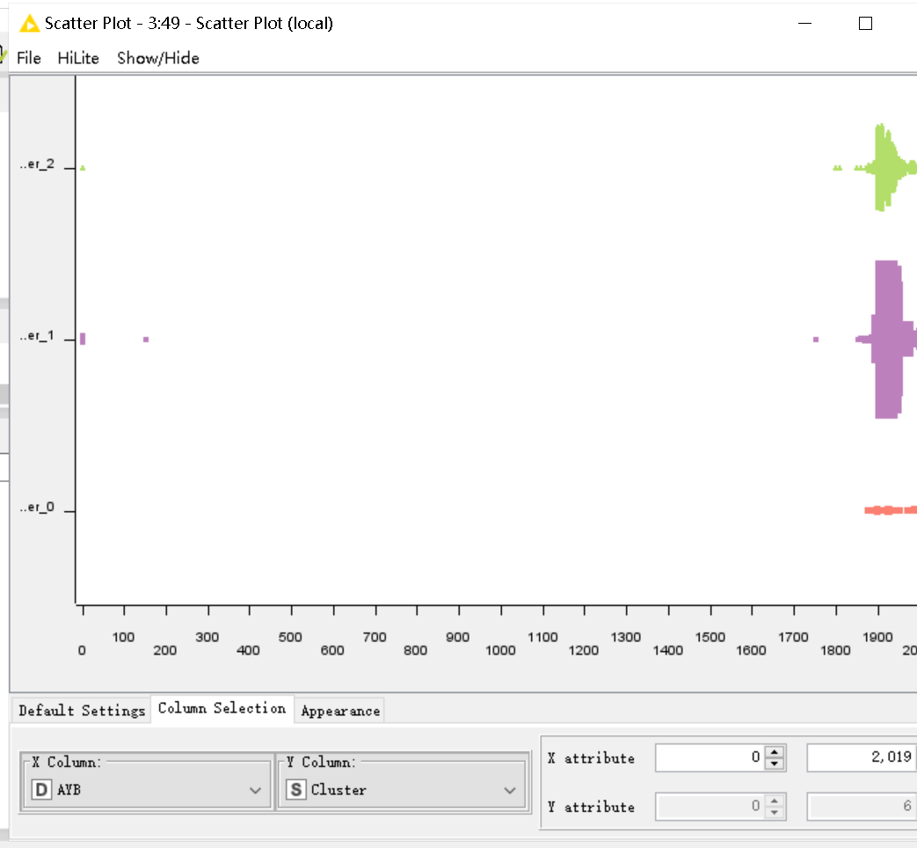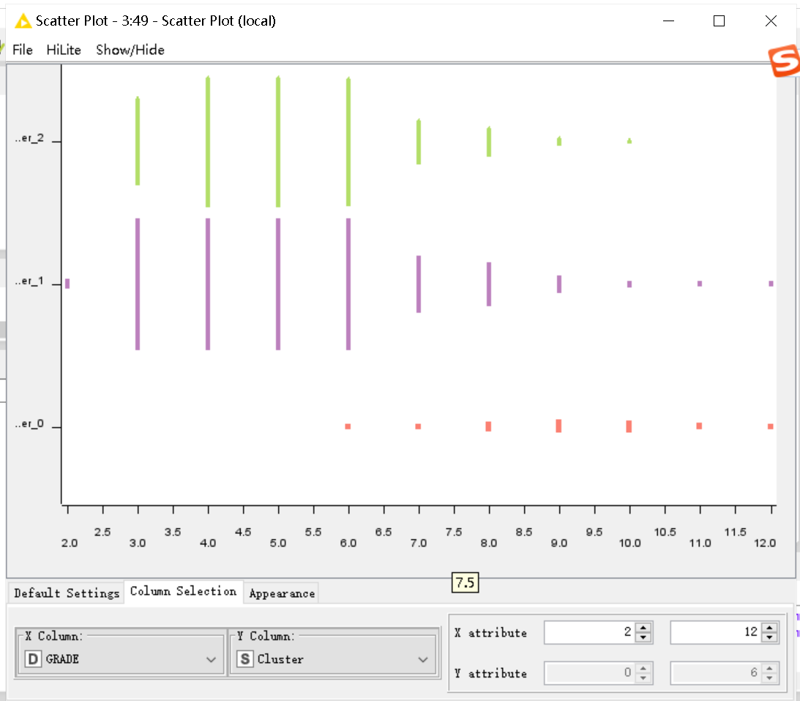

**1B Data Pre-processing**

1. **Binning techniques**

Binning technique is a data preprocessing technique that divides continuous data into a limited number of discrete data or intervals. The following will use the same depth and same width technique to smooth the Value property value.

**1.1 Equi-width binning**

Using “Auto-Binner” and “Histogram(local)”. Auto-Binner is used to Equi-width binning and Histogram is used to view the distribution of binning results.

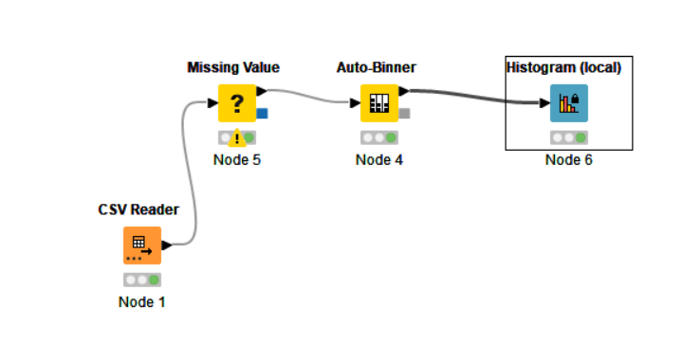

1. **Parameter setting**

The reason why the number of bins is 5 is that when the number of bins is greater than 5, empty boxes will appear.

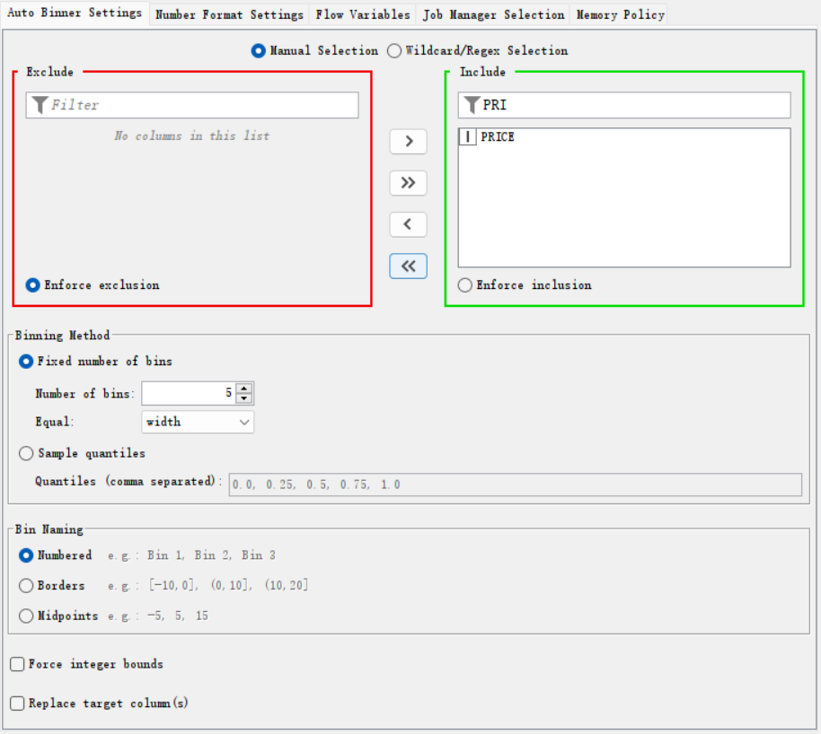

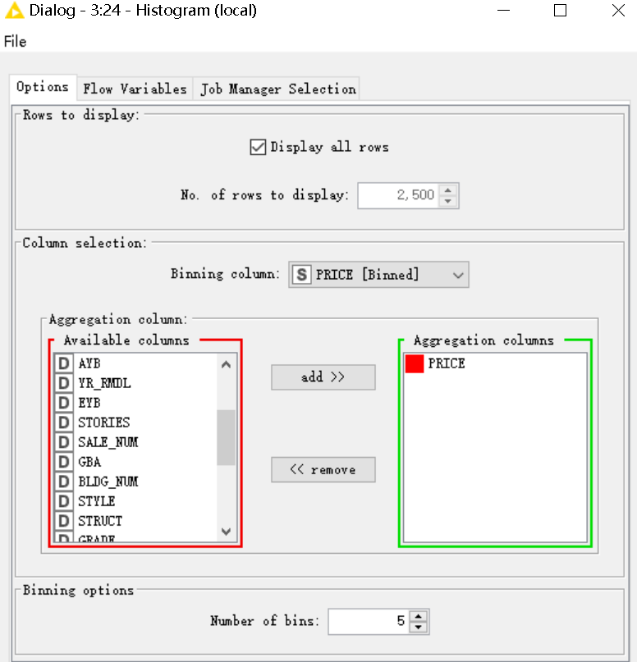

1. **Result of auto-binner：**

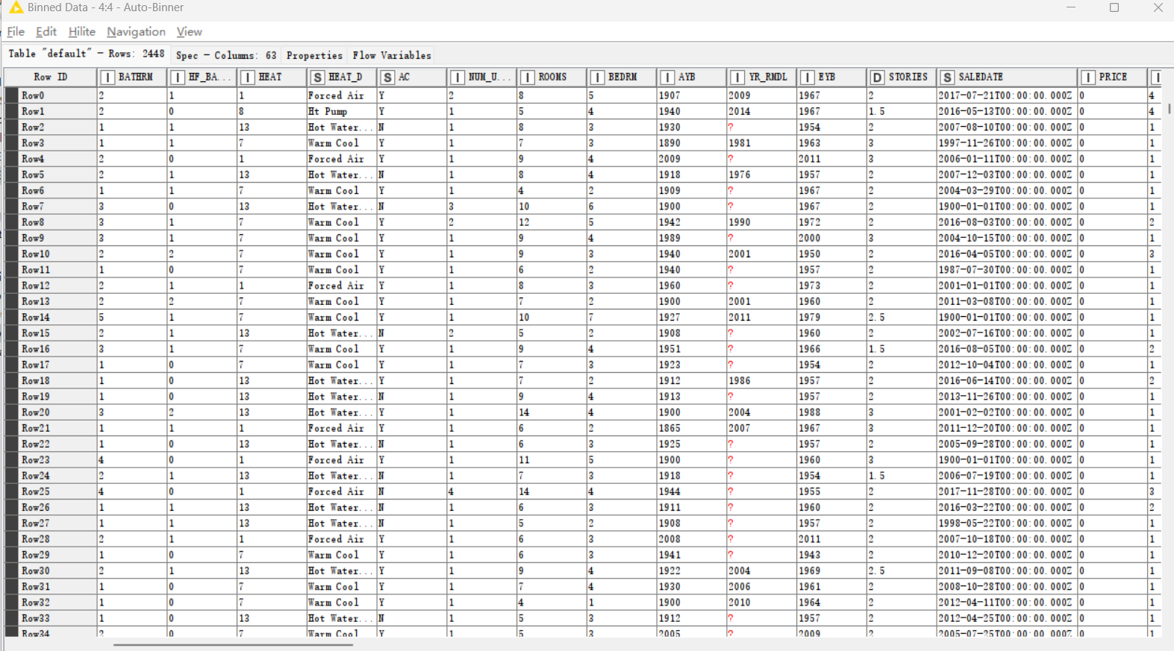

1. **Result of histogram**

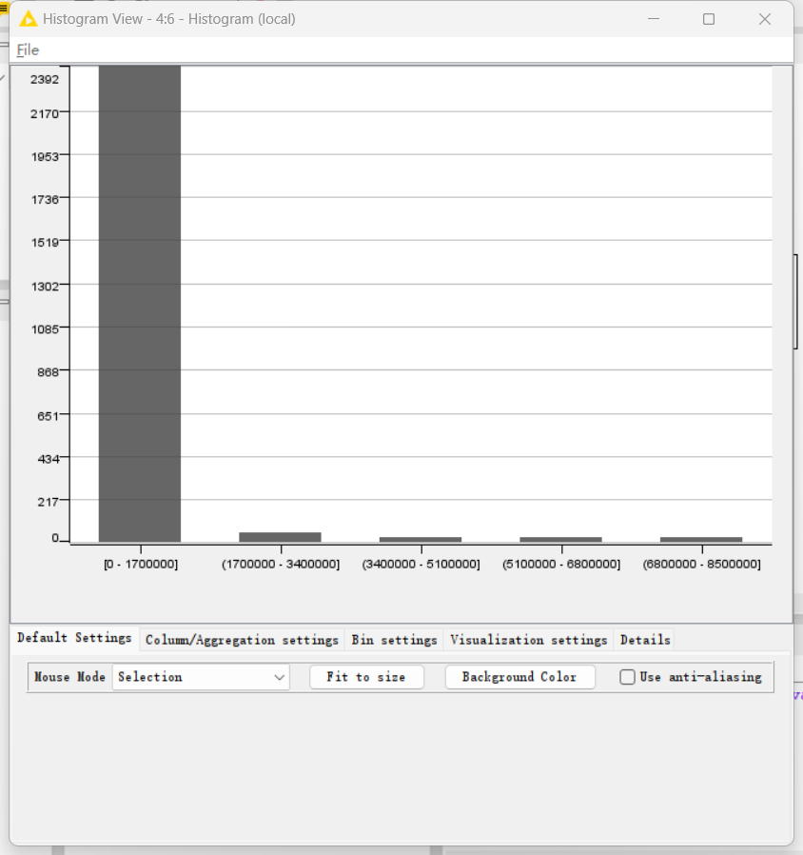

1. **2 Equi-depth binning**

Using “Auto-Binner” and “Interactive Histogram”. Auto-Binner is used to Equi-depth binning and Histogram is used to view the distribution of binning results.

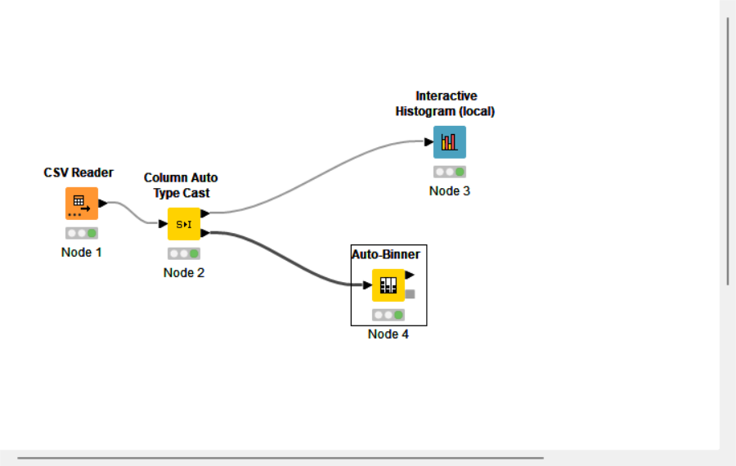

**2. Parameter setting**

The reason why the number of bins is 5 is that when the number of bins is greater than seven, empty boxes will appear. The number of five is chosen because the data will be evenly distributed.

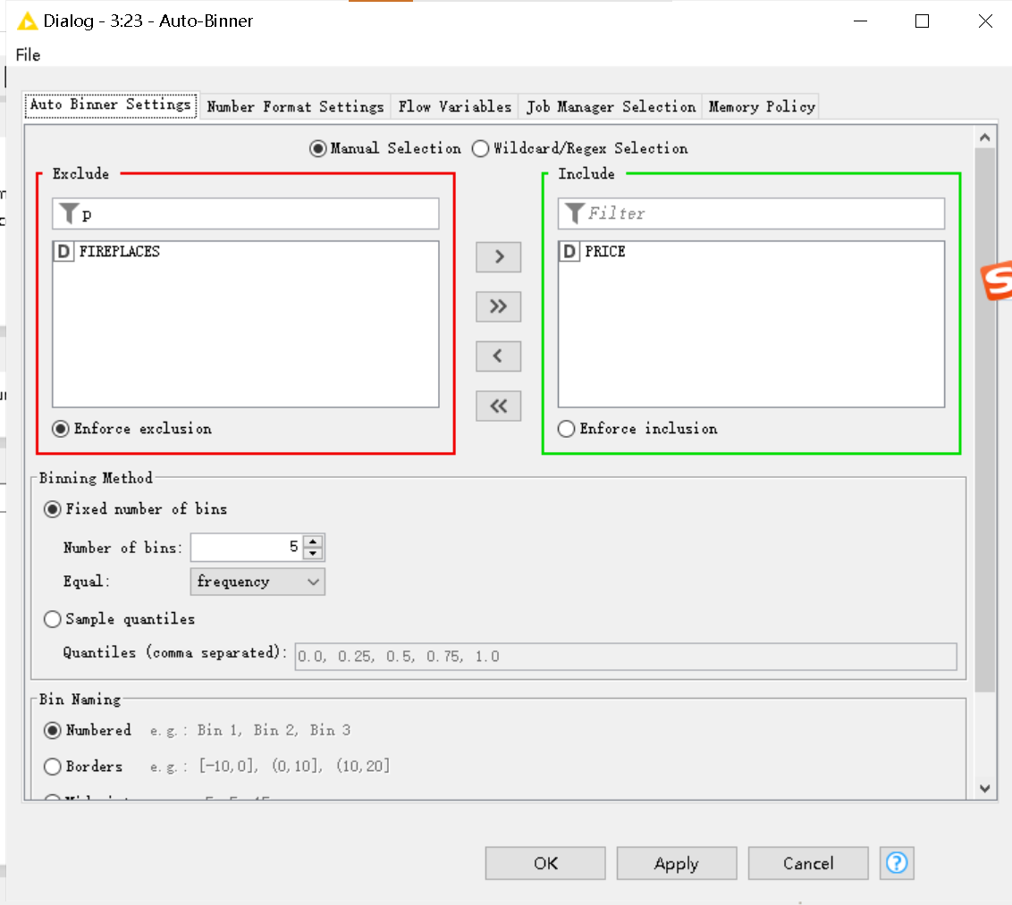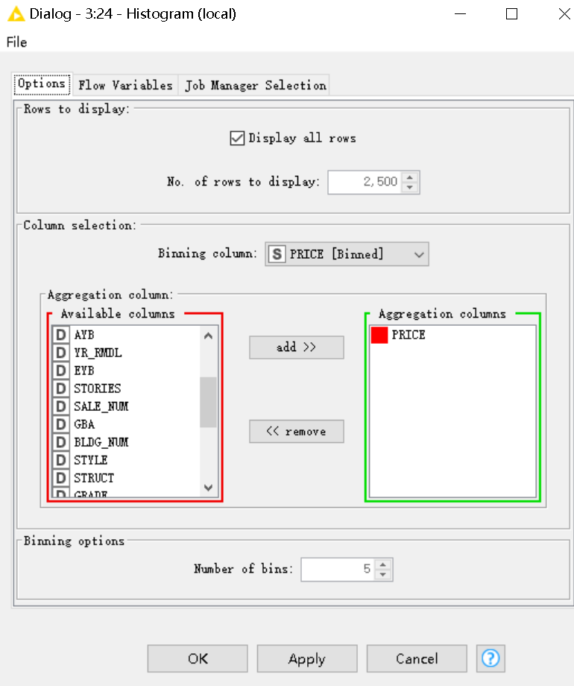

1. **Result of auto-binner：**

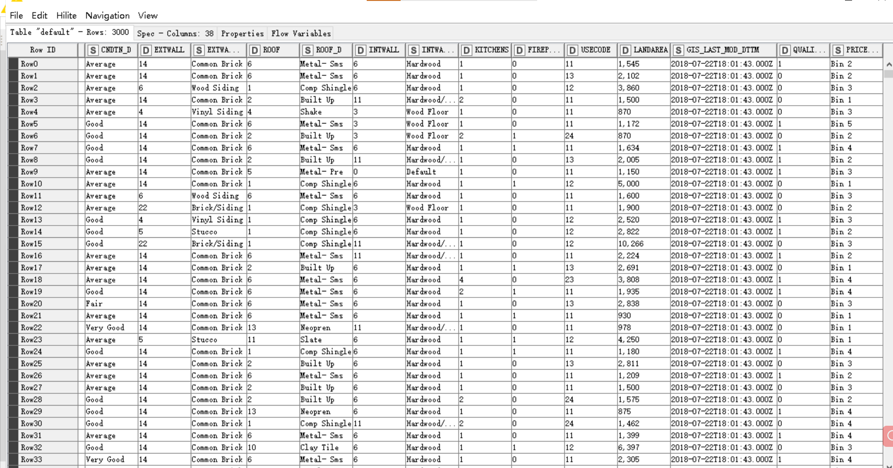

1. **Result of Histogram：**

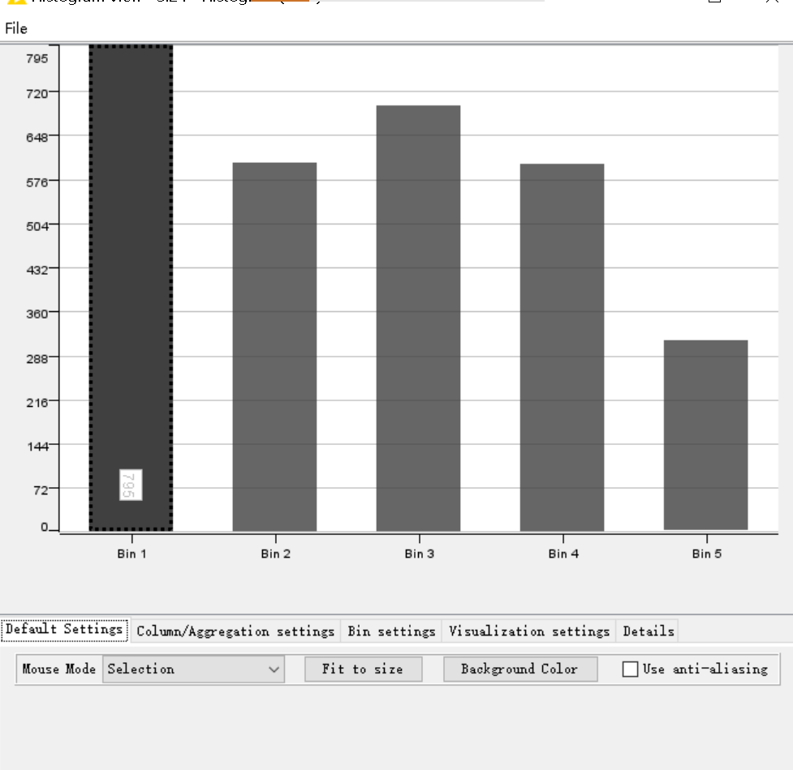

In contrast, using equi-depth bins is more advantageous because the data is more evenly distributed and easier for analysis. Equi-depth binning divides the quantity into the same number of groups for binning, which is conducive to the situation that the data distribution is concentrated or there are obvious outliers. Equal-width bins are divided into the same width, which is conducive to a more uniform distribution of data, but the numerical distribution is uneven in the price attribute.

## 2. Normalize：

**2.1 Min-Max Normalization**

The purpose of standardization is to convert values into uniform units of data, reduce dimensions and reduce bias and confirmation weights, so that the data are comparable and standardized. The method is to map the maximum value in the original data to one, the minimum value to zero, and the others only map to a number from zero to one and distribute the data between zero and one. Using “Normailzer” with the Min-Max Normalization setting and “Excel Writer” to output result.

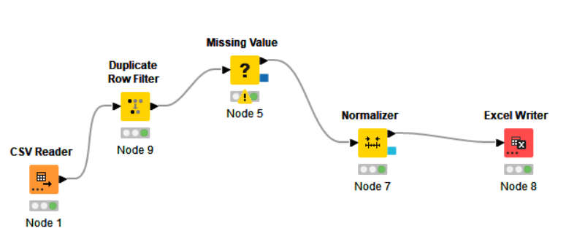

**2. Parameter setting**

Set min is 0 and max is 1. The significance of scaling relative to maximum minimum is that it is easier to train the model and keep none of the data negative.

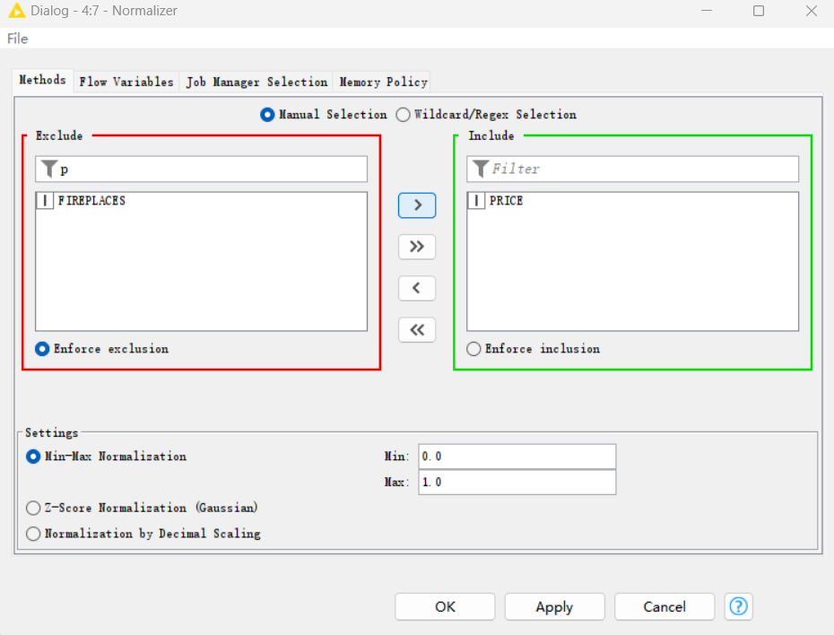

**3.Result of Min-Max Normalization：**

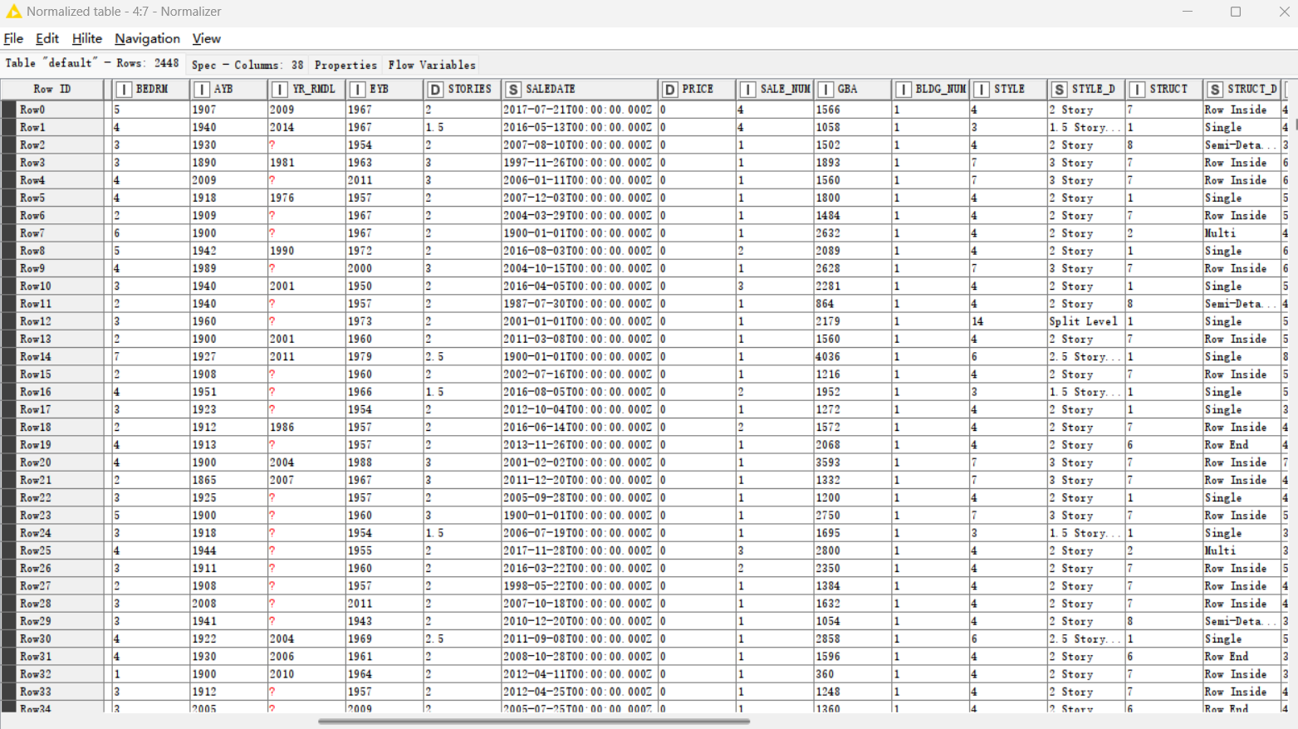

### 2.2 Z-Score Normalization

Z-Score Normalization is normalized to a distribution with a mean of 0 and a standard deviation of one by subtracting the mean from the original data and dividing by the standard deviation. This model can reduce the impact of noise in the data on the model and improve the stability and accuracy of the model, but this method may be affected only by extremes, resulting in poor standardization.

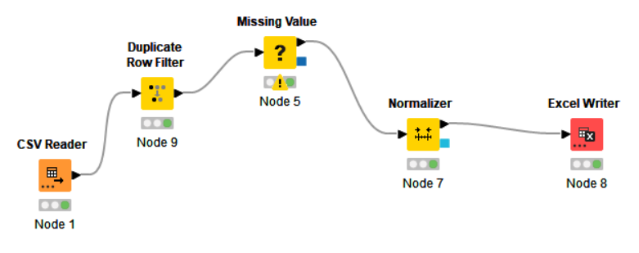

**2. Parameter setting**

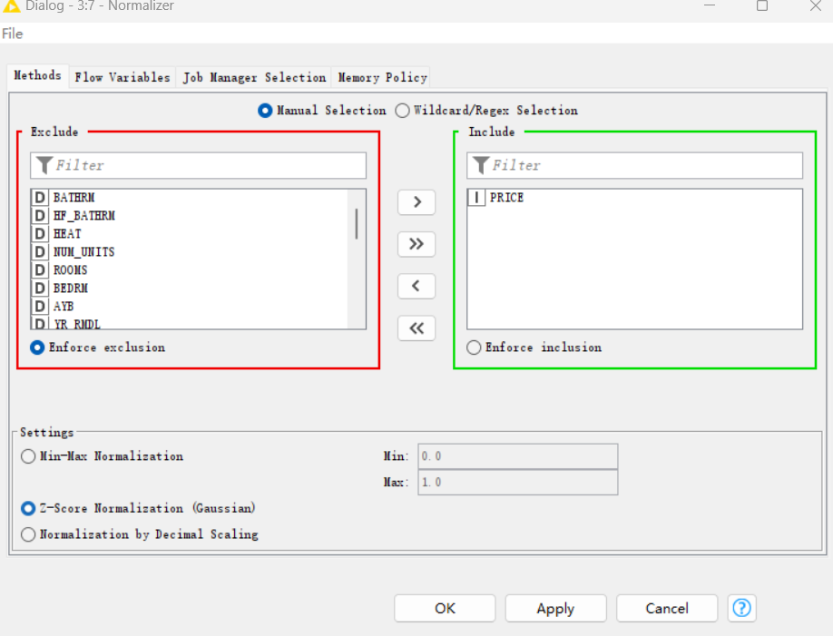

**3.Result of Z-Score Normalization：**

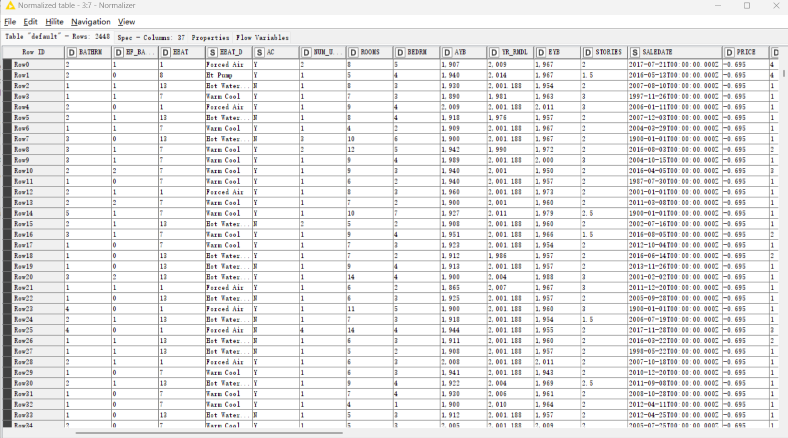

## Discretise the "PRICE"

In the process of converting discretized continuous data into discrete data, it can be used for feature engineering or processing the input data of some computer learning algorithms. In this data, we split the price into high, medium, low and expensive  (e.g.: Low=0-50k; Medium=50k-100k; High=100k-1000k; Expensive= 1000k+ ). Using “Numeric Binner” to discretise and “Excel Writer” to output result.

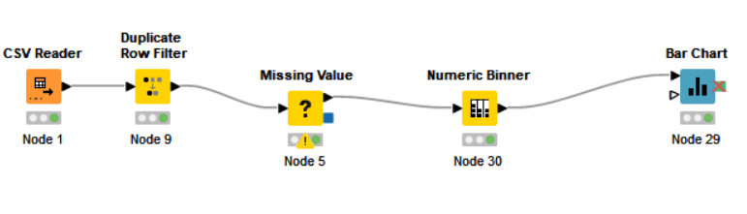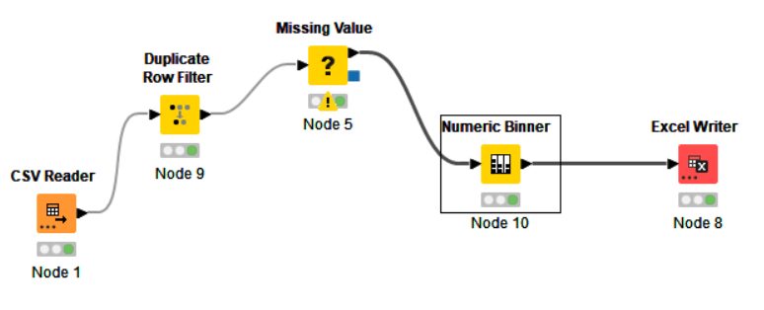

**2. Parameter setting**

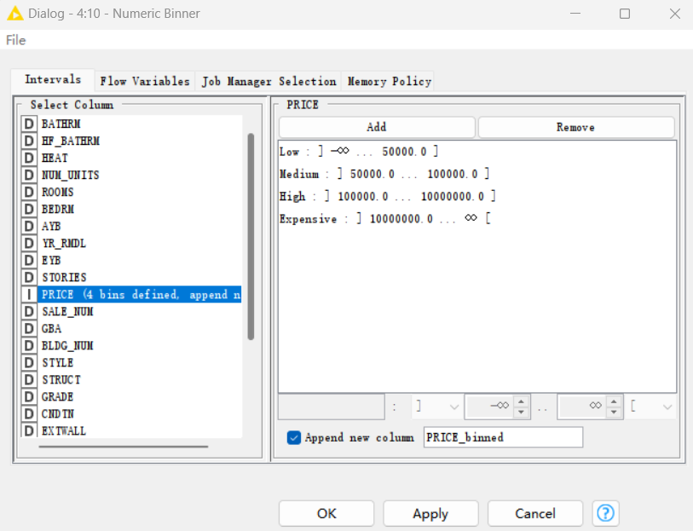

**3. Result of Discretise：**

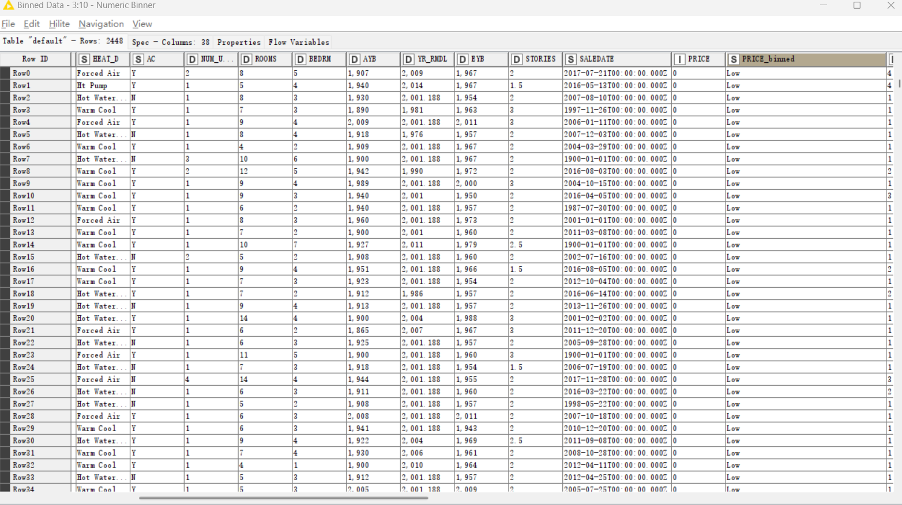

1. **Bar chart**

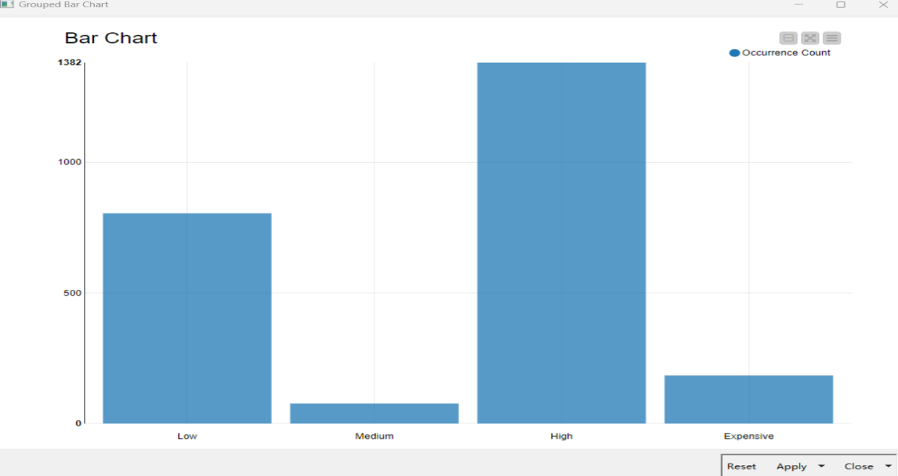

## Binarisation

Binarisation is the process of converting continuous values into binary data. This method is based on a threshold and sets all values less than or equal to that threshold to 0 and all values greater than that threshold to 1. Using “One to many” to binarise the "STRUCT_D" variable [with values "0" or "1"] and “Excel Writer” to output result.

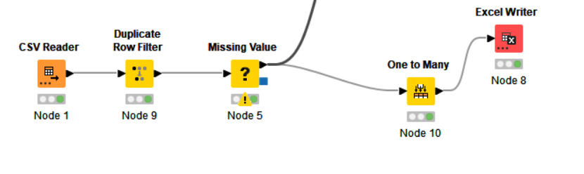

**2. Parameter setting**

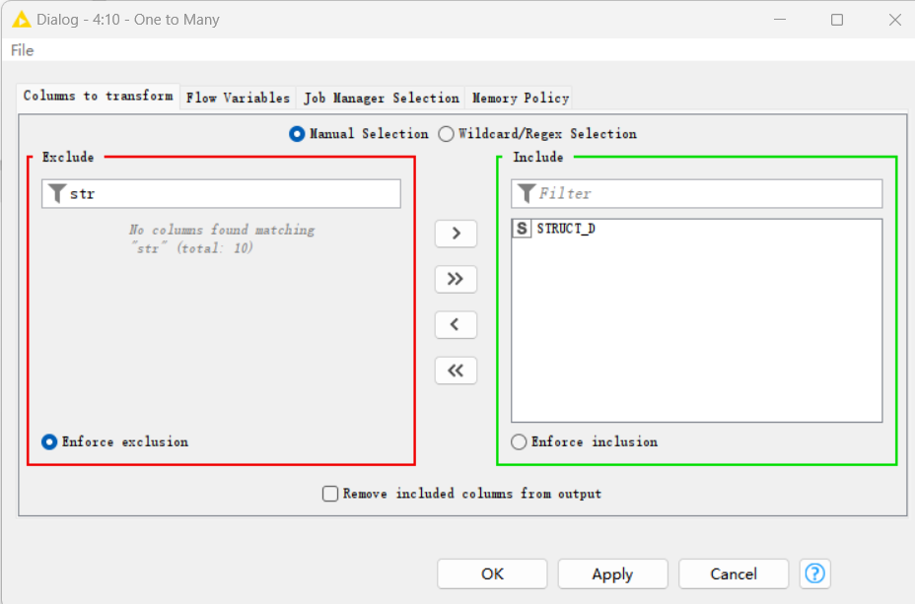

**3. Result of Binarisation：**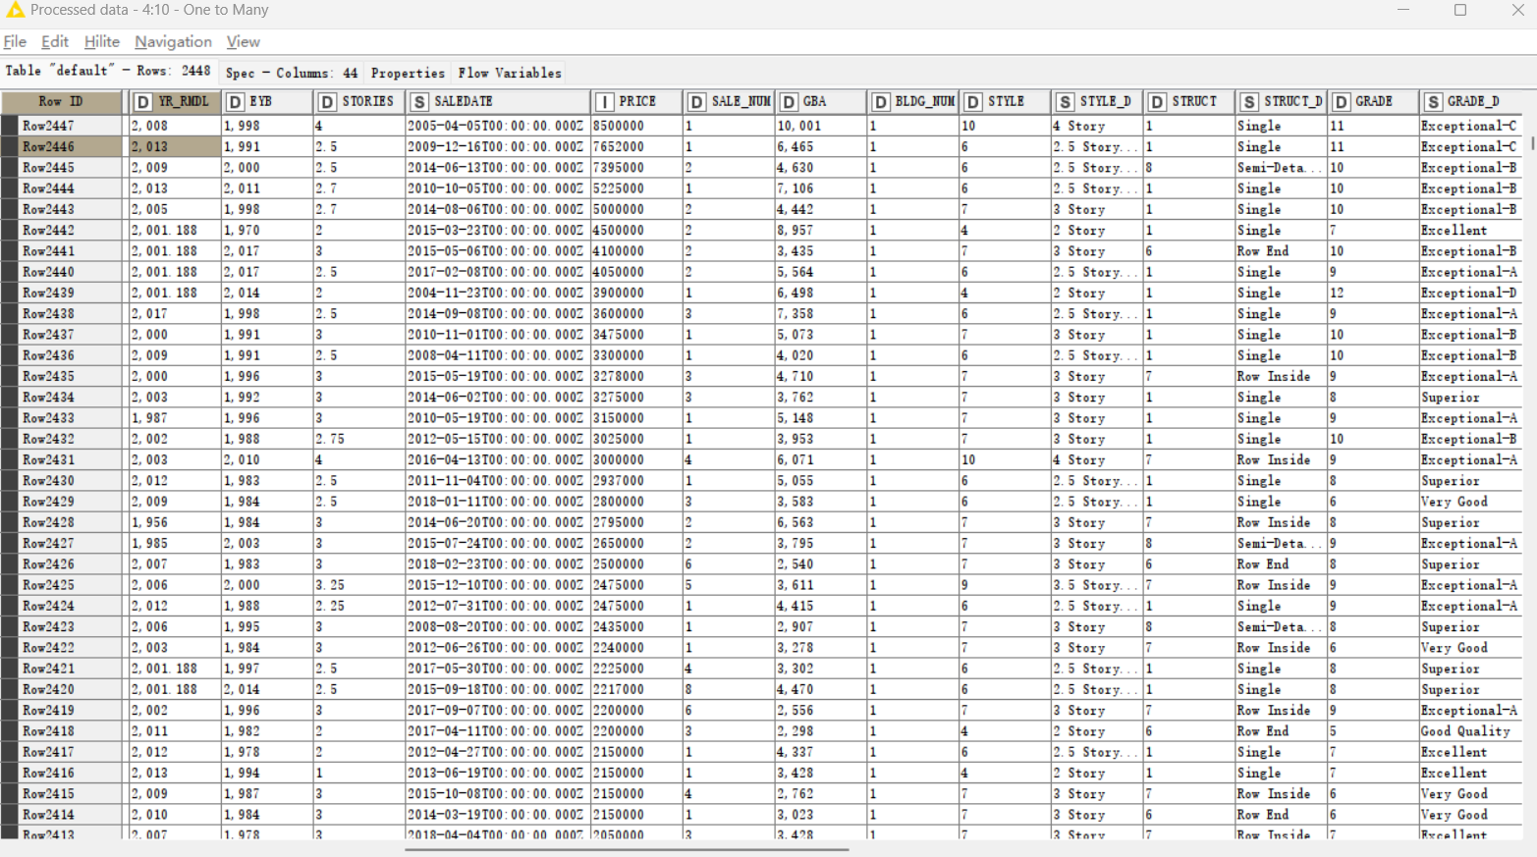

**1C Summary:**

The most important findings of this report include the following:

1. The same data that appears in the data may be duplicated. There are 551 empty data and 795 zero data in the price attribute, resulting in the average median, maximum and minimum values being greatly affected by extreme values, which may be incomplete or wrong in collecting data. All of the data collected were sold on January 1, 1900, and the selling price was either empty or zero, possibly anomalous.

Using the mean or median method in the statistics instead of vacancies can only lead to untruthful and misguided data models. These two properties should be subjected to more rigorous exploration and visual inspection in the future.

1. In the process of identifying correlations, it was found that Style and stories have a strong linear relationship, bathroom and Room have a certain relationship, and grade and price also have a certain association, and the correlation of these attributes should be more studied and more rigorous visual inspection in the future.
2. In the settings, there is a row A Y B is 2019, but EY B years old data is zero, but E YB time will not be earlier than A Y B and most of the other data in this message is blank, so we need to determine whether this row of data is caused by human factors caused by erroneous data.
3. By utilising hierarchical clustering , we found that these data are optimally classified by K-means. In the future, more in-depth research can be carried out by adjusting the model parameters.
4. During the visualization process, it was found that the price data was not very strong correlated with other data, and could be affected by extreme values and error values. In the future, more careful exploration and rigorous collection and investigation of such data will be required.
5. Through the visual chart, it can be inferred that the price is related to the selling time, and the later the selling time, the higher the probability of obtaining a high price. And price has a certain relationship with GBA, and when GBA is larger, the higher the probability of price. In the future, more careful exploration and rigorous collection and investigation of such data will be required.